|  |  |
| --- | --- |
| **Logo_FPT_University_doc** | **MINISTRY OF EDUCATION AND TRAINING** |

**FPT UNIVERSITY**

|  |
| --- |
| Capstone Project Document |
| Test Online |

|  |  |
| --- | --- |
| **Group 10** | |
| **Group Members** | Nguyễn Phan Quang Nhật – Team leader – 60143  Nguyễn Viết Vĩnh – Team member – 00330  Đoàn Xuân Quang – Team member – 60448  Bùi Tường Thi – Team member – 00721 |
| **Supervisor** | Mr. Kiều Trọng Khánh |
| **Ext Supervisor** | N/A |
| **Capstone Project code** | BUSG |

Ho Chi Minh City, 04/2013

# Acknowledgements

We wish to thank various people for their contribution to this project; Our teachers for their advices and participant in the final review. Our friend, Phạm Lê Tấn Đạt, for the valuable technical support as well as his help in the Android application’s construction. Mr. Đoàn Xuân Nam for his supplying of testing devices.

Special thanks should be given to Mr. Kiều Trọng Khánh, our research supervisor for his professional guidance and the useful, constructive recommendations throughout the course of this project.

# Table of Contents

[Acknowledgements 2](#_Toc354257371)

[Table of Contents 3](#_Toc354257372)

[List of Figures 10](#_Toc354257373)

[List of Tables 12](#_Toc354257374)

[List of abbreviations and acronyms 14](#_Toc354257375)

[A. Introduction 1](#_Toc354257376)

[B. Project Management Plan 5](#_Toc354257377)

[I. Problem Definition 5](#_Toc354257378)

[1. Capstone Project Name 5](#_Toc354257379)

[2. Problem Abstract 5](#_Toc354257380)

[3. Project Overview 5](#_Toc354257381)

[3.1 The Current Systems 5](#_Toc354257382)

[3.1.a Government hotline 5](#_Toc354257383)

[3.1.b Government public website 6](#_Toc354257384)

[3.1.c Google maps service 6](#_Toc354257385)

[3.1.d www.donxebuyt.com 6](#_Toc354257386)

[3.2 The Proposed System 6](#_Toc354257387)

[3.3 Boundaries of the System 7](#_Toc354257388)

[3.4 Development Environment 7](#_Toc354257389)

[3.4.a Hardware Requirements 7](#_Toc354257390)

[3.4.b Software Requirements 7](#_Toc354257391)

[II. Project Organization 8](#_Toc354257392)

[1. Software Process Model 8](#_Toc354257393)

[2. Roles and Responsibilities 8](#_Toc354257394)

[3. Tools and Techniques 9](#_Toc354257395)

[III. Project Management Plan 10](#_Toc354257396)

[1. Project Iterations 10](#_Toc354257397)

[2. Iteration Detail 12](#_Toc354257398)

[2.1 Phase 1: Preliminary Investigation or Analysis 12](#_Toc354257399)

[2.2 Phase 2: Data Synchronizer 12](#_Toc354257400)

[2.3 Phase 3: Bus Routes & Bus Stops Management 12](#_Toc354257401)

[2.4 Phase 4: Direction Suggestion 13](#_Toc354257402)

[2.5 Phase 5: Time Schedule 13](#_Toc354257403)

[2.6 Phase 6: Authentication and Authorization 14](#_Toc354257404)

[2.7 Phase 7: Android Client 14](#_Toc354257405)

[3. Meeting minutes 15](#_Toc354257406)

[IV. Coding Convention 15](#_Toc354257407)

[C. Software Requirement Specification 16](#_Toc354257408)

[I. User Requirement Specification 16](#_Toc354257409)

[1. Public users requirements 16](#_Toc354257410)

[2. Logged User 16](#_Toc354257411)

[3. Administrator requirements 16](#_Toc354257412)

[4. Staff requirements 16](#_Toc354257413)

[II. System Requirement Specification 17](#_Toc354257414)

[1. System Features Overview 17](#_Toc354257415)

[2. Public User 18](#_Toc354257416)

[2.1 Login 18](#_Toc354257417)

[2.2 Request Directions 19](#_Toc354257418)

[2.2.a Cheapest Itinerary 19](#_Toc354257419)

[2.2.b Shortest Itinerary 21](#_Toc354257420)

[2.2.c Fewest-Bus Itinerary 23](#_Toc354257421)

[2.2.d Fastest Itinerary 25](#_Toc354257422)

[3. Logged Users 28](#_Toc354257423)

[3.1 Logout 28](#_Toc354257424)

[3.2 Change Own Account Information 28](#_Toc354257425)

[4. Admin 30](#_Toc354257426)

[4.1 View List of Accounts 30](#_Toc354257427)

[4.2 Add an Account 31](#_Toc354257428)

[4.3 Edit an Account Information 32](#_Toc354257429)

[5. Staff 34](#_Toc354257430)

[5.1 Compare Local and Government Data 34](#_Toc354257431)

[5.1.a Compare Local & Government Data 34](#_Toc354257432)

[5.1.b Update System Data 35](#_Toc354257433)

[5.2 Manage Bus Stops 37](#_Toc354257434)

[5.2.a View list of Bus Stops 37](#_Toc354257435)

[5.2.b Add a new Bus Stop 38](#_Toc354257436)

[5.2.c Edit a Bus Stop 40](#_Toc354257437)

[5.2.d Delete a Bus Stop 41](#_Toc354257438)

[5.3 Manage Bus Routes 42](#_Toc354257439)

[5.3.a View list of Bus Routes 42](#_Toc354257440)

[5.3.b Add a new Bus Route 43](#_Toc354257441)

[5.3.c Edit a Bus Route 45](#_Toc354257442)

[5.3.d Delete a Bus Route 46](#_Toc354257443)

[5.4 Manage Bus Schedules 47](#_Toc354257444)

[5.4.a View list of Schedule for a Bus Route 47](#_Toc354257445)

[5.4.b Add a new Schedule for a Bus Route 48](#_Toc354257446)

[5.4.c Edit a Schedule of a Bus Route 50](#_Toc354257447)

[5.4.d Delete a Schedule of a Bus Route 51](#_Toc354257448)

[6. Software System Attributes 52](#_Toc354257449)

[6.1 Usability 52](#_Toc354257450)

[6.1.a Graphic User Interface 52](#_Toc354257451)

[6.1.b Usability for public user 52](#_Toc354257452)

[6.1.c Usability for admin and staff 52](#_Toc354257453)

[6.1.d Installation 52](#_Toc354257454)

[6.2 Reliability 52](#_Toc354257455)

[6.3 Availability 52](#_Toc354257456)

[6.4 Security 53](#_Toc354257457)

[6.5 Maintainability 53](#_Toc354257458)

[6.6 Portability 53](#_Toc354257459)

[6.7 Performance 53](#_Toc354257460)

[III. Main Flows 53](#_Toc354257461)

[1. Public User 53](#_Toc354257462)

[2. Staff 54](#_Toc354257463)

[IV. Entity Relationship - Conceptual 55](#_Toc354257464)

[D. Software Design Description (SDD) 56](#_Toc354257465)

[I. Design Overview 56](#_Toc354257466)

[II. System Architectural Design 56](#_Toc354257467)

[III. Component Diagram 57](#_Toc354257468)

[IV. Detailed Description of Components 59](#_Toc354257469)

[*1.* Graph Loader & Direction Calculator 59](#_Toc354257470)

[1.1 Class Diagram 59](#_Toc354257471)

[1.2 Class Diagram Explanation 60](#_Toc354257472)

[1.2.a TravelExpense 60](#_Toc354257473)

[1.2.b Graph 60](#_Toc354257474)

[1.2.c DirectionService 64](#_Toc354257475)

[1.2.d CompareByTime 64](#_Toc354257476)

[1.2.e CompareByPrice 64](#_Toc354257477)

[1.2.f CompareByNumOfBus 65](#_Toc354257478)

[1.2.g CompareByDistance 66](#_Toc354257479)

[1.2.h RouteInfo 66](#_Toc354257480)

[1.2.i BusStopInfo 66](#_Toc354257481)

[1.2.j AdjacentBusStopInfo 67](#_Toc354257482)

[1.2.k AdjacentWalkingBusStopInfo 67](#_Toc354257483)

[1.2.l Scheduler 67](#_Toc354257484)

[1.2.m SchedulerBuilder 68](#_Toc354257485)

[1.2.n Heap 68](#_Toc354257486)

[1.2.o DoubleHeap 68](#_Toc354257487)

[1.2.p GraphBuilder 69](#_Toc354257488)

[1.2.q DirectionResult 69](#_Toc354257489)

[1.2.r Direction 69](#_Toc354257490)

[1.2.s Leg 70](#_Toc354257491)

[1.3 Algorithms of important methods in each class specified in pseudo code or by Flow-Chart 70](#_Toc354257492)

[1.3.a Dijkstra 70](#_Toc354257493)

[2. Data Synchronizer 71](#_Toc354257494)

[3. Bus Stop Manager 72](#_Toc354257495)

[4. Bus Route Manager 72](#_Toc354257496)

[5. Scheduler 72](#_Toc354257497)

[6. Change Tracker 72](#_Toc354257498)

[V. User Interface Design 72](#_Toc354257499)

[E. Software Test Documentation 80](#_Toc354257500)

[I. Introduction 80](#_Toc354257501)

[1. System Overview 80](#_Toc354257502)

[2. Test Approach 80](#_Toc354257503)

[II. Test Plan 80](#_Toc354257504)

[1. Features to be tested 80](#_Toc354257505)

[2. Features not to be tested 81](#_Toc354257506)

[III. Test Case 82](#_Toc354257507)

[1. Public page 82](#_Toc354257508)

[1.1 Enter, change Starting Point, Destinations’ locations. 82](#_Toc354257509)

[1.2 Create, move, remove Starting Point, Destinations’ markers. 84](#_Toc354257510)

[1.3 Get Directions – Shortest Distance mode 86](#_Toc354257511)

[1.4 Get Directions – Least Bus mode 88](#_Toc354257512)

[1.5 Get Directions – Cheapest mode 90](#_Toc354257513)

[1.6 Get Directions – Fastest mode 92](#_Toc354257514)

[1.7 View results 93](#_Toc354257515)

[2. Synchronizer 94](#_Toc354257516)

[2.1 View asynchronous route 94](#_Toc354257517)

[2.2 Search 94](#_Toc354257518)

[2.3 Synchronizer 96](#_Toc354257519)

[2.4 View Sync log 97](#_Toc354257520)

[3. Route 98](#_Toc354257521)

[3.1 View Route 98](#_Toc354257522)

[3.2 Add Route 98](#_Toc354257523)

[3.3 View, Edit detail of a Route 102](#_Toc354257524)

[4. Schedules 105](#_Toc354257525)

[4.1 Day Schedule 105](#_Toc354257526)

[4.2 Time Schedule 107](#_Toc354257527)

[5. Bus stop 108](#_Toc354257528)

[F. Software User’s Manual 111](#_Toc354257529)

[I. Installation Guide 111](#_Toc354257530)

[II. User’s Guide 113](#_Toc354257531)

[1. Public User 113](#_Toc354257532)

[1.1 Sharing your location 114](#_Toc354257533)

[1.2 Choosing the origin and destinations 114](#_Toc354257534)

[1.3 Changing origin/destinations 115](#_Toc354257535)

[1.4 Removing destinations 116](#_Toc354257536)

[1.5 Setting advance option 116](#_Toc354257537)

[1.6 Getting directions 116](#_Toc354257538)

[2. Staff/Administrator User 118](#_Toc354257539)

[2.1 Synchronizing 118](#_Toc354257540)

[2.2 Managing Route 122](#_Toc354257541)

[2.2.a View Route 122](#_Toc354257542)

[2.2.b Add Route 123](#_Toc354257543)

[2.2.c Edit Route 124](#_Toc354257544)

[2.2.d Delete Route 125](#_Toc354257545)

[2.3 Schedule 127](#_Toc354257546)

[2.3.a Add day schedule 127](#_Toc354257547)

[2.3.b Add time schedule 128](#_Toc354257548)

[2.3.c Delete time schedule 128](#_Toc354257549)

[2.4 Managing bus stop 129](#_Toc354257550)

[2.4.a View bus stop 130](#_Toc354257551)

[2.4.b Add bus stop 130](#_Toc354257552)

[2.4.c Edit bus stop 131](#_Toc354257553)

[2.4.d Delete bus stop 131](#_Toc354257554)

[G. Works Cited 132](#_Toc354257555)

# List of Figures

[Figure 1: Agile Development (www.agilekiwi.com, n.d.) 8](#_Toc354012836)

[Figure 2: System Features Overview 17](#_Toc354012837)

[Figure 3: Public User Features 18](#_Toc354012838)

[Figure 4: Logged Users Features 28](#_Toc354012839)

[Figure 5: Admin Features 30](#_Toc354012840)

[Figure 6: Synchronize Data 34](#_Toc354012841)

[Figure 7: Manage Bus Stops 37](#_Toc354012842)

[Figure 8: Manage Bus Routes 42](#_Toc354012843)

[Figure 9: Manage Bus Schedules 47](#_Toc354012844)

[Figure 10: Public User Main Flow 53](#_Toc354012845)

[Figure 11: Staff Main Flow 54](#_Toc354012846)

[Figure 12: Entity Relationship 55](#_Toc354012847)

[Figure 13: MVC Architecture (ESRI, n.d.) 56](#_Toc354012848)

[Figure 14: Components Overview 57](#_Toc354012849)

[Figure 15: Model Main Components 58](#_Toc354012850)

[Figure 16: Graph Loader & Direction Services 59](#_Toc354012851)

[Figure 17: K shortest path algorithms 71](#_Toc354012852)

[Figure 18: Public user page 72](#_Toc354012853)

[Figure 19: Synchronize bus routes page and modal for synchronizing process 74](#_Toc354012854)

[Figure 20: Routes management page 76](#_Toc354012855)

[Figure 21: Bus stop management page and modal for editing bus stop 77](#_Toc354012856)

[Figure 22: Schedule page 78](file:///D:\Learning%20Resources\Software%20Engineering\Capstone\Stuffs\Report%206.2.docx#_Toc354012857)

[Figure 23: Configure IIS, right click on "Sites" 111](#_Toc354012858)

[Figure 24: Configure IIS, Add Wed Site window 112](file:///D:\Learning%20Resources\Software%20Engineering\Capstone\Stuffs\Report%206.2.docx#_Toc354012859)

[Figure 25: Configure IIS, check out your web 112](#_Toc354012860)

[Figure 26: Public user page's controls 113](file:///D:\Learning%20Resources\Software%20Engineering\Capstone\Stuffs\Report%206.2.docx#_Toc354012861)

[Figure 27: Pop up ask for sharing location 114](#_Toc354012862)

[Figure 28: Choosing origin/destination by typing in address textbox 115](file:///D:\Learning%20Resources\Software%20Engineering\Capstone\Stuffs\Report%206.2.docx#_Toc354012863)

[Figure 29: Choosing origin/destinations by right click on map 115](file:///D:\Learning%20Resources\Software%20Engineering\Capstone\Stuffs\Report%206.2.docx#_Toc354012864)

[Figure 30: Delete destination buttons 116](file:///D:\Learning%20Resources\Software%20Engineering\Capstone\Stuffs\Report%206.2.docx#_Toc354012865)

[Figure 31: Remove destination by right click on marker 116](#_Toc354012866)

[Figure 32: Directions on map 117](#_Toc354012867)

[Figure 33: Click on marker for more information 117](#_Toc354012868)

[Figure 34: List directions in detail 118](file:///D:\Learning%20Resources\Software%20Engineering\Capstone\Stuffs\Report%206.2.docx#_Toc354012869)

[Figure 35: Synchronize page's controls 118](file:///D:\Learning%20Resources\Software%20Engineering\Capstone\Stuffs\Report%206.2.docx#_Toc354012870)

[Figure 36: Click on item in table to see differences 120](file:///D:\Learning%20Resources\Software%20Engineering\Capstone\Stuffs\Report%206.2.docx#_Toc354012871)

[Figure 37: Step by step synchronizing 121](file:///D:\Learning%20Resources\Software%20Engineering\Capstone\Stuffs\Report%206.2.docx#_Toc354012872)

[Figure 38: Route management page's controls 122](file:///D:\Learning%20Resources\Software%20Engineering\Capstone\Stuffs\Report%206.2.docx#_Toc354012873)

[Figure 39: View route and its bus stops 123](file:///D:\Learning%20Resources\Software%20Engineering\Capstone\Stuffs\Report%206.2.docx#_Toc354012874)

[Figure 40: Step by step adding a route 123](file:///D:\Learning%20Resources\Software%20Engineering\Capstone\Stuffs\Report%206.2.docx#_Toc354012875)

[Figure 41: Edit Route button 124](file:///D:\Learning%20Resources\Software%20Engineering\Capstone\Stuffs\Report%206.2.docx#_Toc354012876)

[Figure 42: Edit route's code, name, outward and price 124](file:///D:\Learning%20Resources\Software%20Engineering\Capstone\Stuffs\Report%206.2.docx#_Toc354012877)

[Figure 43: Step by step reordering/removing route's bus stop(s) 125](file:///D:\Learning%20Resources\Software%20Engineering\Capstone\Stuffs\Report%206.2.docx#_Toc354012878)

[Figure 44: Delete route button 125](file:///D:\Learning%20Resources\Software%20Engineering\Capstone\Stuffs\Report%206.2.docx#_Toc354012879)

[Figure 45: Delete route dialog 126](file:///D:\Learning%20Resources\Software%20Engineering\Capstone\Stuffs\Report%206.2.docx#_Toc354012880)

[Figure 46: Schedule page's controls 127](file:///D:\Learning%20Resources\Software%20Engineering\Capstone\Stuffs\Report%206.2.docx#_Toc354012881)

[Figure 47: Step by step adding day schedule 128](file:///D:\Learning%20Resources\Software%20Engineering\Capstone\Stuffs\Report%206.2.docx#_Toc354012882)

[Figure 48: Delete time schedule button 129](file:///D:\Learning%20Resources\Software%20Engineering\Capstone\Stuffs\Report%206.2.docx#_Toc354012883)

[Figure 49: Bus stop management page's controls 129](file:///D:\Learning%20Resources\Software%20Engineering\Capstone\Stuffs\Report%206.2.docx#_Toc354012884)

[Figure 50: Add new bus stop modal 130](#_Toc354012885)

[Figure 51: Edit bus stop modal 131](#_Toc354012886)

# List of Tables

[Table 1: Software Introduction 4](#_Toc354012887)

[Table 2: Use Case PU001 - Login 19](#_Toc354012888)

[Table 3: Use Case PU002 - Request Cheapest Itinerary 21](#_Toc354012889)

[Table 4: Use Case PU003 - Request Shortest Itinerary 23](#_Toc354012890)

[Table 5: Use Case PU004 - Request Fewest-Bus Itinerary 25](#_Toc354012891)

[Table 6: Use Case PU005 - Request Fastest Itinerary 28](#_Toc354012892)

[Table 7: Use Case LU002 - Change Own Account Information 29](#_Toc354012893)

[Table 8: Use Case AD001 - View List of Accounts 31](#_Toc354012894)

[Table 9: Use Case AD002 - Add an Account 32](#_Toc354012895)

[Table 10: Use Case AD003 - Edit an account Information 34](#_Toc354012896)

[Table 11: Use Case ST001 - Compare Local & Government Data 35](#_Toc354012897)

[Table 12: Use Case ST002 - Update System Data 37](#_Toc354012898)

[Table 13: Use Case ST003 - View list of Bus Stops 38](#_Toc354012899)

[Table 14: Use Case ST004 - Add a new Bus Stop 40](#_Toc354012900)

[Table 15: Use Case ST005 - Edit a Bus Stop 41](#_Toc354012901)

[Table 16: Use Case ST006 - Delete a Bus Stop 42](#_Toc354012902)

[Table 17: Use Case ST007 - View list of Bus Routes 43](#_Toc354012903)

[Table 18: Use Case ST008 - Add a new Bus Route 45](#_Toc354012904)

[Table 19: Use Case ST009 - Edit a Bus Route 46](#_Toc354012905)

[Table 20: Use Case ST010 - Delete a Bus Route 47](#_Toc354012906)

[Table 21: Use Case ST011 - View list of Schedule for a Bus Route 48](#_Toc354012907)

[Table 22: Use Case ST012 - Add a new Schedule for a Bus Route 49](#_Toc354012908)

[Table 23: Use Case ST013 - Edit a Schedule for a Bus Route 51](#_Toc354012909)

[Table 24: Use Case ST014 - Delete a Schedule of a Bus Route 52](#_Toc354012910)

[Table 25: TravelExpense attributes 60](#_Toc354012911)

[Table 26: Graph attributes 61](#_Toc354012912)

[Table 27: Dijkstra method's parameters 61](#_Toc354012913)

[Table 28: Hamilton method's parameters 62](#_Toc354012914)

[Table 29: ParseResult method's parameters 62](#_Toc354012915)

[Table 30: Filter method's parameters 62](#_Toc354012916)

[Table 31: UpdateSchedule method's parameters 62](#_Toc354012917)

[Table 32: Cheapest method's parameters 63](#_Toc354012918)

[Table 33: LeastBus method's parameters 63](#_Toc354012919)

[Table 34: Shortest method's parameters 64](#_Toc354012920)

[Table 35: Fastest method's parameters 64](#_Toc354012921)

[Table 36: CompareByTime explanation 64](#_Toc354012922)

[Table 37: CompareByPrice explanation 65](#_Toc354012923)

[Table 38: CompareByNumOfBus explanation 66](#_Toc354012924)

[Table 39: CompareByDistance explanation 66](#_Toc354012925)

[Table 40: RouteInfo attributes 66](#_Toc354012926)

[Table 41: BusStopInfo attributes 67](#_Toc354012927)

[Table 42: AdjacentBusStopInfo attributes 67](#_Toc354012928)

[Table 43: AdjacentWalkingBusStopInfo attributes 67](#_Toc354012929)

[Table 44: Scheduler attributes 67](#_Toc354012930)

[Table 45: FindEarliest method's parameters 68](#_Toc354012931)

[Table 46: DirectionResult attributes 69](#_Toc354012932)

[Table 47: Direction attributes 70](#_Toc354012933)

[Table 48: Leg attributes 70](#_Toc354012934)

[Table 49: Public User page's controls 73](#_Toc354012935)

[Table 50: Synchronize bus routes page's controls 75](#_Toc354012936)

[Table 51: Route Management page's controls 76](#_Toc354012937)

[Table 52: Bus Stop Management page's controls 78](#_Toc354012938)

[Table 53: Schedule page's controls 79](#_Toc354012939)

[Table 54: Meaning of public user page's controls 114](#_Toc354012940)

[Table 55: Step by step choosing origin/destinations by typing in address textbox 115](#_Toc354012941)

[Table 56: Step by step choosing origin/destination by right click on map 115](#_Toc354012942)

[Table 57: Meaning of synchronize page's controls 119](#_Toc354012943)

[Table 58: Step by step synchronizing 120](#_Toc354012944)

[Table 59: Meaning of route management page's controls 122](#_Toc354012945)

[Table 60: Step by step adding route 123](#_Toc354012946)

[Table 61: Step by step reordering/removing route’s bus stop(s) 125](#_Toc354012947)

[Table 62: Meaning of schedule page's controls 127](#_Toc354012948)

[Table 63: Step by step adding day schedule 128](#_Toc354012949)

[Table 64: Step by step adding time schedule 128](#_Toc354012950)

[Table 65: Meaning of bus stop management page's controls 130](#_Toc354012951)

[Table 66: Step by step adding bus stop 131](#_Toc354012952)

[Table 67: Step by step editing bus stop 131](#_Toc354012953)

# List of abbreviations and acronyms

|  |  |  |
| --- | --- | --- |
| **No.** | **Abbreviation & Acronym** | **Definition** |
| 1 | BUSG | Bus Number and Route Suggestion and Management System. |
| 2 | Admin | Administrator who is mainly responsible for maintaining system technically. |
| 3 | Staff | People who is mainly responsible for collecting and maintaining data. |
| 4 | Local Data | Data of bus stops, bus routes and schedule currently stored in BUSG |
| 5 | Remote Data | Date of bus stops and bus routes from government system. |
| 6 | Maximum transfer permitted | Is the maximum number of change in bus allowed during the journey. |
| 7 | Bus tranfer time | Is the necessary time for a passenger to move from one bus to another when they change bus |
| 8 | HCMC | Ho Chi Minh City |
| 9 | BA | Business Analysis |
| 10 | DEV | Developer |
| 11 | GUI | Graphic User Interface |
| 12 | IDE | Integrated Development Environment |
| 13 | DBMS | Database Management System |
| 14 | SVN | Subversion |
| 15 | ADSL | Asymmetric Digital Subscriber Line |

Table 1: List of abbreviations and acronyms

This page intentionally left blank.

# Introduction

|  |  |  |  |  |  |  |  |  |
| --- | --- | --- | --- | --- | --- | --- | --- | --- |
| **Project Title:** | | Bus Number and Route Suggestion and Management | | | | | | |
| **Start Date:** | | Jan 7th, 2013 | | | **Finished Date:** | | Apr 22nd, 2013 | |
| **Overview of Existing Scenario and Project’s Objectives:** | | * Ho Chi Minh City (HCMC) is the largest city and one of the most important economic hubs of Vietnam. The key means of HCMC transportation system are bus and private vehicles, including 3.2 % by the former and 90 % by the later (with motorcycles accounts for 78.8 %, cars 4.8 %, and bicycles 5 %) (Hong Tan Van, 2009). * The bus system in HCMC consists of bus routes. Each bus route has an outward trip and a return trip. The outward trip and the return trip of one bus route might share the same, some or use totally different bus stops. Moreover, different bus routes might also intersect each other at joint bus stops. Each bus route is comprised many buses. Each bus leaves the station with a predetermined time-table. The interval period a bus takes to travel from one station or bus stop to another is around 5 to 10 minutes. HCMC buses are cheap and plentiful, serving more than 110 routes around greater HCMC. * According to the Public Passenger Transport Management and Control Center of HCMC, HCMC bus system currently includes 110 routes. In 2012, there are approximately 370 million arrivals (compared to 318 million in 2011) and more than 392,740 phone call queries asking about bus routes information, increased by 74,400 calls (Báo Tin Mới, n.d.). * In respect to the above statistics, it is obvious that the demand of bus travelling as well as bus routes’ information has become an urgent matter. As a result, we've made attempt to create a bus routes searching system. Here are our initial results in aiming to construct a bus routes searching system in Ho Chi Minh City. | | | | | | |
| **Overview of Existing Solutions:** | | * Government hotline: The government hotline system is friendly and easy to use but it is not designed to serve a large number of users simultaneously. In addition, it is costly and slower in comparison with other services. Many find it difficult to remember hotline number as well as the directions given by operators. * Government public website: The government provides access to public bus information at http://www.buyttphcm.com.vn/. Up-to-date information (i.e. ticket prices, ticket counters, bus routes, etc) can be found here. The website also provides mean for user to get directions, but this service has some shortcomings:   + It is under-performed.   + It is not reliable for it cannot supply any direction for many requests.   + It does not support searching by time of departure or time of arrival.   + It does not support multi-destination search. * Google maps service: Those who use Google maps service at https://maps.google.com/ can find bus direction in HCHM via their engine’s transit service search. This website has a user-friendly and easy-to-use interface and is designed to serve a very large number of users. The service is not satisfiable, however:   + The data is not up-to-date leads to the suggested directions become rather unreliable.   + It does not support searching by multiple criteria (e.g. shortest by distance, shortest by time, least number of bus used …) * Community project [www.donxebuyt.com](http://www.donxebuyt.com): A project to help people finding bus routes. However:   + Its interface is not user-friendly.   + It is very slow (it often takes about 10 seconds for each request).   + The data is out-of-dated. | | | | | | |
| **Proposed Solutions:** | | * A system needs to be established which takes care of bus routes data and bus time schedule. These data should be maintained by staff to keep it up-to-date. It should be possible to synchronize automatically with the data from government website. * The system should be able to forecast the time buses reach a bus stop. This can be done by driver experience or via mathematical method or a combination of both. * The system should also be able to provide a mean by which users can search and get bus directions. Search queries can be carried out by many criteria: shortest time, shortest distance or least number of buses used… Users can also inquiry for directions of multi-destination trips. The direction given by the system should be aware of user’s expectation of departure time or arrival time. The system, when possible, should give more than one direction to benefit user’s self-preference. * The system should be hosted on the web for ease of access. It is possible to expose service as an Android application for mobile devices. * It is possible to implement a component to report buses’ locations for purpose of tracking and data collecting to serve bus time forecasting. | | | | | | |
| **Approach:** | | * Research more about user’s real experience. * Make attempts to create a product that overcome all shortcomings of existing similar services. | | | | | | |
| **References:** | | * <http://www.buyttphcm.com.vn> * <https://maps.google.com> * <http://www.donxebuyt.com/> | | | | | | |
|  | | | | | | | | |
| **Functions:** | | | | | | | | |
| **Group Functions** | | **Summary** | | | | | | |
| **Management Functions** | | * Authentication and Authorization: User must be authenticated and authorized to use management functions. These functions are aimed to be used by management staff. * Bus Route Management: Allow staff to view, add, modify and delete bus route when needed. * Bus Time Schedule: Allow staff to schedule for buses’ departure by day of week or by specific date of year. * Time forecast: Estimate time a bus reaching a bus stop. * Collecting data from government website: Collect and synchronize part of data from government website automatically. | | | | | | |
| **Public Service** | | * Bus Direction Suggestion based on:   + Departure Time (only for fastest)   + Optimize time or distance or cost or number of bus used   + Maximum walking transit   + Maximum bus used (except optimizing number of bus used)   + Minimum transit time (in case of optimizing time) * Should also provide alternative directions * Able to handle one or more destinations | | | | | | |
|  | | | | | | | | |
| **Roles and Responsibility:** | | | | | | | | |
| **No** | **Full name** | | | **Role** | | **Position** | | **Contact** |
| 1 | Kiều Trọng Khánh | | | Project Manager | | Instructor | | KhanhKT@fpt.edu.vn |
| 2 | Nguyễn Phan Quang Nhật | | | Developer | | Team leader | | NhatNPQ60143@fpt.edu.vn |
| 3 | Nguyễn Viết Vĩnh | | | Developer | | Team member | | VinhNV00330@fpt.edu.vn |
| 4 | Đoàn Xuân Quang | | | Developer | | Team member | | QuangDX60448@fpt.edu.vn |
| 5 | Bùi Tường Thi | | | Developer | | Team member | | ThiBT00721@fpt.edu.vn |
|  | | | | | | | | |
| **Project Authorization:** | | | | | | | | |
| **Approved by** | | | | **Role** | | | | **Date** |
| Kiều Trọng Khánh | | | | Project Manager | | | |  |
|  | | | | | | | | |
| **Comments:** | | |  | | | | | |

Table 2: Software Introduction

# Project Management Plan

## Problem Definition

### Capstone Project Name

* Project full name: Bus Number and Route Suggestion and Management
* Project code: BUSG

### Problem Abstract

Ho Chi Minh City (HCMC) is the largest city and one of the most important economic hubs of Vietnam. The key means of HCMC transportation system are bus and private vehicles, including 3.2 % by the former and 90 % by the later (with motorcycles accounts for 78.8 %, cars 4.8 %, and bicycles 5 %) (Hong Tan Van, 2009)1.

The bus system in HCMC consists of bus routes. Each bus route has an outward trip and a return trip. The outward trip and the return trip of one bus route might share the same, some or use totally different bus stops. Moreover, different bus routes might also intersect each other at joint bus stops. Each bus route is comprised many buses. Each bus leaves the station with a predetermined time-table. The interval period a bus takes to travel from one station or bus stop to another is around 5 to 10 minutes. HCMC buses are cheap and plentiful, serving more than 140 routes around greater HCMC.

According to the Public Passenger Transport Management and Control Center of HCMC, HCMC bus system currently includes 150 routes. In 2012, there are approximately 370 million arrivals (compared to 318 million in 2011) and more than 392,740 phone call queries asking about bus routes information, increased by 74,400 calls (Báo Tin Mới, n.d.)2.

In respect to the above statistics, it is obvious that the demand of bus travelling as well as bus routes’ information has become an urgent matter. As a result, we've made attempt to create a bus routes searching system. Here are our initial results in aiming to construct a bus routes searching system in Ho Chi Minh City.

### Project Overview

#### The Current Systems

##### Government hotline

The government hotline system is friendly and easy to use but it is not designed to serve a large number of users simultaneously. In addition, it is costly and slower in comparison with other services. Many find it difficult to remember hotline number as well as the directions given by operators.

##### Government public website

The government provides access to public bus information at http://www.buyttphcm.com.vn/. Up-to-date information (i.e. ticket prices, ticket counters, bus routes, etc.) can be found here. The website also provides mean for user to get directions, but this service has some shortcomings:

* + It is under-performed.
  + It is not reliable for it cannot supply any direction for multiple requests.
  + It does not support searching by time of departure or time of arrival.
  + It does not support multi-destination search.

##### Google maps service

Those who use Google maps service at https://maps.google.com/ can find bus direction in HCHM via their engine’s transit service search. This website has a user-friendly and easy-to-use interface and is designed to serve a very large number of users. The service is not satisfactory, however:

* + The data is not up-to-date leads to the suggested directions become rather unreliable.
  + It does not support searching by multiple criteria (e.g. shortest by distance, cheapest, shortest by time, least number of buses used …)

##### [www.donxebuyt.com](http://www.donxebuyt.com)

People can use the community project at [www.donxebuyt.com](http://www.donxebuyt.com) to find bus directions. However this service has some shortcomings:

* + It is not user-friendly.
  + It is very slow (it often takes about 10 seconds for each request).
  + The data is out-of-dated.

#### The Proposed System

The system needs to be established should have these abilities:

* Takes care of bus routes data and bus time schedule. These data should be maintained by staff to keep it up-to-date. It should be possible to synchronize automatically with the data from government website.
* Forecast the time buses reach a bus stop. This can be done by driver experience or via mathematical method or a combination of both.
* Provide a mean by which users can search and get bus directions. Search queries can be carried out by many criteria: shortest time, shortest distance, least number of buses used or cheapest… Users can also inquiry for directions of multi-destination trips. The direction given by the system should be aware of user’s expectation of departure time. The system, when possible, should give more than one direction to benefit user’s self-preference.
* Be hosted on the web for ease of access. It is possible to expose service as an Android application for mobile devices.

#### Boundaries of the System

* The system is currently used for internal state-supported city bus routes which are managed by Ho Chi Minh City (www.buyttphcm.com.vn, n.d.).
* The system is used to manage these aspects of city bus system:
  + Itinerary of buses
  + Departure time table
* The system is not intended for managing these aspects:
  + Buses
  + Human Resources
  + Finance
* The system can give direction suggestions which include walking and/or using city buses.
* The system supports Vietnamese and English for public users and English for staff.
* The completed product includes
  + The website for public users and staff.
  + Android software to access service via Android smartphone.
  + All the process involved documents.

#### Development Environment

##### Hardware Requirements

* Internet connected computer (ADSL 4Mbs).

##### Software Requirements

* Operating System: Windows 7
* IDE: Visual Studio 2010
* DBMS: SQL Server Express 2008
* Subversion Client: Tortoise SVN, Visual SVN
* Source Control: Assembla Free Private Subversion® Repository[[1]](#footnote-1)
* Tickets System: Assembla Free Tickets Tool for Agile Task Management[[2]](#footnote-2)

## Project Organization

### Software Process Model

Project is developed under agile model.

Figure 1: Agile Development (www.agilekiwi.com, n.d.)

### Roles and Responsibilities

|  |  |  |  |
| --- | --- | --- | --- |
| No | Full name | Role in Group | Responsibilities |
| 1 | Kieu Trong Khanh | Project Manager | * Specify user requirement * Control the development process * Give out technique and business analysis support |
| 2 | Nguyen Phan Quang Nhat | Team Leader, BA, DEV, Tester | * Managing process * Designing database * Clarifying requirements * Support technique * Prepare documents * Create test plan * Coding * Testing |
| 3 | Nguyen Viet Vinh | BA, DEV, Tester | * Designing database * Clarifying requirements * Support technique * Coding * Creating test cases * Testing |
| 4 | Doan Xuan Quang | BA, DEV, Tester | * Coding * Clarifying requirements * GUI Design * Creating test plan and test cases * Testing |
| 5 | Bui Tuong Thi | BA, DEV, Tester | * Coding * Clarifying requirements * GUI Design * Creating test plan and test cases * Testing |

### Tools and Techniques

* Front-end: html, css, javascript, json, jQuery, AJAX, Google Map API
* Back-end: MVC3, .NET framework 4.0, Entity Framework 4.4, log4net, Google Map API, Task Parallel Library.
* Web server: Microsoft IIS 7
* DBMS: SQL Server Express 2008

## Project Management Plan

### Project Iterations

|  |  |  |  |  |  |  |
| --- | --- | --- | --- | --- | --- | --- |
| Phase/Iteration | Description | Deliverables | Resources Needed | Dependencies and Constraints | | Risks |
| 1. Preliminary Investigation or Analysis. | * Study similar existing systems. * Identify and clarify requirements for the system in general. | * Introduction of proposed system. * Main functions. * Project Iteration Plan | 20 man-days | N/A | | * Project may not be feasible for developing because of strange requirements or lack of technologies and/or data. |
| 2. Data Synchronizer | - Study government website. Find a solution to allow synchronize parts of data from it into our system. | - Data Synchronizer Component | 30 man-days | N/A | | * Data structure of government may be changed time to time. * Mal-form data. * The government website may be down. |
| 3. Bus Routes & Bus Stops Management | * Provide mean for staff to view, add, remove and edit bus stops and bus routes in the system | * Bus Stops Management Component. * Bus Route Management Component. | 40 man-days | N/A | | * Mismatch between system data structure and government public website data structure. |
| 4. Direction Suggestion | * Study and implement algorithm to produce direction suggestion based on system data and input criteria. | * A mock of Time Schedule Component. * Direction Suggestion Component. | 60 man-days | Depend on Bus Routes Management & Bus Stops Management Components | | * Lack of experience or bias between algorithms concepts and business concepts. * Feasibility of algorithm performance. |
| 5. Time Schedule | * Provide mean for staff to view, add, remove and edit departure time table for buses. | * Time Schedule Component | 20 man-days | | Depend on Bus Routes Management & Bus Stops Management Components | Lack of experience or bias when defining bus time schedule. |
| 6. Authentication and Authorization | * Authenticate and set permission for which user to use which function. | * Integrate authentication and authorization into system. | 20 man-days | | N/A |  |
| 7. Android Client for public service | * Implement android application to be used as mobile client. | * Android Client Application | 40 man-days | | Depend on Direction Suggestion Component. | Lack of experience of Android development. |

### Iteration Detail

#### Phase 1: Preliminary Investigation or Analysis

|  |  |  |
| --- | --- | --- |
| Task | Description | Author |
| 1. Identifying and studying existing systems | * Find which systems currently provide similar service, their strengths and weaknesses | NhatNPQ, VinhNV, QuangDX, ThiBT |
| 2. Identifying and clarifying main functions | * Define which main function system should provide. | NhatNPQ, VinhNV, QuangDX, ThiBT |
| 3. Introduction | * Complete Introduction Report | NhatNPQ, VinhNV, QuangDX, ThiBT |
| 4. Project Management Plan | * Making Project Management Plan. | NhatNPQ |
| 5. Website Prototype | * Build a prototype of proposed system. | VinhNV, QuangDX |

#### Phase 2: Data Synchronizer

|  |  |  |
| --- | --- | --- |
| Task | Description | Author |
| 1. Identify Requirement & Planning | * Which feature this component should have and how to implement. | NhatNPQ, VinhNV, QuangDX, ThiBT |
| 2. Design DB | * Design DB to store bus stops, bus routes. | NhatNPQ |
| 3. Getting Data from buythcm.com.vn | * Study how to get data from buythcm.com.vn | NhatNPQ |
| 4. Convert Data | * Convert data getting from buythcm.com.vn to internal format | ThiBT |
| 5. Compare Data | * Compare data between 2 systems to find which bus routes have changed. | NhatNPQ |
| 6. Implement GUI | * Showing changes in bus routes to users | VinhNV, QuangDX |
| 7. Paging, Filtering | * Allow user to view, search, filter out changes base on some criteria like Code, Name, Status | VinhNV |
| 8. Drawing route on map. | * Visualize bus route changes on map using Google Map API | QuangDX |
| 9. Testing | * Test system behavior and performance | NhatNPQ, QuangDX, VinhNV, ThiBT |
| 10. Document | * Adding SRS, SDD, Installation Guide, Manual Guide | NhatNPQ, QuangDX, VinhNV, ThiBT |

#### Phase 3: Bus Routes & Bus Stops Management

|  |  |  |
| --- | --- | --- |
| Task | Description | Author |
| 1. Identify Requirement & Planning | * Which feature this component should have and how to implement. | NhatNPQ, VinhNV, QuangDX |
| 2. Bus Stop Model | * Dealing with Add, Remove, Modify, Searching Bus Stops | NhatNPQ |
| 3. Bus Route Model | * Dealing with Add, Remove, Modify, Searching Bus Routes and their details. | NhatNPQ |
| 4. Computing Distance | * Computing straight distance between two geography location | QuangDX |
| 5. Implement GUI | * Allow user to view, search, add, remove, edit information of bus stops and bus routes * Interacting with map for ease of editing. | VinhNV, QuangDX |
| 6. Testing | * Test system behavior and performance | NhatNPQ, QuangDX, VinhNV |
| 7. Document | * Adding SRS, SDD, Installation Guide, Manual Guide | NhatNPQ, QuangDX, VinhNV |

#### Phase 4: Direction Suggestion

|  |  |  |
| --- | --- | --- |
| Task | Description | Author |
| 1. Identify Requirement & Planning | * Which feature this component should have and how to implement. | NhatNPQ, VinhNV, QuangDX |
| 2. Study and implement algorithm | * Building graph from DB. * Find solution with Dijkstra, K-shortest-path, and Hamilton algorithms using different weighting methods. | NhatNPQ |
| 3. Result refinement | * Filter out non-human results. | NhatNPQ |
| 4.Implement GUI | * Allow user to input their expectations and show direction suggestion. * Visualize result on map. | VinhNV |
| 5. Mock instance of Time Schedule Component | * A Mock instance of Time Schedule Component due to its absence. | NhatNPQ |
| 6. Testing | * Test system behavior and performance | NhatNPQ, QuangDX, VinhNV, ThiBT |
| 7. Document | * Adding SRS, SDD, Installation Guide, Manual Guide | NhatNPQ, QuangDX, VinhNV |

#### Phase 5: Time Schedule

|  |  |  |
| --- | --- | --- |
| Task | Description | Author |
| 1. Identify Requirement & Planning | * Which feature this component should have and how to implement. | NhatNPQ, VinhNV, QuangDX |
| 2. Design DB | * Design DB to store time schedule rules and their details. | NhatNPQ |
| 3. Time Schedule Model | * Allow user to add, remove, search and edit time schedules. * Building departure time table based on time schedules. | NhatNPQ |
| 4. Implement GUI | * Allow user to view, search, add, remove, edit information time schedule | VinhNV |
| 5. Testing | * Test system behavior and performance | NhatNPQ, QuangDX, VinhNV |
| 6. Document | * Adding SRS, SDD, Installation Guide, Manual Guide | NhatNPQ, QuangDX, VinhNV |

#### Phase 6: Authentication and Authorization

|  |  |  |
| --- | --- | --- |
| Task | Description | Author |
| 1. Identify Requirement & Planning | * Which feature this component should have and how to implement. | NhatNPQ, VinhNV, QuangDX |
| 2. Design DB | * Design DB to store user accounts and their information. | NhatNPQ |
| 3. User Model | * Allow admin to add, remove, search and edit user accounts. * Allow users to edit their information. | NhatNPQ |
| 4.Authentication and Authorization | * Adding authentication and authorization into current system with minimum affecting existing features. | NhatNPQ |
| 5. Testing | * Test system behavior and performance | NhatNPQ, QuangDX, VinhNV |
| 6. Document | * Adding SRS, SDD, Installation Guide, Manual Guide | NhatNPQ, QuangDX, VinhNV |

#### Phase 7: Android Client

|  |  |  |
| --- | --- | --- |
| Task | Description | Author |
| 1. Identify Requirement & Planning | * Which feature this component should have and how to implement. | NhatNPQ, VinhNV, QuangDX |
| 2. Define Communication Interface | * Define how clients communicate with server. | NhatNPQ |
| 3. Implementation | * Adding authentication and authorization into current system with minimum affecting existing features. | QuangDX |
| 4. Testing | * Test system behavior and performance | NhatNPQ, QuangDX, VinhNV |
| 5. Document | * Adding SRS, SDD, Installation Guide, Manual Guide | NhatNPQ, QuangDX, VinhNV |

### Meeting minutes

Refer to MeetingMinutes folder

## Coding Convention

Follow Microsoft Recommendation for C# Coding conventions (Microsoft MSDN, n.d.).

# Software Requirement Specification

## User Requirement Specification

Bus Number and Route Suggestion and Management provides publics user an easy mean to search and get information, routes and directions of public bus transport. It also allows staff to manage and control data, time schedules of HCHM bus system. As such, for each user there are respective features the system would provide:

### Public users requirements

* Public users could request directions
* Login to system as an administrator or staff (with a valid account)

### Logged User

* Change Own Account Information.
* Logout

### Administrator requirements

* Administrators could view list of accounts.
* Administrators could create an account.
* Administrators could update information of an account.
* Administrators could view system information.

### Staff requirements

* Staff could compare system data with government data.
* Staff could update one or many bus route’s data with government data.
* Staff could view the list of bus stops.
* Staff could add a new bus stop.
* Staff could edit bus stop information.
* Staff could delete a bus stop.
* Staff could view the list of bus routes.
* Staff could add a new bus route.
* Staff could edit a bus route.
* Staff could delete a bus route.
* Staff could view list of schedules for a bus route.
* Staff could create a new schedule.
* Staff could edit a schedule.
* Staff could delete a schedule.

## System Requirement Specification

### System Features Overview

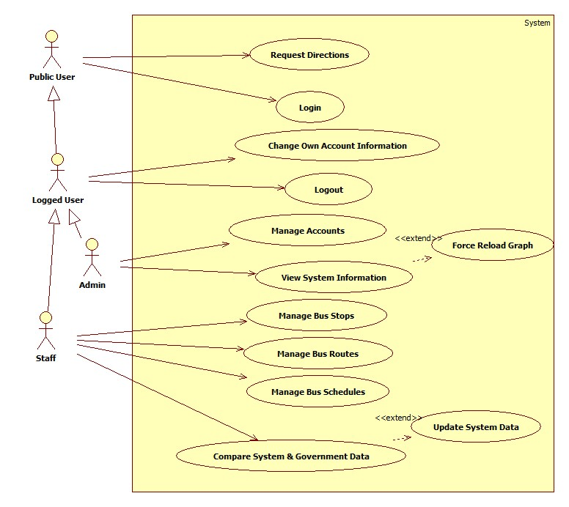

Figure 2: System Features Overview

### Public User

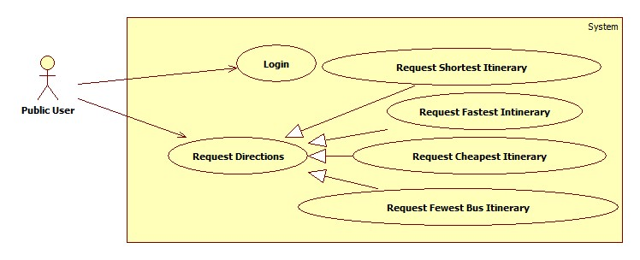

Figure 3: Public User Features

#### Login

|  |  |  |  |  |
| --- | --- | --- | --- | --- |
| USE CASE–PU001 | | | | |
| Use-case No. | PU001 | Use-case Version | | 0.1 |
| Use-case Name | Login | | | |
| Author | Doan Xuan Quang | | | |
| Date | 23/01/2013 | Priority | High | |
| **Actor:** Public User  **Summary:** This use case allows administrator, staff to log on into the system  **Goal:** Authenticate user.  **Triggers:** User access website area that is intended for staff and administrator.  **Pre-conditions:** User has an account and has not logged in yet  **Post-conditions.**  **Success:** User has logged in.  Redirects to Staff or Admin page  **Fail:** Redirects to Public page  **Main Success Scenario.**   |  |  |  | | --- | --- | --- | | Step | Actor Action | System Response | | 1 | User enter Staff or Admin area of the website | Display the form to login includes:   * Username: textbox. * Password: password field. * Login: button * Reset: button | | 2 | User fills username and password |  | | 3 | User click “Login” button [Alternative 1] [Exception 1] | Check for account validity and  Redirect to Synchronize Page for Staff or Account Management page for Admin if user’s credential is valid. [Alternative 2] |   **Alternative Scenario.**   |  |  |  | | --- | --- | --- | | No. | Actor Action | System Response | | 1 | User click “Reset” | Clear username and password textbox. | | 2 | User credential is not valid | Display error message “The username or password you entered is incorrect”. |   **Exceptions**.   |  |  |  | | --- | --- | --- | | No. | Actor Action | System Response | | 1 | User leaves username textbox empty. | Display error message “username cannot be empty”. |   Relationships: N/A  Business Rules: N/A | | | | |

Table 3: Use Case PU001 - Login

#### Request Directions

##### Cheapest Itinerary

|  |  |  |  |  |
| --- | --- | --- | --- | --- |
| USE CASE–PU002 | | | | |
| Use-case No. | PU002 | Use-case Version | | 0.1 |
| Use-case Name | Request Cheapest Itinerary | | | |
| Author | Nguyen Phan Quang Nhat | | | |
| Date | 23/01/2013 | Priority | High | |
| **Actor:** Public User  **Summary:** This use case allows user to find the best bus routes for destinations in term of price.  **Goal:** User’s able to get the itinerary of bus routes, from the start point to the end point.  **Triggers:** User enter public service page.  **Pre-conditions:** None  **Post-conditions:**  **Success:** Display the most suitable itineraries.  **Fail:** Display message “No suitable itineraries found”.  **Main Success Scenario.**   |  |  |  | | --- | --- | --- | | Step | Actor Action | System Response | | 1 | User enters public page | Show Public page includes:   * A map centered at user location [Exception 1]. * Departure Address: textbox. * Destination Address 1: textbox. * Destination Address 2: textbox. * Destination Address 3: textbox. * Max bus used: combo box ( value range: 1-5; default: 3) * Maximum walking transits: combo box (value: none, 100m, 200m, 300m, 400m, 500m; default: 300m) * Search Type: combo box (value: “Rẻ nhất”, “Ngắn nhất”, “Ít buýt nhất”, “Nhanh nhất”;default: “Ít buýt nhất”) | | 1 | User enters address of departure in departure text box [Alternative 1] | Show departure location on map [Exception 2, 3, 4] | | 2 | User enters address of destination in destination text box [Alternative 2] | Show destination location on map [Exception 2, 3, 4] | | 3 | User enters walking transits, max bus used. |  | | 4 | User select “Rẻ nhất” in search type. |  | | 5 | Click “Tìm” | Show the found bus route’s itinerary [Exception 5, 6, 7, 8] and draw the first itinerary on map. | | 6 | User select one of found itinerary | Draw corresponding itinerary on map. |   **Alternative Scenario.**   |  |  |  | | --- | --- | --- | | No. | Actor Action | System Response | | 1 | User point out departure location on map. | Show departure address in departure text box [Exception 3]. | | 2 | User point out destination location on map. | Show destination address in destination text box [Exception 3]. | | 3 | Select “Ngắn nhất” | Refer to Use Case PU003 | | 4 | Select “Ít buýt nhất” | Refer to Use Case PU004 | | 5 | Select “Nhanh nhất” | Refer to Use Case PU005 |   **Exceptions**.   |  |  |  |  | | --- | --- | --- | --- | | No. | Actor Action | System Response | | | 1 | Cannot get user location due to device capability or user privacy | The map is centered at Main City Bus Station. | | | 2 | Cannot find entered address | Display error Message “Cannot find entered address” | | | 3 | Departure or Destination is outside of HCM City | Display error Message “The system cannot provide directions outside of HCM city”. | | | 4 | More than one locations return from Google Map API | Display list of possible locations for user to select. | | 5 | User leaves Departure Address empty. | Display error message “Please select departure location”. | | 6 | User leaves Destination Address empty. | Display error message “Please select destination location”. | | | 7 | The System cannot found any result based on user criteria. | Display error Message “No suitable itinerary found”. | |   Relationships: Shortest itinerary, Fewest bus Itinerary, Fastest Itinerary  Business Rules: Google Map API | | | | |

Table 4: Use Case PU002 - Request Cheapest Itinerary

##### Shortest Itinerary

|  |  |  |  |  |
| --- | --- | --- | --- | --- |
| USE CASE–PU003 | | | | |
| Use-case No. | PU003 | Use-case Version | | 0.1 |
| Use-case Name | Request Shortest Itinerary | | | |
| Author | Nguyen Phan Quang Nhat | | | |
| Date | 23/01/2013 | Priority | High | |
| **Actor:** Public User  **Summary:** This use case allows user to find the best bus routes for destinations in term of distance.  **Goal:** User’s able to get the itinerary of bus routes, from the start point to the end point.  **Triggers:** User enter public service page.  **Pre-conditions:** None  **Post-conditions:**  **Success:** Display the most suitable itineraries.  **Fail:** Display message “No suitable itineraries found”.  **Main Success Scenario.**   |  |  |  | | --- | --- | --- | | Step | Actor Action | System Response | | 1 | User enters public page | Show Public page includes:   * A map centered at user location [Exception 1]. * Departure Address: textbox. * Destination Address 1: textbox. * Destination Address 2: textbox. * Destination Address 3: textbox. * Max bus used: combo box ( value range: 1-5; default: 3) * Maximum walking transits: combo box (value: none, 100m, 200m, 300m, 400m, 500m; default: 300m) * Search Type: combo box (value: “Rẻ nhất”, “Ngắn nhất”, “Ít buýt nhất”, “Nhanh nhất”; default: “Ít buýt nhất”) | | 1 | User enters address of departure in departure text box [Alternative 1] | Show departure location on map [Exception 2, 3, 4] | | 2 | User enters address of destination in destination text box [Alternative 2] | Show destination location on map [Exception 2, 3, 4] | | 3 | User enters walking transits, max bus used. |  | | 4 | User select “Ngắn nhất” in search type. |  | | 5 | Click “Tìm” | Show the found bus route’s itinerary [Exception 5, 6, 7, 8] and draw the first itinerary on map. | | 6 | User select one of found itinerary | Draw corresponding itinerary on map. |   **Alternative Scenario.**   |  |  |  | | --- | --- | --- | | No. | Actor Action | System Response | | 1 | User point out departure location on map. | Show departure address in departure text box [Exception 3]. | | 2 | User point out destination location on map. | Show destination address in destination text box [Exception 3]. | | 3 | Select “Rẻ nhất” | Refer to Use Case PU002 | | 4 | Select “Ít buýt nhất” | Refer to Use Case PU004 | | 5 | Select “Nhanh nhất” | Refer to Use Case PU005 |   **Exceptions**.   |  |  |  |  | | --- | --- | --- | --- | | No. | Actor Action | System Response | | | 1 | Cannot get user location due to device capability or user privacy | The map is centered at Main City Bus Station. | | | 2 | Cannot find entered address | Display error Message “Cannot find entered address” | | | 3 | Departure or Destination is outside of HCM City | Display error Message “The system cannot provide directions outside of HCM city”. | | | 4 | More than one locations return from Google Map API | Display list of possible locations for user to select. | | 5 | User leaves Departure Address empty. | Display error message “Please select departure location”. | | 6 | User leaves Destination Address empty. | Display error message “Please select destination location”. | | | 7 | The System cannot found any result based on user criteria. | Display error Message “No suitable itinerary found”. | |   Relationships: Cheapest itinerary, Fewest bus Itinerary, Fastest Itinerary  Business Rules: Google Map API | | | | |

Table 5: Use Case PU003 - Request Shortest Itinerary

##### Fewest-Bus Itinerary

|  |  |  |  |  |
| --- | --- | --- | --- | --- |
| USE CASE–PU004 | | | | |
| Use-case No. | PU004 | Use-case Version | | 0.1 |
| Use-case Name | Request Fewest-Bus Itinerary | | | |
| Author | Nguyen Phan Quang Nhat | | | |
| Date | 23/01/2013 | Priority | High | |
| **Actor:** Public User  **Summary:** This use case allows user to find the best bus routes for destinations using least number of buses.  **Goal:** User’s able to get the itinerary of bus routes, from the start point to the end point.  **Triggers:** User enter public service page.  **Pre-conditions:** None  **Post-conditions:**  **Success:** Display the most suitable itineraries.  **Fail:** Display message “No suitable itineraries found”.  **Main Success Scenario.**   |  |  |  | | --- | --- | --- | | Step | Actor Action | System Response | | 1 | User enters public page | Show Public page includes:   * A map centered at user location [Exception 1]. * Departure Address: textbox. * Destination Address 1: textbox. * Destination Address 2: textbox. * Destination Address 3: textbox. * Maximum walking transits: combo box (value: none, 100m, 200m, 300m, 400m, 500m; default: 300m) * Search Type: combo box (value: “Rẻ nhất”, “Ngắn nhất”, “Ít buýt nhất”, “Nhanh nhất”;default: “Ít buýt nhất”) | | 1 | User enters address of departure in departure text box [Alternative 1] | Show departure location on map [Exception 2, 3, 4] | | 2 | User enters address of destination in destination text box [Alternative 2] | Show destination location on map [Exception 2, 3, 4] | | 3 | User enters walking transits. |  | | 4 | User select “Ít buýt nhất” in search type. |  | | 5 | Click “Tìm” | Show the found bus route’s itinerary [Exception 5, 6, 7, 8] and draw the first itinerary on map. | | 6 | User select one of found itinerary | Draw corresponding itinerary on map. |   **Alternative Scenario.**   |  |  |  | | --- | --- | --- | | No. | Actor Action | System Response | | 1 | User point out departure location on map. | Show departure address in departure text box [Exception 3]. | | 2 | User point out destination location on map. | Show destination address in destination text box [Exception 3]. | | 3 | Select “Rẻ nhất” | Refer to Use Case PU002 | | 4 | Select “Ngắn nhất” | Refer to Use Case PU003 | | 5 | Select “Nhanh nhất” | Refer to Use Case PU005 |   **Exceptions**.   |  |  |  |  | | --- | --- | --- | --- | | No. | Actor Action | System Response | | | 1 | Cannot get user location due to device capability or user privacy | The map is centered at Main City Bus Station. | | | 2 | Cannot find entered address | Display error Message “Cannot find entered address” | | | 3 | Departure or Destination is outside of HCM City | Display error Message “The system cannot provide directions outside of HCM city”. | | | 4 | More than one locations return from Google Map API | Display list of possible locations for user to select. | | 5 | User leaves Departure Address empty. | Display error message “Please select departure location”. | | 6 | User leaves Destination Address empty. | Display error message “Please select destination location”. | | | 7 | The System cannot found any result based on user criteria. | Display error Message “No suitable itinerary found”. | |   Relationships: Shortest itinerary, Fewest bus Itinerary, Fastest Itinerary  Business Rules: Google Map API | | | | |

Table 6: Use Case PU004 - Request Fewest-Bus Itinerary

##### Fastest Itinerary

|  |  |  |  |  |
| --- | --- | --- | --- | --- |
| USE CASE–PU005 | | | | |
| Use-case No. | PU005 | Use-case Version | | 0.1 |
| Use-case Name | Request Fastest Itinerary | | | |
| Author | Nguyen Phan Quang Nhat | | | |
| Date | 23/01/2013 | Priority | High | |
| **Actor:** Public User  **Summary:** This use case allows user to find the best bus routes for destinations in term of arrival time.  **Goal:** User’s able to get the itinerary of bus routes, from the start point to the end point.  **Triggers:** User enter public service page.  **Pre-conditions:** None  **Post-conditions:**  **Success:** Display the most suitable itineraries.  **Fail:** Display message “No suitable itineraries found”.  **Main Success Scenario.**   |  |  |  | | --- | --- | --- | | Step | Actor Action | System Response | | 1 | User enters public page | Show Public page includes:   * A map centered at user location [Exception 1]. * Departure Address: textbox. * Destination Address: textbox. * Max Bus Used: combo box (value range: 1-5; default 3) * Departure Time: Time Picker (value range: 4:00 – 22:00; default: current time plus 5 minutes or 6:00 if current time is out of value range) * Maximum walking transits: combo box (value: none, 100m, 200m, 300m, 400m, 500m; default: 300m) * Search Type: combo box (value: “Rẻ nhất”, “Ngắn nhất”, “Ít buýt nhất”, “Nhanh nhất”;default: “t buýt nhất”) | | 1 | User enters address of departure in departure text box [Alternative 1] | Show departure location on map [Exception 2, 3, 4] | | 2 | User enters address of destination in destination text box [Alternative 2] | Show destination location on map [Exception 2, 3, 4] | | 3 | User enters walking transits, max bus used and departure time. |  | | 4 | User select “Nhanh nhất” in search type. |  | | 5 | Click “Tìm” | Show the found bus route’s itinerary [Exception 5, 6, 7, 8] and draw the first itinerary on map. | | 6 | User select one of found itinerary | Draw corresponding itinerary on map. |   **Alternative Scenario.**   |  |  |  | | --- | --- | --- | | No. | Actor Action | System Response | | 1 | User point out departure location on map. | Show departure address in departure text box [Exception 3]. | | 2 | User point out destination location on map. | Show destination address in destination text box [Exception 3]. | | 3 | Select “Rẻ nhất” | Refer to Use Case PU002 | | 4 | Select “Ngắn nhất” | Refer to Use Case PU003 | | 5 | Select “Ít buýt nhất” | Refer to Use Case PU004 |   **Exceptions**.   |  |  |  |  | | --- | --- | --- | --- | | No. | Actor Action | System Response | | | 1 | Cannot get user location due to device capability or user privacy | The map is centered at Main City Bus Station. | | | 2 | Cannot find entered address | Display error Message “Cannot find entered address” | | | 3 | Departure or Destination is outside of HCM City | Display error Message “The system cannot provide directions outside of HCM city”. | | | 4 | More than one locations return from Google Map API | Display list of possible locations for user to select. | | 5 | User leaves Departure Address empty. | Display error message “Please select departure location”. | | 6 | User leaves Destination Address empty. | Display error message “Please select destination location”. | | | 7 | The System cannot found any result based on user criteria. | Display error message “No suitable itinerary found”. | | | 8 | Departure Time is outside of value range. | Display error message: “Invalid departure time”. | |   Relationships: Shortest itinerary, Fewest bus Itinerary, Fastest Itinerary  Business Rules: Google Map API | | | | |

Table 7: Use Case PU005 - Request Fastest Itinerary

### Logged Users

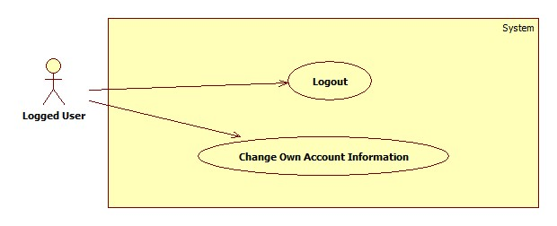

Figure 4: Logged Users Features

#### Logout

#### Change Own Account Information

|  |  |  |  |  |
| --- | --- | --- | --- | --- |
| USE CASE–LU002 | | | | |
| Use-case No. | LU002 | Use-case Version | | 0.1 |
| Use-case Name | Change Own Account Information | | | |
| Author | Nguyen Viet Vinh | | | |
| Date | 23/01/2013 | Priority | High | |
| **Actor:** Logged User  **Summary:** This use case allows user to edit his or her account information  **Goal:** Change information of his or her account.  **Triggers:** User clicks “Edit Information” on navigation bar.  **Pre-conditions:** User has logged in as an administrator or staff.  **Post-conditions:**  **Success:** The information of his or her account is updated.  **Fail:** The information of his or her account is not updated. Display error message.  **Main Success Scenario.**   |  |  |  | | --- | --- | --- | | Step | Actor Action | System Response | | 1 | User clicks “Edit Information” on navigation bar. | Display account information page includes:   * Username: label. * Password: password field (min length: 6, max length: 30) * Full name: textbox (min length: 3, max length: 50) * Email: textbox (regular expression: ^[\_a-z0-9-]+(\.[\_a-z0-9-]+)\*@[a-z0-9-]+(\.[a-z0-9-]+)\*(\.[a-z]{2,4})$) * Is Admin: label. * Is Staff: label. * Save: button * Reset: button | | 2 | User modifies account information |  | | 3 | Click “Save” [Alternative 2, 3] | Valid entered information and update account information. [Exception 1, 2, 3, 4, 5, 6, 7, 8] |   **Alternative Scenario.**   |  |  |  | | --- | --- | --- | | No. | Actor Action | System Response | | 1 | User clicks “Reset” | Refresh the all input controls with original values. | | 2 | User clicks “Reset Password” | Generate a new password for that account, update account password and send it to his or her email |   **Exceptions**.   |  |  |  | | --- | --- | --- | | Step | Actor Action | System Response | | 1 | Password length is less than 6 | Display error message “Your password is too short”. | | 2 | Password length is more than 30 | Display error message “Your password is too long”. | | 3 | Full name length is less than 3 | Display error message “Your full name is too short”. | | 4 | Full name length is more than 50 | Display error message “Your full name is too long”. | | 5 | Email address is not in correct format. | Display error message “Invalid email address. Please check your email address”. |   Relationships: N/A  Business Rules: N/A | | | | |

Table 8: Use Case LU002 - Change Own Account Information

### Admin

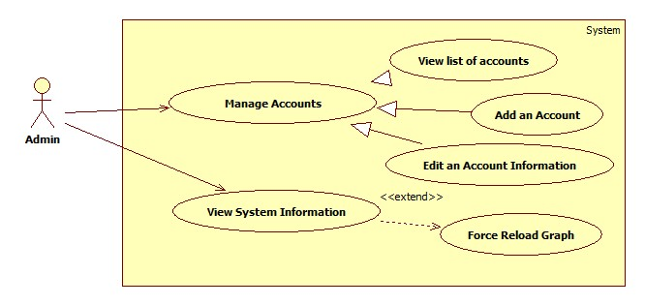

Figure 5: Admin Features

#### View List of Accounts

|  |  |  |  |  |
| --- | --- | --- | --- | --- |
| USE CASE–AD001 | | | | |
| Use-case No. | AD001 | Use-case Version | | 0.1 |
| Use-case Name | View List of Accounts | | | |
| Author | Doan Xuan Quang | | | |
| Date | 23/01/2013 | Priority | High | |
| **Actor:** Administrator  **Summary:** This use case allows administrator to view the list of accounts in system.  **Goal:** List of accounts in system is displayed.  **Triggers:** Administrator access Account Management Page.  **Pre-conditions:** User has logged in as an administrator.  **Post-conditions:**  **Success:** List of accounts in system is displayed.  **Fail:** Redirect to General Error Page.  **Main Success Scenario.**   |  |  |  | | --- | --- | --- | | Step | Actor Action | System Response | | 1 | Enter the Account Management page | Display the list of accounts in system and their information includes:   * Add new account: button * A table with these column   + Username: label   + Full name: label   + Email: label   + Is Admin: disabled checkbox.   + Is Staff: disabled checkbox   + Enable: label   + Edit: button |   **Alternative Scenario.**  N/A  **Exceptions**.  N/A  Relationships: N/A  Business Rules: N/A | | | | |

Table 9: Use Case AD001 - View List of Accounts

#### Add an Account

|  |  |  |  |  |
| --- | --- | --- | --- | --- |
| USE CASE-AD002 | | | | |
| Use-case No. | AD002 | Use-case Version | | 0.1 |
| Use-case Name | Add an Account | | | |
| Author | Doan Xuan Quang | | | |
| Date | 23/01/2013 | Priority | High | |
| **Actor:** Administrator  **Summary:** This use case allows administrator to add a new account in system.  **Goal:** Create a new account.  **Triggers:** Administrator click “Add New Account” in Account Management Page.  **Pre-conditions:** User has logged in as an administrator.  **Post-conditions:**  **Success:** A new account has been created in system.  **Fail:** None of account is added to the system. Display error message.  **Main Success Scenario.**   |  |  |  | | --- | --- | --- | | Step | Actor Action | System Response | | 1 | Admin clicks “Add New Account” in Account Management Page. | Display account information page includes:   * Username: textbox (min length: 4, max length: 30) * Full name: textbox (min length: 3, max length: 50) * Email: textbox (regular expression: ^[\_a-z0-9-]+(\.[\_a-z0-9-]+)\*@[a-z0-9-]+(\.[a-z0-9-]+)\*(\.[a-z]{2,4})$) * Is Admin: checkbox. * Is Staff: checkbox. * Enable: checkbox. * Add: button * Reset: button | | 2 | Admin enters account information |  | | 3 | Admin clicks “Add” [Alternative 1] | Valid entered information and create a new account with entered information [Exception 1, 2, 3, 4, 5, 6, 7, 8]. |   **Alternative Scenario.**   |  |  |  | | --- | --- | --- | | No. | Actor Action | System Response | | 1 | Admin clicks “Reset” | Clear all input controls on form. |   **Exceptions**.   |  |  |  | | --- | --- | --- | | No. | Actor Action | System Response | | 1 | Username contains whitespaces | Display error message “Username cannot contain white space”. | | 2 | Username’s length less than 4 | Display error message “Your username is too short.” | | 3 | Username’s length is more than 30 | Display error message “Your username is too long”. | | 4 | Full name’s length is less than 3 | Display error message “Your full name is too short”. | | 5 | Full name’s length is more than 50 | Display error message “Your full name is too long”. | | 6 | Email is not in right format. | Display error message “Email is not in right format ” | | 7 | Username is already in the system. | Display error message “Username is already in the system, please choose another one”. |   Relationships: N/A  Business Rules: N/A. | | | | |

Table 10: Use Case AD002 - Add an Account

#### Edit an Account Information

|  |  |  |  |  |
| --- | --- | --- | --- | --- |
| USE CASE–AD003 | | | | |
| Use-case No. | AD003 | Use-case Version | | 0.1 |
| Use-case Name | Edit an Account Information | | | |
| Author | Doan Xuan Quang | | | |
| Date | 23/01/2013 | Priority | High | |
| **Actor:** Administrator  **Summary:** This use case allows administrator to edit an account information  **Goal:** Change information of an existing account.  **Triggers:** Administrator click “Edit” associated with an account in Account Management Page.  **Pre-conditions:** User has logged in as an administrator.  **Post-conditions:**  **Success:** The information of edited account is updated.  **Fail:** The information of edited account is not updated. Display error message.  **Main Success Scenario.**   |  |  |  | | --- | --- | --- | | Step | Actor Action | System Response | | 1 | Click “Edit” associated with an account in Account Management page. | Display account information page includes:   * Username: disabled textbox * Full name: textbox (min length: 3, max length: 50) * Email: textbox (regular expression: ^[\_a-z0-9-]+(\.[\_a-z0-9-]+)\*@[a-z0-9-]+(\.[a-z0-9-]+)\*(\.[a-z]{2,4})$) * Is Admin: checkbox. * Is Staff: checkbox. * Enable: checkbox. * Reset Password: button * Save: button * Cancel: button | | 2 | Admin modify account information |  | | 3 | Click “Save” [Alternative 1, 2] | Valid entered information and update account information [Exception 1, 2, 3, 4, 5, 6, 7]. |   **Alternative Scenario.**   |  |  |  | | --- | --- | --- | | No. | Actor Action | System Response | | 1 | Admin clicks “Cancel” | Redirect to Account Management Page. | | 2 | Admin clicks “Reset Password” | Generate a new password for that account, update account password and send it to his or her email |   **Exceptions**.   |  |  |  | | --- | --- | --- | | Step | Actor Action | System Response | | 1 | Full name’s length is less than 3 | Display error message “Your full name is too short”. | | 2 | Full name’s length is more than 50 | Display error message “Your full name is too long”. | | 2 | Email is not in right format. | Display error message “Email is not in right format ” | | 5 | Admin set himself/herself not an admin | Display error message “You cannot set yourself as non-admin”. |   Relationships: N/A  Business Rules: N/A. | | | | |

Table 11: Use Case AD003 - Edit an account Information

### Staff

#### Compare Local and Government Data

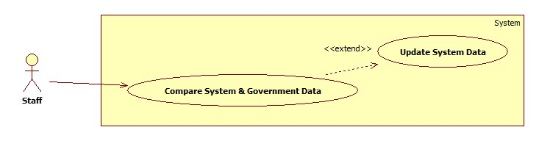

Figure 6: Synchronize Data

##### Compare Local & Government Data

|  |  |  |  |  |
| --- | --- | --- | --- | --- |
| USE CASE–ST001 | | | | |
| Use-case No. | ST001 | Use-case Version | | 0.1 |
| Use-case Name | Compare System & Government Data | | | |
| Author | Nguyen Phan Quang Nhat | | | |
| Date | 23/01/2013 | Priority | High | |
| **Actor:** Staff  **Summary:** This use case allows staff to view the differences between system and government bus routes data.  **Goal:** Show differences between system and government bus routes data.  **Triggers:** Staff access “Synchronizer” page.  **Pre-conditions:** User has logged in as a staff.  **Post-conditions.**  **Success:** List of differences is displayed.  **Fail:** List of differences is not displayed or displayed in wrong way.  **Main Success Scenario.**   |  |  |  | | --- | --- | --- | | Step | Actor Action | System Response | | 1 | Staff access Synchronizer page. | Display list of bus routes that system and government data differ includes [Exception 1]:   * A table with these columns:   + No: label   + Code: label + image   + Name: label   + Change: label   + Sync: checkbox * Synchronize: button * A map. | | 2 | Click on a difference (a row in the table of changes) | Draw 2 bus routes on map:   * One from system data. * One from government data. |   **Alternative Scenario.**  N/A  **Exceptions**.   |  |  |  | | --- | --- | --- | | Step | Actor Action | System Response | | 1 | Cannot access government data. | Display error message “Government data is not available at this time”. | | 2 | Government Data Structure changed | Display error message “Government Data Structure has been changed. Please contract administrator”. |   Relationships: N/A.  Business Rules: Google Map API | | | | |

Table 12: Use Case ST001 - Compare Local & Government Data

##### Update System Data

|  |  |  |  |  |
| --- | --- | --- | --- | --- |
| USE CASE–ST002 | | | | |
| Use-case No. | ST002 | Use-case Version | | 0.1 |
| Use-case Name | Update System Data. | | | |
| Author | Nguyen Phan Quang Nhat | | | |
| Date | 23/01/2013 | Priority | High | |
| **Actor:** Staff  **Summary:** This use case allows staff to update system data from government data.  **Goal:** System data is updated from government data.  **Triggers:** Staff click “Synchronize” button displayed in “Synchronizer” page.  **Pre-conditions:** User has logged in as a staff.  **Post-conditions:**  **Success:** System routes data is updated.  **Fail:** System routes data is not updated. Display error message.  **Main Success Scenario.**   |  |  |  | | --- | --- | --- | | Step | Actor Action | System Response | | 1 | Staff access Synchronizer page. | Display list of bus routes that system and government data differ includes [Exception 1]:   * A table with these columns:   + No: label   + Code: label + image   + Name: label   + Change: label   + Sync: checkbox * Synchronize: button * A map. | | 2 | User checks on which bus routes to update. |  | | 3 | User click “Synchronize” button | Update system bus routes data of selected routes. [Exception 3]  Show dialog contain result of synchronization process. | | 4 | User click OK | Close dialog. |   **Alternative Scenario.**  N/A  **Exceptions**.   |  |  |  | | --- | --- | --- | | Step | Actor Action | System Response | | 1 | Cannot access government data. | Display error message “Government data is not available at this time”. | | 2 | Government Data Structure changed | Display error message “Government Data Structure has been changed. Please contract administrator”. | | 3 | User click “Cancel” while synchronization is in process. | Stop synchronization process. |   Relationships: N/A  Business Rules: Google Map API | | | | |

Table 13: Use Case ST002 - Update System Data

#### Manage Bus Stops

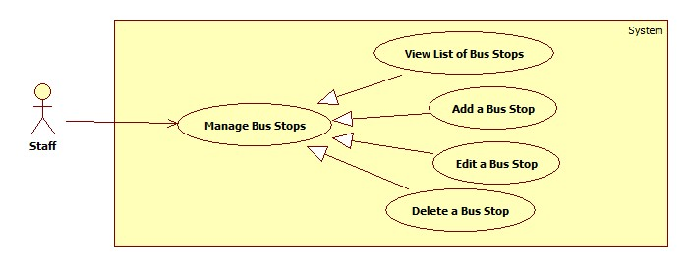

Figure 7: Manage Bus Stops

##### View list of Bus Stops

|  |  |  |  |  |
| --- | --- | --- | --- | --- |
| USE CASE–ST003 | | | | |
| Use-case No. | ST003 | Use-case Version | | 0.1 |
| Use-case Name | View List of Bus Stops | | | |
| Author | Nguyen Viet Vinh | | | |
| Date | 23/01/2013 | Priority | High | |
| **Actor:** Staff  **Summary:** This use case allows staff to view the list of bus stops.  **Goal:** List of bus stops in system is displayed.  **Triggers:** Staff access Bus Stops Management Page.  **Pre-conditions:** User has logged in as a staff.  **Post-conditions:**  **Success:** List of bus stops in system is displayed.  **Fail:** Redirect to General Error Page.  **Main Success Scenario.**   |  |  |  | | --- | --- | --- | | Step | Actor Action | System Response | | 1 | Enter the Bus Stops Management page | Display the list of bus stops in system and their information includes:   * Add new bus stop: button * A table with these column   + No: label   + Code: label   + Name: label   + Street: label   + Ward: label   + Edit: button   + Delete: button * A Map to display bus stops location |   **Alternative Scenario.**  N/A  **Exceptions**.  N/A  Relationships: N/A  Business Rules: N/A | | | | |

Table 14: Use Case ST003 - View list of Bus Stops

##### Add a new Bus Stop

|  |  |  |  |  |
| --- | --- | --- | --- | --- |
| USE CASE-ST004 | | | | |
| Use-case No. | ST004 | Use-case Version | | 0.1 |
| Use-case Name | Add a new Bus Stop | | | |
| Author | Nguyen Viet Vinh | | | |
| Date | 23/01/2013 | Priority | High | |
| **Actor:** Staff  **Summary:** This use case allows staff to add a new bus stop into system.  **Goal:** Create a new bus stop.  **Triggers:** Staff clicks “Add New Bus Stop” in Account Management Page.  **Pre-conditions:** User has logged in as a staff.  **Post-conditions:**  **Success:** A new bus stop has been created in system.  **Fail:** None of bus stop is added to the system. Display error message.  **Main Success Scenario.**   |  |  |  | | --- | --- | --- | | Step | Actor Action | System Response | | 1 | Staff clicks “Add New Bus Stop” in Bus Stop Management Page. | Display bus stop information page includes:   * Address: textbox (min length: 5, max length 255). * Latitude: number (min: -180.0, max 180.0) * Longitude: number (min: -180.0, max: 180.0) * Add: button * Cancel: button * A map to show bus stop location | | 2 | Staff enters bus stop address [Alternative 1, 2] | * Display bus stop on map. * Show latitude, longitude of new bus stop. | | 3 | Staff clicks “Add” [Alternative 3] | Valid entered information and create a new bus stop with entered information and generated bus stop code [Exception 1, 2, 3, 4, 5]. |   **Alternative Scenario.**   |  |  |  | | --- | --- | --- | | No. | Actor Action | System Response | | 1 | Staff enter Latitude, Longitude | Display bus stop address in Address textbox and show location on map. | | 2 | Staff show bus stop location on map | Display bus stop address in Address textbox, latitude and longitude in Latitude and Longitude inputs. | | 3 | Staff clicks “Cancel” | Redirect to Bus Stop Management page. |   **Exceptions**.   |  |  |  | | --- | --- | --- | | No. | Actor Action | System Response | | 1 | Address’ length is less than 5 | Display error message “Address is too short”. | | 2 | Address’ length is more than 255 | Display error message “Address is too long”. | | 3 | Latitude is less than -180.0 or greater than 180.0 | Display error message “Invalid latitude. It should be in range [-180.0, 180.0]” | | 4 | Longitude is less than -180.0 or greater than 180.0 | Display error message “Invalid longitude. It should be in range [-180.0, 180.0]” |   Relationships: N/A  Business Rules: Google Map API, Latitude, Longitude domain value is [-180, 180] | | | | |

Table 15: Use Case ST004 - Add a new Bus Stop

##### Edit a Bus Stop

|  |  |  |  |  |
| --- | --- | --- | --- | --- |
| USE CASE–ST005 | | | | |
| Use-case No. | ST005 | Use-case Version | | 0.1 |
| Use-case Name | Edit a Bus Stop | | | |
| Author | Nguyen Viet Vinh | | | |
| Date | 23/01/2013 | Priority | High | |
| **Actor:** Staff  **Summary:** This use case allows staff to update information of a bus stop.  **Goal:** Change information of an existing bus stop.  **Triggers:** Staff clicks “Edit” associated with a bus stop in Bus Stop Management Page.  **Pre-conditions:** User has logged in as a staff.  **Post-conditions:**  **Success:** The information of edited bus stop is updated.  **Fail:** The information of edited bus stop is not updated. Display error message.  **Main Success Scenario.**   |  |  |  | | --- | --- | --- | | Step | Actor Action | System Response | | 1 | Click “Edit” associated with a bus stop in Bus Stop Management page. | Display bus stop information page includes:   * Code: disabled textbox * Address: textbox (min length 5, max length 255) * Latitude: number (min: -180.0, max 180.0) * Longitude: number (min: -180.0, max: 180.0) * Save: button * Cancel: button * A map to show bus stop location | | 2 | Staff modify account information |  | | 3 | Click “Cancel” [Alternative 1] | Valid entered information and update bus stop information [Exception 1, 2, 3, 4, 5]. |   **Alternative Scenario.**   |  |  |  | | --- | --- | --- | | No. | Actor Action | System Response | | 1 | Staff clicks “Cancel” | Redirect to Bus Stop Management page. |   **Exceptions**.   |  |  |  | | --- | --- | --- | | No. | Actor Action | System Response | | 1 | Address’ length is less than 5 | Display error message “Address is too short”. | | 2 | Address’ length is more than 255 | Display error message “Address is too long”. | | 3 | Latitude is less than -180.0 or greater than 180.0 | Display error message “Invalid latitude. It should be in range [-180.0, 180.0]” | | 4 | Longitude is less than -180.0 or greater than 180.0 | Display error message “Invalid longitude. It should be in range [-180.0, 180.0]” |   Relationships: N/A  Business Rules: Google Map API, Latitude, Longitude domain value is [-180, 180] | | | | |

Table 16: Use Case ST005 - Edit a Bus Stop

##### Delete a Bus Stop

|  |  |  |  |  |
| --- | --- | --- | --- | --- |
| USE CASE–ST006 | | | | |
| Use-case No. | ST006 | Use-case Version | | 0.1 |
| Use-case Name | Delete a Bus Stop | | | |
| Author | Nguyen Viet Vinh | | | |
| Date | 23/01/2013 | Priority | High | |
| **Actor:** Staff  **Summary:** This use case allows staff to delete a bus stop.  **Goal:** Remove a bus stop out of the system.  **Triggers:** Staff clicks “Delete” associated with a bus stop in Bus Stop Management Page.  **Pre-conditions:** User has logged in as a staff.  **Post-conditions:**  **Success:** The information of selected bus stop is deleted.  **Fail:** None of bus stop is deleted. Display error message.  **Main Success Scenario.**   |  |  |  | | --- | --- | --- | | Step | Actor Action | System Response | | 1 | Click “Delete” associated with a bus stop in Bus Stop Management page. | Display a confirm message. | | 2 | Click “Yes” [Alternative 1] | Remove the selected bus stop out of the system [Exception 1]. |   **Alternative Scenario.**   |  |  |  | | --- | --- | --- | | No. | Actor Action | System Response | | 1 | Staff clicks “Cancel” | Redirect to Bus Stop Management page. |   **Exceptions**.   |  |  |  | | --- | --- | --- | | No. | Actor Action | System Response | | 1 | The selected bus stop belongs to one or more bus routes. | Display error message “Cannot delete the selected bus stop because it is in use”. |   Relationships: N/A  Business Rules: The deleted bus stop must not be in any bus route. | | | | |

Table 17: Use Case ST006 - Delete a Bus Stop

#### Manage Bus Routes

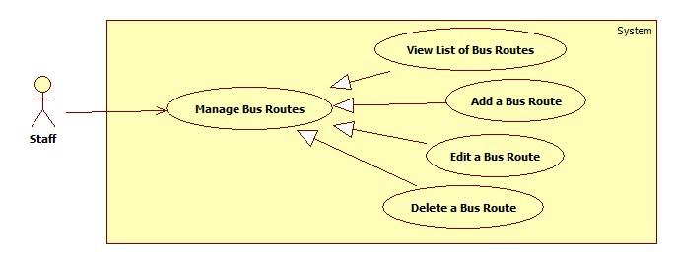

Figure 8: Manage Bus Routes

##### View list of Bus Routes

|  |  |  |  |  |
| --- | --- | --- | --- | --- |
| USE CASE–ST007 | | | | |
| Use-case No. | ST007 | Use-case Version | | 0.1 |
| Use-case Name | View List of Bus Routes | | | |
| Author | Nguyen Viet Vinh | | | |
| Date | 23/01/2013 | Priority | High | |
| **Actor:** Staff  **Summary:** This use case allows staff to view the list of bus routes.  **Goal:** List of bus routes in system is displayed.  **Triggers:** Staff access Bus Routes Management Page.  **Pre-conditions:** User has logged in as a staff.  **Post-conditions:**  **Success:** List of bus routes in system is displayed.  **Fail:** Redirect to General Error Page.  **Main Success Scenario.**   |  |  |  | | --- | --- | --- | | Step | Actor Action | System Response | | 1 | Enter the Bus Routes Management page | Display the list of bus routes in system and their information includes:   * Add new bus route: button * A table with these column   + No: label   + Code: label   + Name: label   + Outward: label   + Edit: button   + Delete: button * A Map to display bus route. |   **Alternative Scenario.**  N/A  **Exceptions**.  N/A  Relationships: N/A  Business Rules: Google Map API | | | | |

Table 18: Use Case ST007 - View list of Bus Routes

##### Add a new Bus Route

|  |  |  |  |  |
| --- | --- | --- | --- | --- |
| USE CASE-ST008 | | | | |
| Use-case No. | ST008 | Use-case Version | | 0.1 |
| Use-case Name | Nguyen Viet Vinh | | | |
| Author | Nguyen Phan Quang Nhat, Nguyen Viet Vinh | | | |
| Date | 23/01/2013 | Priority | High | |
| **Actor:** Staff  **Summary:** This use case allows staff to add a new bus route into system.  **Goal:** Create a new bus route.  **Triggers:** Staff clicks “Add New Bus Route” in Account Management Page.  **Pre-conditions:** User has logged in as a staff.  **Post-conditions:**  **Success:** A new bus route has been created in system.  **Fail:** None of bus route is added to the system. Display error message.  **Main Success Scenario.**   |  |  |  | | --- | --- | --- | | Step | Actor Action | System Response | | 1 | Staff clicks “Add New Bus Route” in Bus Route Management Page. | Display bus route information page includes:   * Code: textbox (min length: 1, max length: 10) * Name: textbox (min length: 1, max length: 100) * Outward: checkbox * Price: Number * List of box stops: table. * Available bus stop: combo box * Add bus stop: button * Move up: button * Move down: button * Remove bus stop: button * Add: button * Cancel: button * A map to show bus route | | 2 | Staff enters bus route information |  | | 3 | Staff edit list of stop of the route | * Update route on map. | | 3 | Staff clicks “Add” [Alternative 1] | Valid entered information and create a new bus route with entered information [Exception 1, 2, 3, 4, 5, 6]. |   **Alternative Scenario.**   |  |  |  | | --- | --- | --- | | No. | Actor Action | System Response | | 1 | Staff clicks “Cancel” | Redirect to Bus Route Management page. |   **Exceptions**.   |  |  |  | | --- | --- | --- | | No. | Actor Action | System Response | | 1 | Staff leaves code empty. | Display error message “Code cannot be empty”. | | 2 | Code’s length is more than 10 | Display error message “Code is too long”. | | 3 | Name’s length is less than 1 | Display error message “Name is too short” | | 4 | Name’s length is more than 100 | Display error message “Name is too long”. | | 5 | There is another bus route with the same value of code and outward. | Display error message “Duplicate bus route”. | | 6 | Entered is less than 1000. | Display error message “Invalid price” |   Relationships: N/A  Business Rules: Google Map API. A Bus Route is identified by its code and outward value. | | | | |

Table 19: Use Case ST008 - Add a new Bus Route

##### Edit a Bus Route

|  |  |  |  |  |
| --- | --- | --- | --- | --- |
| USE CASE-ST009 | | | | |
| Use-case No. | ST009 | Use-case Version | | 0.1 |
| Use-case Name | Edit a Bus Route | | | |
| Author | Nguyen Viet Vinh | | | |
| Date | 23/01/2013 | Priority | High | |
| **Actor:** Staff  **Summary:** This use case allows staff to edit a bus route in system.  **Goal:** Update information of a bus route.  **Triggers:** Click “Edit” associated with a bus stop in Bus Route Management page.  **Pre-conditions:** User has logged in as a staff.  **Post-conditions:**  **Success:** The information of edited bus route is updated.  **Fail:** The information of edited bus route is not updated. Display error message.  **Main Success Scenario.**   |  |  |  | | --- | --- | --- | | Step | Actor Action | System Response | | 1 | Click “Edit” associated with a bus stop in Bus Route Management page. | Display bus route information page includes:   * Code: disabled textbox * Name: textbox (min length: 1, max length: 100) * Outward: checkbox * Price: Number (min value: 0) * List of stops: table. * Available bus stop: combo box * Add bus stop: button * Move up: button * Move down: button * Remove bus stop: button * Save: button * Cancel: button * A map to show bus route | | 2 | Staff modify bus route information |  | | 3 | Staff edit list of stop of the route | * Update route on map. | | 3 | Staff clicks “Save” [Alternative 1] | Valid entered information and update information of the bus [Exception 1, 2, 3, 4]. |   **Alternative Scenario.**   |  |  |  | | --- | --- | --- | | No. | Actor Action | System Response | | 1 | Staff clicks “Cancel” | Redirect to Bus Route Management page. |   **Exceptions**.   |  |  |  | | --- | --- | --- | | No. | Actor Action | System Response | | 1 | Name’s length is less than 1 | Display error message “Name is too short” | | 2 | Name’s length is more than 100 | Display error message “Name is too long”. | | 3 | There is another bus route with the same value of code and outward. | Display error message “Duplicate bus route”. | | 4 | Entered price is less than 1000 | Display error message “Invalid price”. |   Relationships: N/A  Business Rules: Google Map API. A Bus Route is identified by its code and outward value. | | | | |

Table 20: Use Case ST009 - Edit a Bus Route

##### Delete a Bus Route

|  |  |  |  |  |
| --- | --- | --- | --- | --- |
| USE CASE–ST010 | | | | |
| Use-case No. | ST010 | Use-case Version | | 0.1 |
| Use-case Name | Delete a Bus Route | | | |
| Author | Nguyen Viet Vinh | | | |
| Date | 23/01/2013 | Priority | High | |
| **Actor:** Staff  **Summary:** This use case allows staff to delete a bus route.  **Goal:** Remove a bus route out of the system.  **Triggers:** Staff clicks “Delete” associated with a bus route in Bus Route Management Page.  **Pre-conditions:** User has logged in as a staff.  **Post-conditions:**  **Success:** The information of selected bus route is deleted.  **Fail:** None of bus route is deleted. Display error message.  **Main Success Scenario.**   |  |  |  | | --- | --- | --- | | Step | Actor Action | System Response | | 1 | Click “Delete” associated with a bus route in Bus Route Management page. | Display a confirm message. | | 2 | Click “Yes” [Alternative 1] | Remove the selected bus route out of the system and its associated schedule. |   **Alternative Scenario.**   |  |  |  | | --- | --- | --- | | No. | Actor Action | System Response | | 1 | Staff clicks “Cancel” | Redirect to Bus Route Management page. |   **Exceptions**.  N/A  Relationships: N/A  Business Rules: N/A | | | | |

Table 21: Use Case ST010 - Delete a Bus Route

#### Manage Bus Schedules

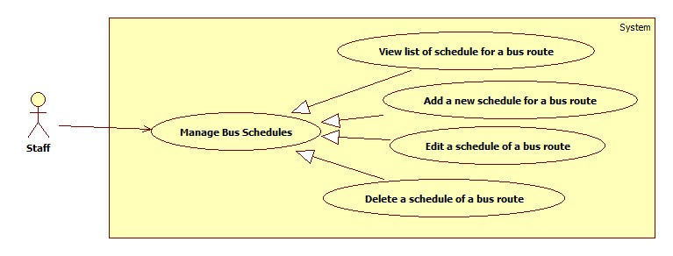

Figure 9: Manage Bus Schedules

##### View list of Schedule for a Bus Route

|  |  |  |  |  |
| --- | --- | --- | --- | --- |
| USE CASE–ST011 | | | | |
| Use-case No. | ST011 | Use-case Version | | 0.1 |
| Use-case Name | View List of Schedules for a bus route | | | |
| Author | Doan Xuan Quang | | | |
| Date | 23/01/2013 | Priority | High | |
| **Actor:** Staff  **Summary:** This use case allows staff to view the list of schedules for a bus route.  **Goal:** List of schedules for a bus route in system is displayed.  **Triggers:** Staff access Schedule Management Page.  **Pre-conditions:** User has logged in as a staff.  **Post-conditions:**  **Success:** List of schedule for a bus route in system is displayed.  **Fail:** Redirect to General Error Page.  **Main Success Scenario.**   |  |  |  | | --- | --- | --- | | Step | Actor Action | System Response | | 1 | Enter the Schedule Management page | * Display the list of bus route with these information:   + Code   + Name   + Outward | | 2 | Staff choose a bus route from the list | * Display the list of week days. * A Date picker (default: current date) | | 3 | Staff chooses a week day or select specific date from Data picker. | * Display the list of departure time of selected bus route in selected date. |   **Alternative Scenario.**  N/A  **Exceptions**.  N/A  Relationships: N/A  Business Rules: N/A | | | | |

Table 22: Use Case ST011 - View list of Schedule for a Bus Route

##### Add a new Schedule for a Bus Route

|  |  |  |  |  |
| --- | --- | --- | --- | --- |
| USE CASE–ST012 | | | | |
| Use-case No. | ST012 | Use-case Version | | 0.1 |
| Use-case Name | Add a new schedule for a bus route | | | |
| Author | Doan Xuan Quang | | | |
| Date | 23/01/2013 | Priority | High | |
| **Actor:** Staff  **Summary:** This use case allows staff to add a new schedule for a bus route.  **Goal:** Add a new schedule for a bus route.  **Triggers:** Staff access Schedule Management Page and click “Add” in the schedule list.  **Pre-conditions:** User has logged in as a staff.  **Post-conditions:**  **Success:** A new schedule is added for a bus route.  **Fail:** None of schedule is added. Display error message.  **Main Success Scenario.**   |  |  |  | | --- | --- | --- | | Step | Actor Action | System Response | | 1 | Enter the Schedule Management page | * Display the list of bus route with these information:   + Code   + Name   + Outward | | 2 | Staff choose a bus route from the list | * Display the list of week days. * A Date picker (default: current date). | | 3 | Staff chooses a week day or select specific date from Data picker. | * Display the list of departure time of selected bus route in selected date. | | 4 | Click “Add Schedule” button | * Display a dialog:   + Departure time: time picker (min: 4:00, max 22:00).   + Add: button   + Cancel: button | | 5 | Staff selects departure time and clicks “Add” [Alternative 1] | * Valid information and add a new schedule for the selected bus route in selected date [Exception 1, 2]. |   **Alternative Scenario.**   |  |  |  | | --- | --- | --- | | No. | Actor Action | System Response | | 1 | Staff clicks “Cancel” | Dialog disappears without any affect. |   **Exceptions**.   |  |  |  | | --- | --- | --- | | No. | Actor Action | System Response | | 1 | There is an existing schedule with the same time in the same date for the same bus route. | Display error message “The departure time already exists”. | | 2 | Departure time is less than 4:00 or greater than 22:00 | Display error message “Invalid departure time”. |   Relationships: N/A  Business Rules: Departure must be from 4:00 to 22:00 | | | | |

Table 23: Use Case ST012 - Add a new Schedule for a Bus Route

##### Edit a Schedule of a Bus Route

|  |  |  |  |  |
| --- | --- | --- | --- | --- |
| USE CASE–ST013 | | | | |
| Use-case No. | ST013 | Use-case Version | | 0.1 |
| Use-case Name | Edit a schedule for a bus route | | | |
| Author | Doan Xuan Quang | | | |
| Date | 23/01/2013 | Priority | High | |
| **Actor:** Staff  **Summary:** This use case allows staff to edit a schedule of a bus route.  **Goal:** Update a schedule of a bus route.  **Triggers:** Staff access Schedule Management Page and double click on a schedule in the list.  **Pre-conditions:** User has logged in as a staff.  **Post-conditions:**  **Success:** The edited schedule is update for the bus route.  **Fail:** None of schedule is updated. Display error message.  **Main Success Scenario.**   |  |  |  | | --- | --- | --- | | Step | Actor Action | System Response | | 1 | Enter the Schedule Management page | * Display the list of bus route with these information:   + Code   + Name   + Outward | | 2 | Staff choose a bus route from the list | * Display the list of week days. * A Date picker (default: current date). | | 3 | Staff chooses a week day or select specific date from Data picker. | * Display the list of departure time of selected bus route in selected date. | | 4 | Double click on a schedule in the list | * Display a dialog:   + Departure time: time picker (min: 4:00, max: 22:00).   + Save: button   + Cancel: button | | 5 | Staff selects departure time and clicks “Save” [Alternative 1] | * Valid information and update the schedule for the selected bus route in selected date [Exception 1]. |   **Alternative Scenario.**   |  |  |  | | --- | --- | --- | | No. | Actor Action | System Response | | 1 | Staff clicks “Cancel” | Dialog disappears without any affect. |   **Exceptions**.   |  |  |  | | --- | --- | --- | | No. | Actor Action | System Response | | 1 | There is an existing schedule with the same time in the same date for the same bus route. | Display error message “The departure time already exists”. | | 2 | Departure time is less than 4:00 or greater than 22:00 | Display error message “Invalid departure time”. |   Relationships: N/A  Business Rules: Departure must be between 4:00 and 22:00 | | | | |

Table 24: Use Case ST013 - Edit a Schedule for a Bus Route

##### Delete a Schedule of a Bus Route

|  |  |  |  |  |
| --- | --- | --- | --- | --- |
| USE CASE–ST014 | | | | |
| Use-case No. | ST014 | Use-case Version | | 0.1 |
| Use-case Name | Delete a schedule of a bus route | | | |
| Author | Doan Xuan Quang | | | |
| Date | 23/01/2013 | Priority | High | |
| **Actor:** Staff  **Summary:** This use case allows staff to delete a schedule of a bus route.  **Goal:** Delete a schedule of a bus route.  **Triggers:** Staff access Schedule Management Page and click “x” button associated with a schedule in the list.  **Pre-conditions:** User has logged in as a staff.  **Post-conditions:**  **Success:** The selected schedule is removed.  **Fail:** None of schedule is removed. Display error message.  **Main Success Scenario.**   |  |  |  | | --- | --- | --- | | Step | Actor Action | System Response | | 1 | Enter the Schedule Management page | * Display the list of bus route with these information:   + Code   + Name   + Outward | | 2 | Staff choose a bus route from the list | * Display the list of week days. * A Date picker (min, max, default). | | 3 | Staff chooses a week day or select specific date from Data picker. | * Display the list of departure time of selected bus route in selected date. | | 4 | Click on “x” button associated with a schedule in the list | * Display a confirm dialog | | 5 | Staff clicks “Yes” [Alternative 1] | * Remove the selected schedule out of system. |   **Alternative Scenario.**   |  |  |  | | --- | --- | --- | | No. | Actor Action | System Response | | 1 | Staff clicks “Cancel” | Dialog disappears without any affect. |   **Exceptions**.  N/A  Relationships: N/A  Business Rules: N/A | | | | |

Table 25: Use Case ST014 - Delete a Schedule of a Bus Route

### Software System Attributes

#### Usability

##### Graphic User Interface

* + All the text, label and image in public user page should be in Vietnamese.
  + All the text, label and image in Admin page, Staff page should be in English.

##### Usability for public user

* + Can use some public function without login.
  + Can use their android devices to access service easily.

##### Usability for admin and staff

* + Admin and staff must understand and use English.
  + Website admin and staff should need no more than one week of training to be productive with the system.

##### Installation

* + The system must be easy to deploy. Customer can deploy successfully and learn to configure, maintain the system within one day of training.
  + The attached manual guide must be clear. User can read and do itself without developers’ help.

#### Reliability

N/A

#### Availability

N/A

#### Security

* + Privacy: Each role of user has a specific permission to interact with system. System always checks authorization and authenticated before do anything. Only admin can grant permission to users.

#### Maintainability

#### Portability

#### Performance

## Main Flows

### Public User

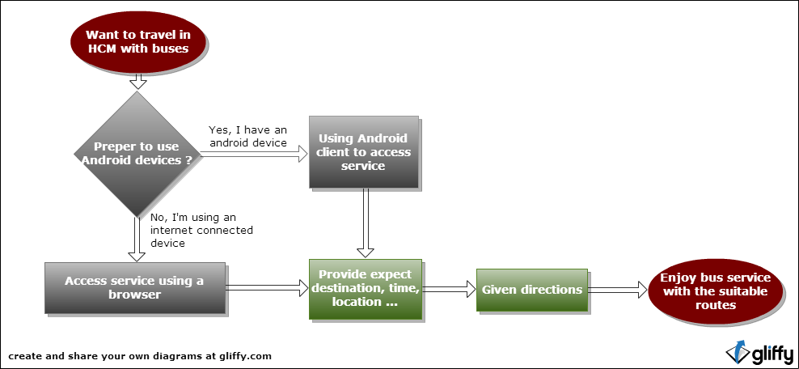

Figure 10: Public User Main Flow

### Staff

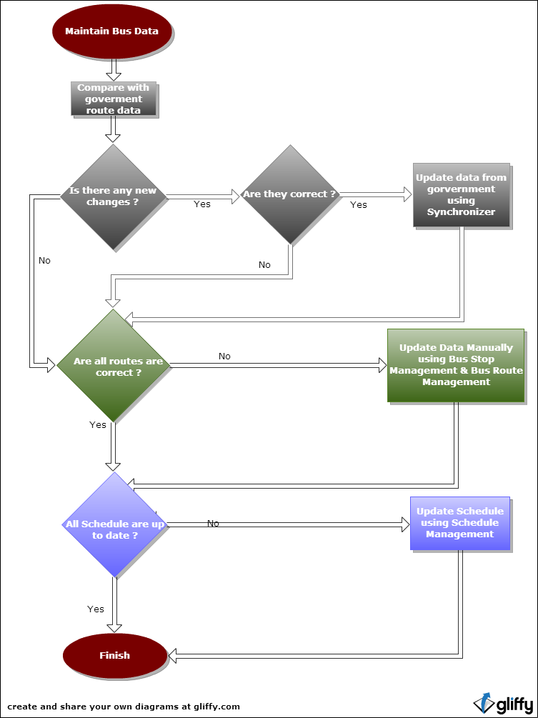

Figure 11: Staff Main Flow

## Entity Relationship - Conceptual

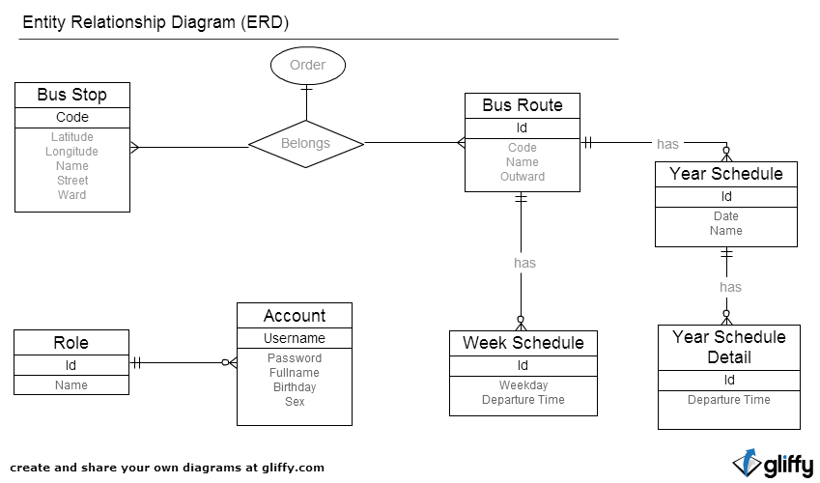

Figure 12: Entity Relationship

# Software Design Description (SDD)

## Design Overview

This part provides for project’s stakeholders multi specific views of BUSG system like:

* + System architecture design which describes the planned model of system, its’ layers, and each layer function
  + Component design which describes all system’s component (class, interface…) together with relationships between them. It also explains clearly their purposes, methods within each component and detailed algorithms, pseudo code to implement them.
  + Sequence diagram design which shows how system processes operate and in what order. Besides, this section depicts the objects which contained in each scenario and theirs interaction by transferred messages.
  + User interface design which describes all screens’ interface; each screen includes which types of input, output element and used by what action.
  + Database design section shows and explains the physical model of system database which includes all tables and their relationship

## System Architectural Design

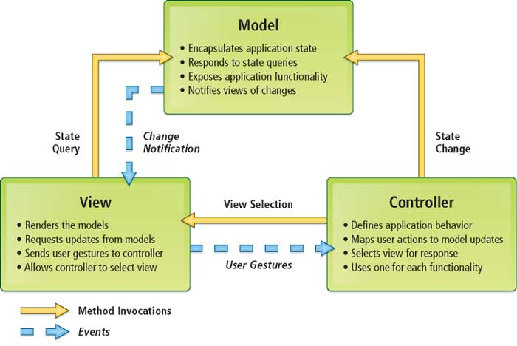

Figure 13: MVC Architecture (ESRI, n.d.)[[3]](#endnote-1)

## Component Diagram

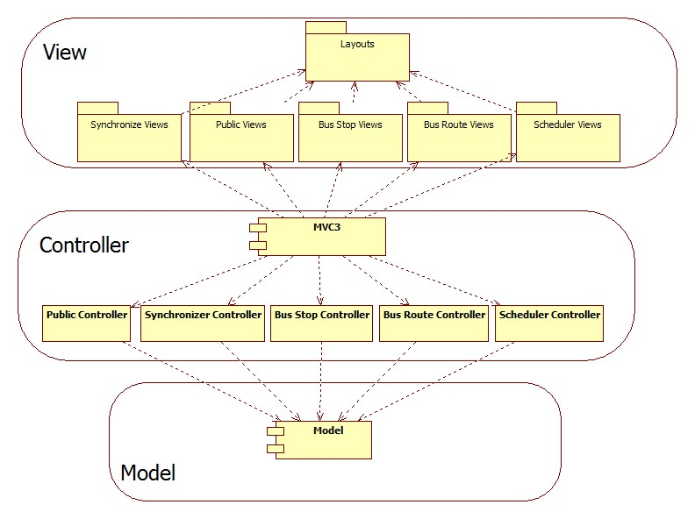

Figure 14: Components Overview

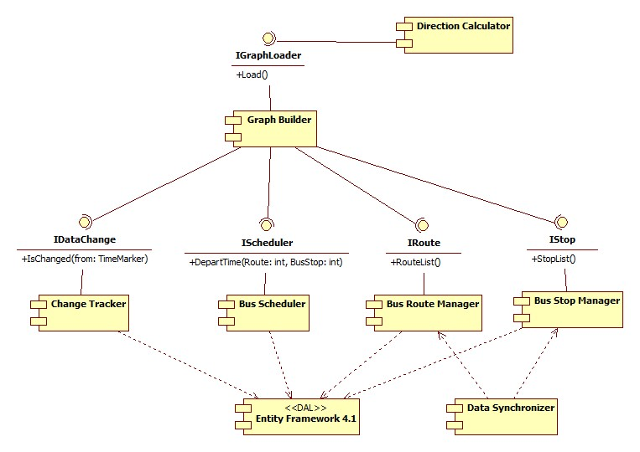

Figure 15: Model Main Components

## Detailed Description of Components

### Graph Loader & Direction Calculator

#### Class Diagram

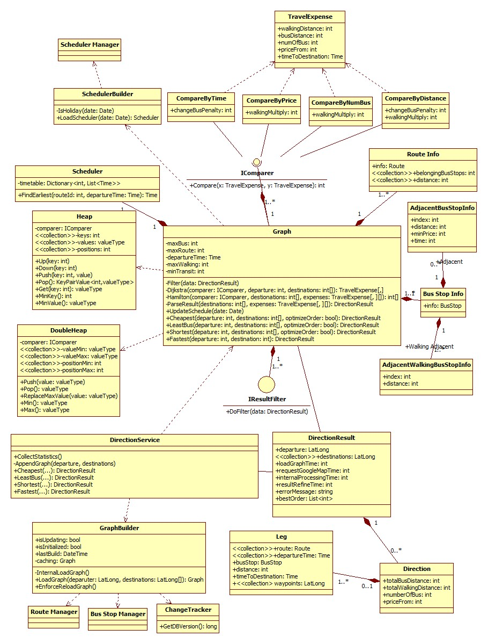

Figure 16: Graph Loader & Direction Services

#### Class Diagram Explanation

##### TravelExpense

This class contains information of expenses used to travel from one node to another in graph.

###### Attributes

|  |  |  |
| --- | --- | --- |
| **Name** | **Type** | **Description** |
| walkingDistance | int | The total walking distance. |
| busDistance | int | The total distance traveled by buses. |
| numOfBus | int | The number of buses used. |
| priceFrom | int | The minimum price. |
| timeToDestination | Time | The earliest point to time to reach destination. |

Table 26: TravelExpense attributes

##### Graph

This class contains all information about the city map buses. These information are used to perform searching algorithms finding out suitable directions depends on different criteria such as: time, number of bus, price, distance, walking distance, transit time, departure time…

###### Attributes

|  |  |  |
| --- | --- | --- |
| **Name** | **Type** | **Description** |
| maxBus | int | The maximum number of bus to be used for travelling from departure to one destination (is not used for FewestBus) |
| maxRoute | int | The maximum number of alternative results. |
| departureTime | Time | The departure time (is used for Fastest) |
| maxWalking | int | The maximum walking distance between bus stops transit in result. Except from the departure to the first bus stop and from the last bus stop to the destination. |
| minTransit | int | The minimum time for traveler changing buses. |
| routes | <<collection>>RouteInfo | The information of all bus routes. |
| busStops | <<collection>>BusStopInfo | The information of all bus stops. |
| scheduler | <<collection>>Scheduler | The information of departure time of all bus routes. |
| filters | <<collection>>IResultFilter | Rules to filter out non-human results. |

Table 27: Graph attributes

###### Methods

- Dijkstra(comparer: IComparer, departure: int, destinations: int[]): TravelExpense[,]

This method implements the generic modified version of Dijkstra algorithms. This allows finding out **maxRoute** shortest paths from one **departure** to all **destinations** in the graph. The term shortest is defined by the **comparer**. The compare specifies which criterion should be optimized: time, distance, price, and number of bus used or a function combining some of them.

The produced result must satisfy criteria of maxBus (maximum of bus used), maxWalking (maximum walking distance between transits) and minTransit (minimum time for changing buses).

|  |  |  |
| --- | --- | --- |
| **Parameter/Return** | **Type** | **Description** |
| comparer | IComparer | The concrete implementation of IComparer which describes the optimizing criterion. |
| departure | int | The index of departure node in graph. |
| destinations | int[] | The indexes of destination nodes in graph that we focus on. |
| Return | TravelExpense[,] | The expense matrix. [x,k] is the expense the kth shortest path to travel from departure node to node x. |

Table 28: Dijkstra method's parameters

-Hamilton(destinations: int[], expenses: TravelExpense[,][]):int[]

This method find out which order of travelling will give the best expense.

|  |  |  |
| --- | --- | --- |
| **Parameter/Return** | **Type** | **Description** |
| comparer | IComparer | The concrete implementation of IComparer which describes the optimizing criterion. |
| destinations | int[] | The indexes of destination nodes in graph that we focus on. |
| expenses | TravelExpense[,][] | List of matrix expense corresponding to each destination. |
| Return | int[] | The order of travelling that give best expense. |

Table 29: Hamilton method's parameters

ParseResult(destinations:int[], expenses:TravelExpense[,][]):DirectionResult

The method converts expense matrixes to DirectionResult object.

|  |  |  |
| --- | --- | --- |
| **Parameter/Return** | **Type** | **Description** |
| destinations | int[] | The indexes of destination nodes in graph that we focus on. |
| expenses | TravelExpense[,][] | List of matrix expense corresponding to each destination. |
| Return | DirectionResult | The DirectionResult object containing information only related to the final result. |

Table 30: ParseResult method's parameters

Filter(data: DirectionResult)

The method filter out directions those are not reasonable to human.

|  |  |  |
| --- | --- | --- |
| **Parameter/Return** | **Type** | **Description** |
| data | DirectionResult | The result produced from base algorithms. |

Table 31: Filter method's parameters

UpdateSchedule(date: Date)

Reload schedules of all routes for specified date.

|  |  |  |
| --- | --- | --- |
| **Parameter/Return** | **Type** | **Description** |
| date | Date | The operating date. |

Table 32: UpdateSchedule method's parameters

Cheapest(departure: int, destinations: int[], optimizeOrder: bool): DirectionResult

Find cheapest directions to travel from departure to all destinations.

|  |  |  |
| --- | --- | --- |
| **Parameter/Return** | **Type** | **Description** |
| departure | int | The index of departure node in graph. |
| destinations | int[] | The indexes of destination nodes in graph that we concern. |
| optimizeOrder | bool | Indicate that should we compute the best travelling order. |
| Return | DirectionResult | The directions to travel that are cheapest and satisfy criteria. |

Table 33: Cheapest method's parameters

LeastBus(departure: int, destinations: int[], optimizeOrder: bool): DirectionResult

Find directions to travel from departure to all destinations that use fewest number of buses.

|  |  |  |
| --- | --- | --- |
| **Parameter/Return** | **Type** | **Description** |
| departure | int | The index of departure node in graph. |
| destinations | int[] | The indexes of destination nodes in graph that we concern. |
| optimizeOrder | bool | Indicate that should we compute the best travelling order. |
| Return | DirectionResult | The directions to travel that use fewest buses and satisfy criteria. |

Table 34: LeastBus method's parameters

Shortest(depature: int, destinations: int[], optimizeOrder: bool): DirectionResult

Find shortest (in term of distance) directions to travel from departure to all destinations.

|  |  |  |
| --- | --- | --- |
| **Parameter/Return** | **Type** | **Description** |
| departure | int | The index of departure node in graph. |
| destinations | int[] | The indexes of destination nodes in graph that we concern. |
| optimizeOrder | bool | Indicate that should we compute the best travelling order. |
| Return | DirectionResult | The directions to travel that use fewest buses and satisfy criteria. |

Table 35: Shortest method's parameters

Fastest(departure: int, destination: int): DirectionResult

Find fastest directions to travel from departure to all destinations.

|  |  |  |
| --- | --- | --- |
| **Parameter/Return** | **Type** | **Description** |
| departure | int | The index of departure node in graph. |
| destinations | int[] | The indexes of destination nodes in graph that we concern. |
| optimizeOrder | bool | Indicate that should we compute the best travelling order. |
| Return | DirectionResult | The directions to travel that are shortest in term of distance and satisfy criteria. |

Table 36: Fastest method's parameters

##### DirectionService

This class wraps and exposes the main functions of Graph class to outside world as services. It is also responsible for collecting statistics on using services such as executing time.

##### CompareByTime

This class implements IComparer that express time as the optimizing criterion using this function:

f(x) = x.time + x.numberOfBus \* changeBusPenalty

|  |  |  |
| --- | --- | --- |
| **Name** | **Type** | **Description** |
| x.time | int | Real cost of time to travel |
| x.numOfBus | int | The number of buses used |
| changeBusPenalty | int | A constant to express people behavior of tending to avoid changing bus even it takes a little longer. |

Table 37: CompareByTime explanation

##### CompareByPrice

This class implements IComparer that express price as the optimizing criterion using this function:

f(x) = x.minPrice \* MAX\_DISTANCE + x.walkingDistance \* walkingMultiply + x.busDistance

|  |  |  |
| --- | --- | --- |
| **Name** | **Type** | **Description** |
| x.minPrice | int | Real cost of money to travel |
| x.walkingDistance | int | The walking distance to travel |
| walkingMultiply | int | A constant to express people behavior of tending to avoid walking even it takes a little longer. |
| x.busDistance | int | The distance to travel by bus |
| MAX\_DISTANCE | int | A constant to represent a very long distance that never happens in real situations. It means that we optimize price first, then distance later |

Table 38: CompareByPrice explanation

##### CompareByNumOfBus

This class implements IComparer that express the number of buses used as the optimizing criterion using this function:

f(x) = x. numberOfBus \* MAX\_DISTANCE + x.walkingDistance \* walkingMultiply + x.busDistance

|  |  |  |
| --- | --- | --- |
| **Name** | **Type** | **Description** |
| x.numberOfBus | int | The number of buses used |
| x.walkingDistance | int | The walking distance to travel |
| walkingMultiply | int | A constant to express people behavior of tending to avoid walking even it takes a little longer. |
| x.busDistance | int | The distance to travel by bus |
| MAX\_DISTANCE | int | A constant to represent a very long distance that never happens in real situations. It means that we optimize price first, then distance later |

Table 39: CompareByNumOfBus explanation

##### CompareByDistance

This class implements IComparer that express distance as the optimizing criterion using this function:

f(x) = x.busDistance + x.walkingDistance \* walkingMultiply + x.numberOfBus \* changeBusPenalty

|  |  |  |
| --- | --- | --- |
| **Name** | **Type** | **Description** |
| x.walkingDistance | int | The walking distance to travel |
| walkingMultiply | int | A constant to express people behavior of tending to avoid walking even it takes a little longer. |
| x.busDistance | int | The distance to travel by bus |
| changeBusPenalty | int | A constant to express people behavior of tending to avoid changing bus even it takes a little longer. |

Table 40: CompareByDistance explanation

##### RouteInfo

This class contains information of a route in graph. Its structure differs from the underlying storage (database structure) to support graph operations.

|  |  |  |
| --- | --- | --- |
| **Name** | **Type** | **Description** |
| info | Route | General information of route. |
| belongingBusStops | <<collection>> int | The indexes of bus stops on the route. |
| distance | <<collection>> int | Corresponding distance of bus stops from the first one. |

Table 41: RouteInfo attributes

##### BusStopInfo

This class contains information of a bus stop in graph. Its structure differs from the underlying storage (database structure) to support graph operations.

|  |  |  |
| --- | --- | --- |
| **Name** | **Type** | **Description** |
| info | BusStop | General information of bus stop. |
| AdjacentBusStops | <<collection>> AdjacentBusStopInfo | Bus stops that are connected directly by a bus route. |
| AdjacentWalkingBusStops | <<collection>> AdjacentWalkingBusStopInfo | Bus stops that are connected directly by a short walking distance (<= 1000m) |

Table 42: BusStopInfo attributes

##### AdjacentBusStopInfo

|  |  |  |
| --- | --- | --- |
| **Name** | **Type** | **Description** |
| index | int | Index in graph |
| distance | int | Travelling distance by bus |
| minPrice | int | Minimum price |
| time | int | Time (in minutes) |

Table 43: AdjacentBusStopInfo attributes

##### AdjacentWalkingBusStopInfo

|  |  |  |
| --- | --- | --- |
| **Name** | **Type** | **Description** |
| index | int | Index in graph |
| distance | int | Travelling distance by walking |

Table 44: AdjacentWalkingBusStopInfo attributes

##### Scheduler

This class contains information of departure time of all bus routes. Its structure differs from underlying storage (database structure) to support fast searching required by graph operations.

###### Attributes

|  |  |  |
| --- | --- | --- |
| **Name** | **Type** | **Description** |
| timetable | Dictionary<int, List<Time>> | List of departure times corresponding to each route id. |

Table 45: Scheduler attributes

###### Methods

FindEarliest(routeId: int, departureTime: Time): Time

Find the first departure time of a route after a specified point of time.

|  |  |  |
| --- | --- | --- |
| **Parameter/Return** | **Type** | **Description** |
| routeId | int | The id of route. |
| departureTime | Time | The point of time that we cannot depart earlier |
| Return | Time | The first departure time of specified route that is not earlier than specified point of time. |

Table 46: FindEarliest method's parameters

##### SchedulerBuilder

This class responsible for convert schedule information of specified date in form of underlying structure (database) to memory structure of Scheduler to support fast searching required by graph operations.

###### IsHoliday(date: Date):boolean

Check if a date is a holiday.

###### LoadScheduler(date: Date): Scheduler

Load schedule information of a specified date and convert into memory structure.

##### Heap

This class implements a priority queue that has pre-defined maximum element and support these operations:

* + Get min value in O(1).
  + Push a new value into priority queue in O(lgN).
  + Pop the min value out of queu in O(lgN).
  + Update value of an existing element in queue in O(lgN).
  + Get size of queue in O(1).

Formal definition of Priority Queue: <http://en.wikipedia.org/wiki/Priority_queue> (Wikipedia, n.d.)

Heap Structure: <http://en.wikipedia.org/wiki/Heap_(data_structure)> (Wikipedia, n.d.)

##### DoubleHeap

This class implements a double-ended priority queue that has pre-defined maximum element and support these operations:

* + Get min value in O(1).
  + Get max value in O(1).
  + Push a new value into queue in O(lgN).
  + Pop the min value out of queue in O(lgN).
  + Pop the max value out of queue in O(lgN).
  + Update value of an existing element in queue in O(lgN).
  + Get size of queue in O(1).

Formal definition of Double-ended Priority Queue: <http://en.wikipedia.org/wiki/Double-ended_priority_queue> (Wikipedia, n.d.)

We implement this structure using 2 heaps and 2 arrays to track position of each element in each heap.

##### GraphBuilder

This class loads information of all routes and all bus stops from underlying storage (database) and converts them into memory structure that is suitable for graph operations.

##### DirectionResult

This class contains all travelling information needed for a response as well as statistics information.

|  |  |  |
| --- | --- | --- |
| **Name** | **Type** | **Description** |
| departure | Latlong | Coordinate of departure |
| destinations | <<collection>> Latlong | Coordinates of destinations |
| loadGraphTime | int | Time to load graph (in milliseconds) |
| requestGoogleMap | int | Time to request information from Google Map service (in milliseconds) |
| internalProcessingTime | int | Time for internal processing (in milliseconds) |
| resultRefineTime | int | Time for further processing such as filtering (in milliseconds) |
| errorMessage | string | Error message if something wrong happens. |
| directions | <<collection>> Direction | Information to travel with least expenses. Each corresponding to each result. |

Table 47: DirectionResult attributes

##### Direction

This contains travelling information for a single result.

|  |  |  |
| --- | --- | --- |
| **Name** | **Type** | **Description** |
| totalBusDistance | int | Total travelling distance by bus (in meters) |
| totalWalkingDistance | int | Total walking distance (in meters) |
| numOfBus | int | The number of buses used. |
| priceFrom | int | The minimum price. |
| legs | <<collection>> Leg | Information for each travel segment |

Table 48: Direction attributes

##### Leg

|  |  |  |
| --- | --- | --- |
| **Name** | **Type** | **Description** |
| routes | <<collection>>Route | List of bus routes can be used. |
| departureTimes | <<collection>> Time | Corresponding departure time for each bus route. |
| busStop | BusStop | Information of the next bus stop. |
| distance | int | Distance to the next bus stop (in meters) |
| timeToDestination | Time | The next bus stop arrival time. |
| waypoints | <<collection> Latlong | These are used to draw route correctly. |

Table 49: Leg attributes

#### Algorithms of important methods in each class specified in pseudo code or by Flow-Chart

##### Dijkstra

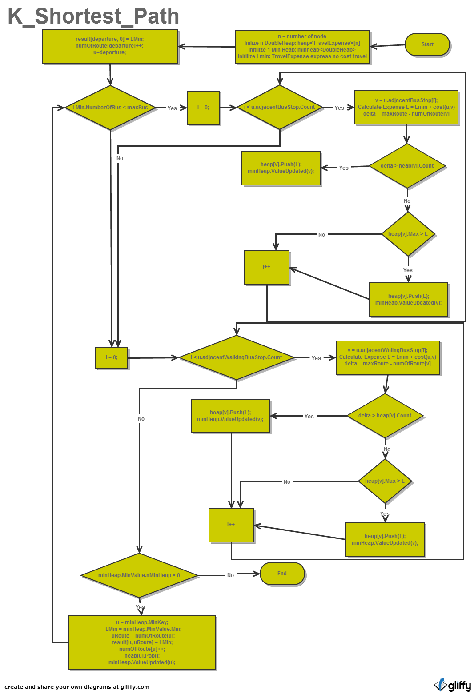

Figure 17: K shortest path algorithms

### Data Synchronizer

<Optional>

### Bus Stop Manager

<Optional>

### Bus Route Manager

<Optional>

### Scheduler

<Optional>

### Change Tracker

<Optional>

## User Interface Design

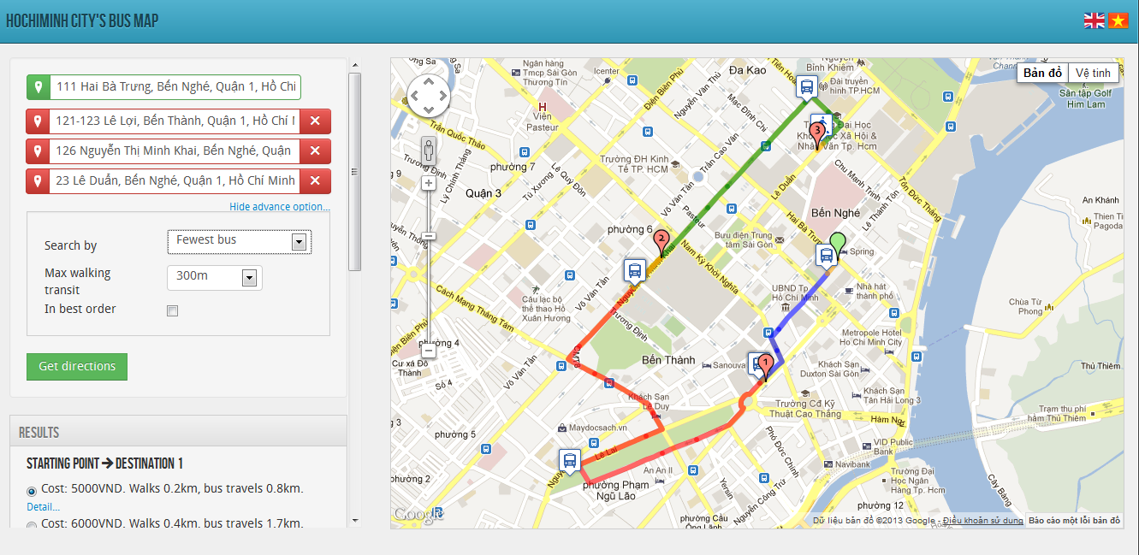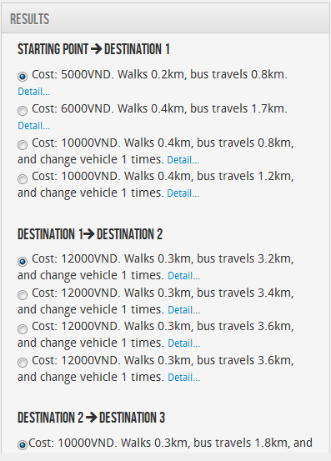

**3**

**6**

**5**

**1**

**4**

**2**

**7**

Figure 18: Public user page

|  |  |
| --- | --- |
| Item No | Meaning of item |
| 1 | Address boxes:   * Green text box is origin address * Red text boxes are destination address (maximum 3 destinations) |
| 2 | Delete destination buttons: delete destination address in text box and marker on map |
| 3 | Map:   * Green marker: starting point * Red marker: destination. * Orange line: walking * Blue line: direction from starting point to destination * Red line: direction from destination to destination 2 * Green line: direction from destination 2 to destination 3 * Walking marker: walking from here * Bus marker: take bus from here |
| 4 | Advance options:   * Show/Hide advance options * Search by: condition to get direction. There are 4 mode of search by: * Shortest distance: get direction that is the shortest one * Fewest bus: get direction that use the fewest number of bus * Lowest cost: get direction that total cost is lowest * Fastest: get direction that spent the least amount of time * Max walking transit: maximum walking distance you desire to walk * Max transfer permitted: maximum bus transfer time (available for all mode except fewest bus) * Time of departure: time you start your trip(only available in fastest mode) * Bus transfer time: time between each bus transfer time(only available in fastest mode) |
| 5 | Get directions button |
| 6 | Result table: List of results is described in words. |
| 7 | Language option |

Table 50: Public User page's controls

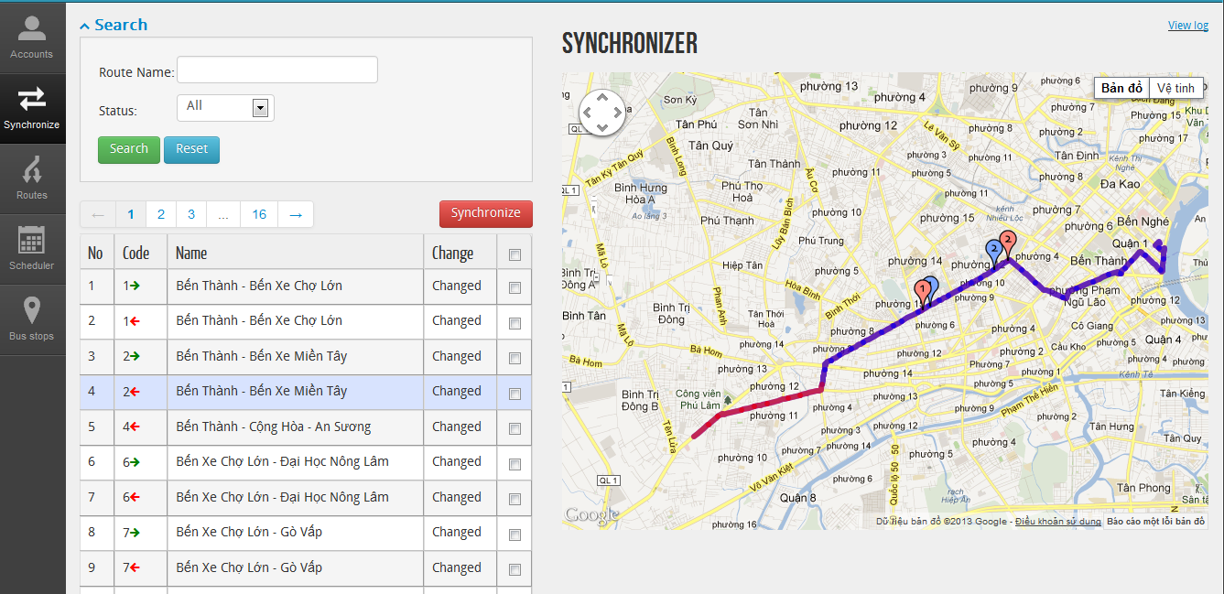

**1**

**3**

**5**

**2**

**6**

**4**

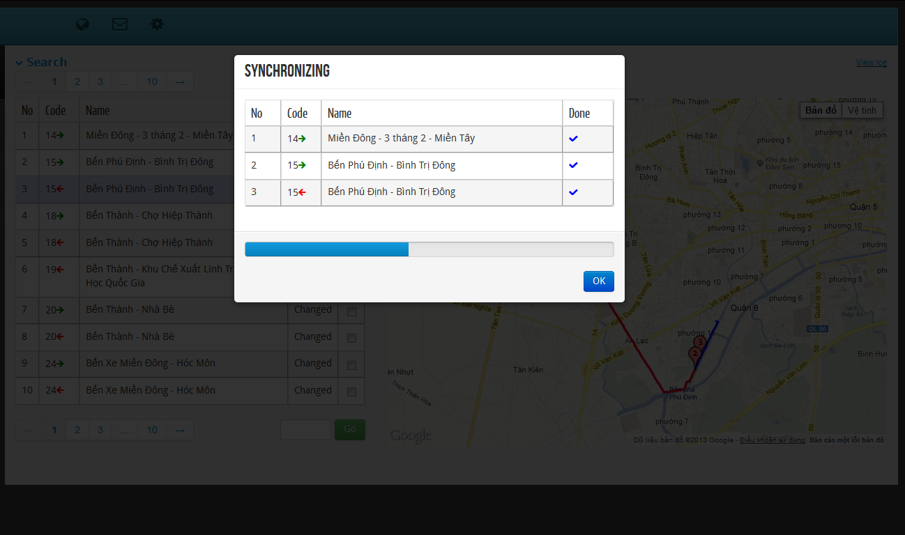

Figure 19: Synchronize bus routes page and modal for synchronizing process

|  |  |
| --- | --- |
| Item No | Meaning of item |
| 1 | Navigation bar |
| 2 | Search route:   * Search by name * Search by status. There are 4 items in status combo box * New: This route is in buyttphcm server but you haven’t had yet * Changed: route that both you and buyttphcm have but different data (bus stop coordinate, number of bus stop…) * Removed: you have this route but buyttphcm don’t * All: all above status * Search button * Reset button: reset route name and status combo box to default |
| 3 | Map:   * Blue markers: bus stops belong to remote route that differ from local route * Red markers: bus stops belong to local route that differ from remote route * Blue line: remote route * Red line: local route |
| 4 | Synchronize button |
| 5 | Sync table: list all routes that are different between our data and buyttphcm’s data. Columns meaning:   * Code: is the code of bus. Green arrow is outward and red arrow is inward. * Name: is name of bus * Change: there are 3 status of change   + New:   + Changed   + Removed |
| 6 | Synchronize log: sync history |

Table 51: Synchronize bus routes page's controls

**5**

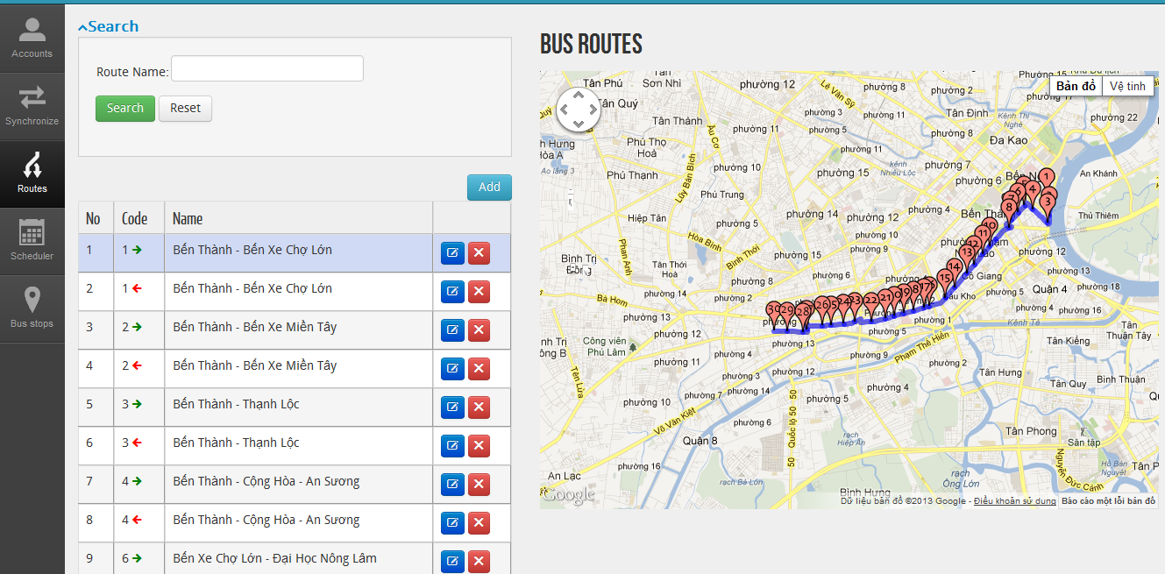

**1**

**44**

**3**

**2**

Figure 20: Routes management page

|  |  |
| --- | --- |
| Item No | Meaning of item |
| 1 | Navigation bar |
| 2 | Search route:   * Search by name * Search button * Reset button: reset route name to default |
| 3 | Map:   * Red markers: bus stops * Blue line: bus route |
| 4 | Add button: add more route |
| 5 | Route table: list all routes that match search condition. Columns meaning:   * Code: is the code of bus. Green arrow is outward and red arrow is inward. * Name: is name of bus * Edit button: edit route by changing code, name, price, reorder/remove bus stops. * Delete button: delete route |

Table 52: Route Management page's controls

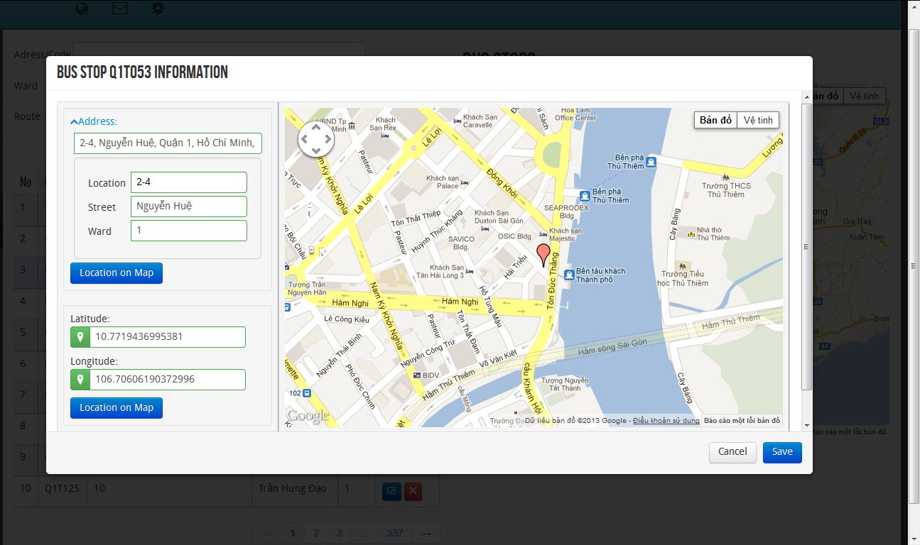

**14**

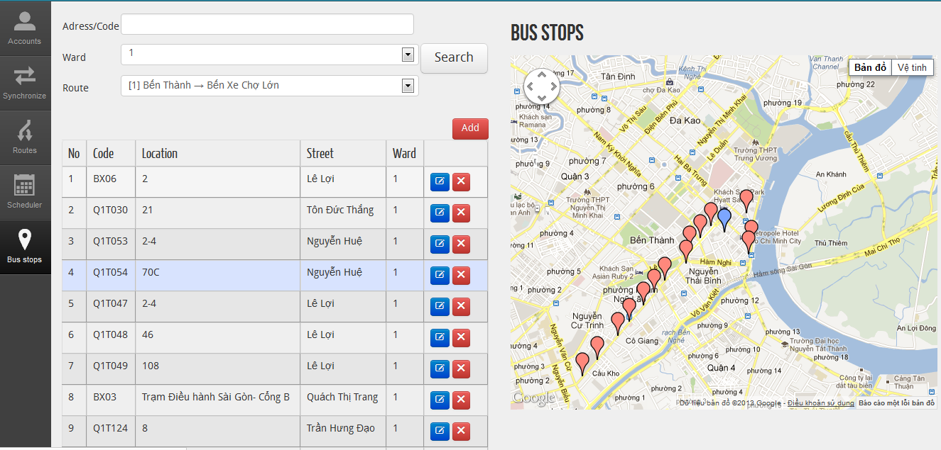

**5**

**3**

**4**

**2**

Figure 21: Bus stop management page and modal for editing bus stop

|  |  |
| --- | --- |
| Item No | Meaning of item |
| 1 | Navigation bar |
| 2 | Search bus stop:   * Search by address code: list all bus stop that match location address * Search by ward: list all bus stop belong to chosen ward in bus stop table * Search by route: list all bus stop belong to chosen route in bus stop table * Search button |
| 3 | Map:   * Red markers: bus stops * Blue marker: current chosen marker |
| 4 | Add button: add more bus stop |
| 5 | Bus stop table: list all bus stops that match search condition. Columns meaning:   * Code: is the code of bus stop * Location: address code * Street * Ward * Edit button: edit route by changing address, coordinate * Delete button: delete bus stop |

Table 53: Bus Stop Management page's controls

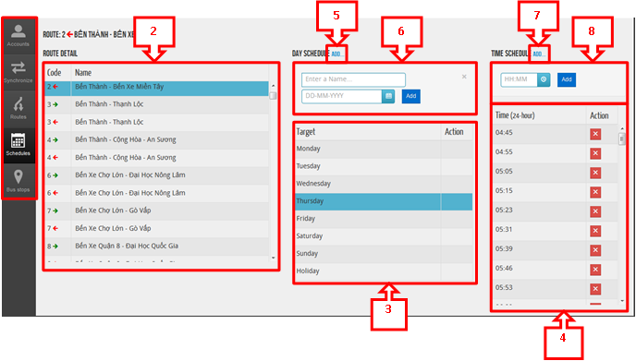

Figure 22: Schedule page

|  |  |
| --- | --- |
| Item No | Meaning of item |
| 1 | Navigation bar |
| 2 | Route detail table |
| 3 | Day schedule table |
| 4 | Time schedule table |
| 5 | Add hypertext: click to show/hide add day schedule form |
| 6 | Add day schedule form:   * Name: Name of day schedule * Date * Add button: add item to day schedule table |
| 7 | Add hypertext: click to show/hide add time schedule form |
| 8 | Add time schedule form:   * Time * Add button: add item to tine schedule table |

Table 54: Schedule page's controls

# Software Test Documentation

## Introduction

### System Overview

This section provides in detail all necessary information about test plans, test cases, test results, test environments, pass/fail criteria and risks estimation as well as a checklist to cover all possible cases of BUSG.

### Test Approach

* Goal: To determine and discover all remaining bugs and error of BUSG.
* Method: Black-box testing.
* Size: System components.

## Test Plan

The purpose of this section is to verify and ensure that BUSG meets its design specification and other requirements from user. The following part will describe which features will be tested and which will not.

### Features to be tested

All following features will be tested, which can include one or more functions. These features will be focused and tested thoroughly during the test phase:

* Public page
  + Enter, change Starting Point, Destinations’ locations.
  + Create, move, remove Starting Point, Destinations’ markers.
  + Get Directions (Shortest Distance mode)
  + Get Directions (Shortest Distance mode in best order)
  + Get Directions (Least Bus mode)
  + Get Directions (Least Bus mode in best order)
  + Get Directions (Cheapest mode)
  + Get Directions (Cheapest mode in best order)
  + Get Directions (Fastest mode)
  + View result.
* Synchronizer
  + Synchronize remote route and local route
* Route
  + View Route
  + Add Route
  + Delete Route
  + View and edit Route Detail
* Schedules
  + Add, edit, delete Day Schedule
  + Add, edit, delete Time Schedule
* Bus stops
  + Add, edit, delete Bus stops

### Features not to be tested

* Login
* Account

## Test Case

### Public page

#### Enter, change Starting Point, Destinations’ locations.

|  |  |  |  |  |  |  |  |
| --- | --- | --- | --- | --- | --- | --- | --- |
| **ID** | **Test Case Description** | **Test Case Procedure** | **Expected Output** | **Inter-test case Dependence** | **Result** | **Test Date** | **Note** |
|  | List roles |  |  |  |  |  |  |
|  | Steps 1. Go to Index page | | | | | | |
| PP001 | Enter Starting Point’s location | At Index page, enter an address that belongs to HCHM into Starting Point textbox:   * Công viên phần mềm Quang Trung   and hit Tab key. | A green marker is displayed on map at the location according to the input. |  | Passed | 14/04/2013 |  |
| PP001b | Enter *wrong* Starting Point’s location | At Index page, enter an address that NOT belongs to HCHM into Starting Point textbox:   * Võ Thành Long   and hit Tab key. | Message “Error: Location not found in Ho Chi Minh City!” |  | Passed | 16/04/2013 |  |
| PP002 | Change Starting Point’s location | Change the input in Starting Point textbox into another address belongs to HCHM   * Bến xe An Sương   and hit Tab key. | The green marker is moved to the new location in accordant with the new input. | PP001 | Passed | 14/04/2013 |  |
| PP003 | Enter Destinations’ location | At Index page, enter addresses that belongs to HCHM into destination textboxes   * Destination : 510 Tô Ký, Tân Chánh Hiệp * Destination 2: 152 Xuyên Á, Trung Mỹ Tây * Destination 3: 222 Nguyễn Văn Quá   and hit Tab key respectively. | Red markers are displayed on map at the locations according to the inputs. |  | Passed | 14/04/2013 |  |
| PP003b | Enter *wrong* Destination’ location | At Index page, enter addresses that belongs to HCHM into destination textboxes   * Destination : 30 Khuất Duy Tiến | Message “Error: Location not found in Ho Chi Minh City!” |  | Passed | 16/04/2013 |  |
| PP004 | Change Destination’ location | Change the inputs in Destination, Destination 2, Destination 3 textboxes into other addresses that belong to HCHM   * Destination: 40 Nguyễn Huệ * Destination 2: 53 Trần Nhật Duật * Destination 3: 52 Trần Khắc Chân   and hit Tab key respectively. | The red markers are moved to the new locations in accordant with the new inputs. | PP003 | Passed | 14/04/2013 |  |

#### Create, move, remove Starting Point, Destinations’ markers.

|  |  |  |  |  |  |  |  |
| --- | --- | --- | --- | --- | --- | --- | --- |
| **ID** | **Test Case Description** | **Test Case Procedure** | **Expected Output** | **Inter-test case Dependence** | **Result** | **Test Date** | **Note** |
|  | List roles |  |  |  |  |  |  |
|  | Steps 1. Go to Index page | | | | | | |
| PP005 | Create Starting Point’s marker | At Index page, right click on the map at a location belongs to HCHM. On the menu appears, select **Starting Point**. | A green marker is displayed at the location of the mouse’s right click. The address of the marker is displayed on Starting Point’s textbox. |  | Passed | 14/04/2013 |  |
| PP005b | Create Starting Point’s marker that NOT belongs to HCHM | At Index page, right click on the map at a location NOT belongs to HCHM. On the menu appears, select **Starting Point**. | Message “Error: Location not found in Ho Chi Minh City!” |  | Passed | 16/04/2013 |  |
| PP006 | Move Starting Point’s marker | Click and drag the green marker to another location on the map that belongs to HCHM. | The text on Starting Point’s textbox is change to the address of the new location. | PP005 | Passed | 14/04/2013 |  |
| PP006b | Move Starting Point’s marker to a location NOT belongs to HCHM | Click and drag the green marker to another location on the map that NOT belongs to HCHM. | Message “Error: Location not found in Ho Chi Minh City!” | PP005 | Passed | 16/04/2013 |  |
| PP007 | Remove Starting Point’s marker | Right click on the green marker. On the menu appears, select **Remove**. | The green marker disappears from the map. The address of the marker is erased from Starting Point’s textbox. | PP005 | Passed | 14/04/2013 |  |
| PP008 | Create Destination’s marker , Destination 2’s marker, Destination 3’s marker | At Index page, right click on a random location of the map. On the menu appears, select **Destination.** Repeat this step with **Destination 2** and **Destination 3.** | Red markers are displayed at the locations of each respective mouse’s right click. The addresses of the markers are displayed on Destination, Destination 2, Destination 3 textboxes accordingly. |  | Passed | 14/04/2013 |  |
| PP008b | Create Destination’s marker that NOT belongs to HCHM | At Index page, right click on the map at a location NOT belongs to HCHM. On the menu appears, select **Destination.** | Message “Error: Location not found in Ho Chi Minh City!” |  | Passed | 16/04/2013 |  |
| PP009 | Move Destination, Destination 2, Destination 3’s markers. | Click and drag the red marker of **Destination 1** to a new location. Repeat with the red markers of **Destination 2** and **Destination 3**. | The text on Destination, Destination 2 and Destination 3’s textboxes are change to the address of the new locations respectively. | PP008 | Passed | 14/04/2013 |  |
| PP009b | Move Destination’s marker to a location NOT belongs to HCHM | Click and drag the Destination marker to another location on the map that NOT belongs to HCHM. | Message “Error: Location not found in Ho Chi Minh City!” | PP008 | Passed | 16/04/2013 |  |
| PP010 | Remove Destination, Destination 2, Destination 3 markers. | Right click on each red marker. On the menu appears, select **Remove**. | The red markers disappear from the map. The address of the markers is erased from Destination, Destination 2, Destination 3 textboxes accordingly. | PP008 | Passed | 14/04/2013 |  |

#### Get Directions – Shortest Distance mode

|  |  |  |  |  |  |  |  |
| --- | --- | --- | --- | --- | --- | --- | --- |
| **ID** | **Test Case Description** | **Test Case Procedure** | **Expected Output** | **Inter-test case Dependence** | **Result** | **Test Date** | **Note** |
|  | List roles |  |  |  |  |  |  |
|  | Steps 1. Go to Index page  2. At the Advance option, select Search by **Shortest Distance**. | | | | | | |
| PP011 | Get Directions using Shortest Distance mode (single destination) | Enter a location into Destination textbox.   * 510 Tô Ký, Tân Chánh Hiệp   Select an option for *Walking Transit* and *Maximum transfers permitted*   * *Walking Transit*: 300m * *Maximum transfers permitted*: 2 | A direction from the Starting Point to Destination is displayed on the map.  Options about directions from Starting Point to Destination (with the currently displaying direction’s option is selected) is displayed at the Result menu, under the search menu. | PP001 | Passed | 14/04/2013 |  |
| PP012 | Get Directions using Shortest Distance mode (multiple destinations) | Select an option for *Walking Transit* and *Maximum transfers permitted*   * *Walking Transit*: 300m * *Maximum transfers permitted*: 2   Leave the *In best order* checkbox unchecked. | * A direction is from the Starting Point to Destination * A direction is from the Destination to Destination 2 * A direction is from the Destination 2 to Destination 3   are displayed on the map in different colors.  Multiple options (with the currently displaying directions are selected) are displayed at the Result menu, under the search menu. | PP001, PP003 | Passed | 14/04/2013 |  |
| PP013 | Get Directions using Shortest Distance mode in best order (multiple destinations) | Select an option for *Walking Transit* and *Maximum transfers permitted*   * *Walking Transit*: 300m * *Maximum transfers permitted*: 2   Check the *In best order* checkbox. | Directions are displayed on maps in best order: Starting Point -> Destination -> Destination 3 -> Destination 2  Multiple options (with the currently displaying directions are selected) are displayed at the Result menu, under the search menu in order:   * Starting Point -> Destination 1 * Destination 1-> Destination 3 * Destination 3 -> Destination 2 | PP001, PP003 | Passed | 14/04/2013 |  |

#### Get Directions – Least Bus mode

|  |  |  |  |  |  |  |  |
| --- | --- | --- | --- | --- | --- | --- | --- |
| **ID** | **Test Case Description** | **Test Case Procedure** | **Expected Output** | **Inter-test case Dependence** | **Result** | **Test Date** | **Note** |
|  | List roles |  |  |  |  |  |  |
|  | Steps 1. Go to Index page  2. At the Advance option, select Search by **Least bus used**. | | | | | | |
| PP014 | Get Directions using Least Bus mode (single destination) | Enter a location into Destination textbox.   * 510 Tô Ký, Tân Chánh Hiệp   Select an option for *Walking Transit*.   * 300m | A direction from the Starting Point to Destination is displayed on the map.  Options about directions from Starting Point to Destination (with the currently displaying direction’s option is selected) is displayed at the Result menu, under the search menu. | PP001 | Passed | 14/04/2013 |  |
| PP015 | Get Directions using Least Bus mode (multiple destinations) | Select an option for *Walking Transit*   * 300m   Leave the *In best order* checkbox unchecked. | * A direction is from the Starting Point to Destination * A direction is from the Destination to Destination 2 * A direction is from the Destination 2 to Destination 3   are displayed on the map in different colors.  Multiple options (with the currently displaying directions are selected) are displayed at the Result menu, under the search menu. | PP001, PP003 | Passed | 14/04/2013 |  |
| PP016 | Get Directions using Least Bus mode in best order (multiple destinations) | Select an option for *Walking Transit* and *Maximum transfers permitted*   * 500m   Check the *In best order* checkbox. | Directions are displayed on maps in best order: Starting Point -> Destination -> Destination 3 -> Destination 2  Multiple options (with the currently displaying directions are selected) are displayed at the Result menu, under the search menu in order:   * Starting Point -> Destination 1 * Destination 1-> Destination 3 * Destination 3 -> Destination 2 | PP001, PP003 | Passed | 14/04/2013 |  |

#### Get Directions – Cheapest mode

|  |  |  |  |  |  |  |  |
| --- | --- | --- | --- | --- | --- | --- | --- |
| **ID** | **Test Case Description** | **Test Case Procedure** | **Expected Output** | **Inter-test case Dependence** | **Result** | **Test Date** | **Note** |
|  | List roles |  |  |  |  |  |  |
|  | Steps 1. Go to Index page  2. At the Advance option, select Search by **Cheapest**. | | | | | | |
| PP017 | Get Directions using Cheapest mode (single destination) | Enter a location into Destination textbox.   * 510 Tô Ký, Tân Chánh Hiệp   Select an option for *Walking Transit* and *Maximum transfers permitted*   * *Walking Transit*: 300m * *Maximum transfers permitted*: 2 | A direction from the Starting Point to Destination is displayed on the map.  Options about directions from Starting Point to Destination (with the currently displaying direction’s option is selected) is displayed at the Result menu, under the search menu. | PP001 | Passed | 14/04/2013 |  |
| PP018 | Get Directions using Cheapest mode (multiple destinations) | Select an option for *Walking Transit* and *Maximum transfers permitted*   * *Walking Transit*: 300m * *Maximum transfers permitted*: 2   Leave the *In best order* checkbox unchecked. | * A direction is from the Starting Point to Destination * A direction is from the Destination to Destination 2 * A direction is from the Destination 2 to Destination 3   are displayed on the map in different colors.  Multiple options (with the currently displaying directions are selected) are displayed at the Result menu, under the search menu. | PP001, PP003 | Passed | 14/04/2013 |  |
| PP019 | Get Directions using Cheapest mode in best order (multiple destinations) | Select an option for *Walking Transit* and *Maximum transfers permitted*   * *Walking Transit*: 300m * *Maximum transfers permitted*: 2   Check the *In best order* checkbox. | Directions are displayed on maps in best order: Starting Point -> Destination -> Destination 2 -> Destination 3  Multiple options (with the currently displaying directions are selected) are displayed at the Result menu, under the search menu in order:   * Starting Point -> Destination 1 * Destination 1-> Destination 2 * Destination 2 -> Destination 3 | PP001, PP003 | Passed | 14/04/2013 |  |

#### Get Directions – Fastest mode

|  |  |  |  |  |  |  |  |
| --- | --- | --- | --- | --- | --- | --- | --- |
| **ID** | **Test Case Description** | **Test Case Procedure** | **Expected Output** | **Inter-test case Dependence** | **Result** | **Test Date** | **Note** |
|  | List roles |  |  |  |  |  |  |
|  | Steps 1. Go to Index page  2. At the Advance option, select Search by **Fastest**. | | | | | | |
| PP020 | Get Directions using Fastest mode | Enter a location into Destination textbox.   * 4 Xuyên Á, Trung Mỹ Tây   Select an option for *Walking Transit*, *Maximum transfers permitted, Departing time, Transferring time*   * *Walking Transit*: 300m * *Maximum transfers permitted*: 2 * *Departing time*: 08:25 * *Transferring time*: 3 minutes | A direction from the Starting Point to Destination is displayed on the map.  Options about directions from Starting Point to Destination (with the currently displaying direction’s option is selected) is displayed at the Result menu, under the search menu. | PP001 | Passed | 14/04/2013 |  |

#### View results

|  |  |  |  |  |  |  |  |
| --- | --- | --- | --- | --- | --- | --- | --- |
| **ID** | **Test Case Description** | **Test Case Procedure** | **Expected Output** | **Inter-test case Dependence** | **Result** | **Test Date** | **Note** |
|  | List roles |  |  |  |  |  |  |
|  | Steps 1. Go to Index page  2. Create a search for direction. | | | | | | |
| PP021 | View a non-default results | At the Result menu, select a different radio button from the default radio.  Click on Detail... link. | A new direction from the Starting Point to Destination is displayed on the map.  The detail information is different from the former direction. | PP011 | Passed | 14/04/2013 |  |
| PP022 | View paths | Open direction detail by click on Detail... link.  Select a bus route. | Map is panned to the first bus-stop of that route. | PP021 | Passed | 14/04/2013 |  |

### Synchronizer

#### View asynchronous route

|  |  |  |  |  |  |  |  |
| --- | --- | --- | --- | --- | --- | --- | --- |
| **ID** | **Test Case Description** | **Test Case Procedure** | **Expected Output** | **Inter-test case Dependence** | **Result** | **Test Date** | **Note** |
|  | List roles |  |  |  |  |  |  |
|  | Steps 1. Go to Login page.  2. Log in with valid Admin/Staff account.  3. Select Synchronizer on the side bar. | | | | | | |
| SY001 | View asynchronous route | Click on a route displayed on the table | 2 routes are displayed on the map, with the red route is the representation of the local data, and the blue route is the representation of the remote data. |  | Passed | 14/04/2013 |  |

#### Search

|  |  |  |  |  |  |  |  |
| --- | --- | --- | --- | --- | --- | --- | --- |
| **ID** | **Test Case Description** | **Test Case Procedure** | **Expected Output** | **Inter-test case Dependence** | **Result** | **Test Date** | **Note** |
|  | List roles |  |  |  |  |  |  |
|  | Steps 1. Go to Login page.  2. Log in with valid Admin/Staff account.  3. Select Synchronizer on the side bar. | | | | | | |
| SY002 | Search (success) | Click on Search to reveal Search control group.  Enter a search query which has words that are contained in a route.   * Chợ lớn   Select a status   * All | Results are filtered down to routes that contained the word “chợ” or “lớn”. |  | Passed | 14/04/2013 |  |
| SY003 | Search (fail) | Click on Search to reveal Search control group.  Enter a search query which has words that are contained in a route.   * Khuất duy tiến   Select a status   * All | No result. |  | Passed | 14/04/2013 |  |
| SY004 | Reset result table | Click Reset button. | Result table is reset to show all results. | SY001 or SY002 | Passed | 14/04/2013 |  |

#### Synchronizer

|  |  |  |  |  |  |  |  |
| --- | --- | --- | --- | --- | --- | --- | --- |
| **ID** | **Test Case Description** | **Test Case Procedure** | **Expected Output** | **Inter-test case Dependence** | **Result** | **Test Date** | **Note** |
|  | List roles |  |  |  |  |  |  |
|  | Steps 1. Go to Login page.  2. Log in with valid Admin/Staff account.  3. Select Synchronizer on the side bar. | | | | | | |
| SY005 | Synchronize 1 route. | Check the check box of an available route.  Click Synchronizer button. | A small pop-up appears showing the selected route is being synchronized.  After the synchronizing process successfully finished, an OK button appears. |  | Passed | 14/04/2013 |  |
| SY006 | Synchronize multiple routes. | Check the check boxes of 7 different available routes.  Click Synchronizer button. | A small pop-up appears showing the selected routes are being synchronized.  After the synchronizing process successfully finished, an OK button appears. |  | Passed | 14/04/2013 |  |
| SY007 | Cancel synchronization process | Check the check boxes of 7 different available routes.  Click Synchronizer button.  During the process of synchronization, click Cancel button. | The synchronization process stops immediately.  The OK button appears. |  | Passed | 14/04/2013 |  |
| S8008 | Synchronize multiple routes (fail). | Check the check boxes of 7 different available routes.  Click Synchronizer button.  During the process of synchronization, unplug the internet connection. | The synchronization process still continues and finish.  The status Done of some route is displayed as an **X** in red color**.** |  | Passed | 16/04/2013 |  |

#### View Sync log

|  |  |  |  |  |  |  |  |
| --- | --- | --- | --- | --- | --- | --- | --- |
| **ID** | **Test Case Description** | **Test Case Procedure** | **Expected Output** | **Inter-test case Dependence** | **Result** | **Test Date** | **Note** |
|  | List roles |  |  |  |  |  |  |
|  | Steps 1. Go to Login page.  2. Log in with valid Admin/Staff account.  3. Select Synchronizer on the side bar. | | | | | | |
| SY009 | View Sync log | On the top-right corner, click on the link View log | A small pop-up appears displaying a log that contains all synchronization that have been made. | SY006 | Passed | 14/04/2013 |  |

### Route

#### View Route

|  |  |  |  |  |  |  |  |
| --- | --- | --- | --- | --- | --- | --- | --- |
| **ID** | **Test Case Description** | **Test Case Procedure** | **Expected Output** | **Inter-test case Dependence** | **Result** | **Test Date** | **Note** |
|  | List roles |  |  |  |  |  |  |
|  | Steps 1. Go to Login page.  2. Log in with valid Admin/Staff account.  3. Select Route on the side bar. | | | | | | |
| RO001 | View a route | Click on a route displayed on the table:   * 13-> Bến Thành → Bến Xe Củ Chi | A route is display on the map in blue poly-line with red markers as bus-stops’ representation. |  | Passed | 14/04/2013 |  |

#### Add Route

|  |  |  |  |  |  |  |  |
| --- | --- | --- | --- | --- | --- | --- | --- |
| **ID** | **Test Case Description** | **Test Case Procedure** | **Expected Output** | **Inter-test case Dependence** | **Result** | **Test Date** | **Note** |
|  | List roles |  |  |  |  |  |  |
|  | Steps 1. Go to Login page.  2. Log in with valid Admin/Staff account.  3. Select Route on the side bar. | | | | | | |
| RO002 | Leave a required field blank. | Click on the Add button, a new pop-up appears.  Enter information for some but not all required fields:   * Code: 300 * Name: (blank) * Price: 10000 * Outward: true   Click Confirm button. | Message “Please provide all required information.” |  | Passed | 14/04/2013 |  |
| RO003 | Enter information of an existed local route. | Click on the Add button, a new pop-up appears.  Enter all required information with Code and Outward consist with a local route:   * Code: 1 * Outward: True   Click Confirm button. | Message “Already existed a Route with Code = 1 and Outward = true.” |  | Passed | 14/04/2013 |  |
| RO004 | Enter information of a new route. | Click on the Add button, a new pop-up appears.  Enter all required information of a new route:   * Code: 300 * Name: Test route – Test route * Price: 10000 * Outward: True   Click Confirm button. | Add screen is open in a new tab with the Code, Name, Outward, Price are displayed as:  *300 Test Route – Test route True 10000* |  | Passed | 14/04/2013 |  |
| RO005 | Search bus-stop for the new route. | On search control, enter a street name:   * 3 tháng 2   And select an option for Wards and Routes   * All Wards * All Routes | A list of bus-stops appears. | RO004 | Passed | 14/04/2013 |  |
| RO006 | Review bus-stop. | Select a bus stops from the search results.   * Q10T001 | A green marker is display at the location of the selected bus-stop. | RO005 | Passed | 14/04/2013 |  |
| RO007 | Add bus-stop for the new route. | Select some bus-stops from the search results.   * Q10T001 * Q10T002 * Q10T004 * Q10T005 * Q10T006   Click the Select button. | A route is displayed on the maps in blue polyline with red markers as bus-stops.  Bus-stops are added to the table on the rights.  The selected bus-stops are disabled on the search results table. | RO005 | Passed | 14/04/2013 |  |
| RO008 | Change the order of new route’s bus-stops. | Select some bus-stops on the left table:   * Q10T002 * Q10T004   Click button Up or Down. | The order of bus-stops is change accordingly. | RO007 | Passed | 14/04/2013 |  |
| RO009 | Remove some bus-stops from the new route. | Select some bus-stops on the left table:   * Q10T002 * Q10T004   Click button Remove.  A pop-up appears and requests a confirmation for the removal.  Select Yes. | The bus-stops are removed from the maps and table. | RO007 | Passed | 14/04/2013 |  |
| RO010 | Add new route to local database. | Click button Add.  A new pop-up appears “Are you sure you want to create a new Route?”  Select Yes.  Another popup appears “A new Route has been added successfully.”  Select OK. | The page is directed to the detail page of the newly created route. | RO007 or RO008 or  RO009 |  |  |  |

#### View, Edit detail of a Route

|  |  |  |  |  |  |  |  |
| --- | --- | --- | --- | --- | --- | --- | --- |
| **ID** | **Test Case Description** | **Test Case Procedure** | **Expected Output** | **Inter-test case Dependence** | **Result** | **Test Date** | **Note** |
|  | List roles |  |  |  |  |  |  |
|  | Steps 1. Go to Login page.  2. Log in with valid Admin/Staff account.  3. Select Route on the side bar. | | | | | | |
| RO011 | View a Route’s detail. | Click Detail button. | The page is redirected to the detail page of that route. | RO001 | Passed | 14/04/2013 |  |
| RO012 | Open title’s Edit form. | Click on pencil icon next to route’s title. | Tittle’s Edit form appears as a pop-up window. | RO011 | Passed | 14/04/2013 |  |
| RO013 | Edit title with a blank field | Erase the information of one or multiple fields.  Click Confirm button. | Message “Please provide all required information.” | RO012 | Passed | 14/04/2013 |  |
| RO014 | Edit tile with information to an existed local route. | Change Code and Outward fields to:   * Code: 1 * Outward: True   Click Confirm button. | Message “Already existed a Route with Code = 1 and Outward = true.” | RO012 | Passed | 14/04/2013 |  |
| RO015 | Edit with valid information | Change route’s information:   * Code: 400 * Name: New name – New name * Price: 10000 * Outward: True   Click Confirm button.  New pop-up appear “Route's information has been updated successfully.” Select Yes. | Route’s title is updated to   * *400 New name – New name*   *True 10000* | RO012 | Passed | 14/04/2013 |  |
| RO016 | Open Detail Edit view | Click on Edit Button | The interface is changed to Detail Edit view. | RO011 | Passed | 14/04/2013 |  |
| RO017 | Change the order of new route’s bus-stops. | Select some bus-stops on the left table:   * Q3T010 * QTBT058   Click button Up or Down. | The order of bus-stops is change accordingly. | RO016 | Passed | 14/04/2013 |  |
| RO018 | Remove some bus-stops from the route. | Select some bus-stops on the left table:   * Q3T010 * QTBT058   Click button Remove.  A pop-up appears and requests a confirmation for the removal.  Select Yes. | The bus-stops are removed from the maps and table. | RO016 | Passed | 14/04/2013 |  |
| RO019 | Search new bus-stop. | On search control, enter a street name:   * Quốc lộ 22   And select an option for Wards and Routes   * Wards: All Wards * Routes: All Routes | A list of bus-stops appears. | RO016 | Passed | 14/04/2013 |  |
| RO020 | Review bus-stop. | Select a bus stops from the search results.   * BX41 | A green marker is display at the location of the selected bus-stop. | RO019 | Passed | 14/04/2013 |  |
| RO021 | Add new bus-stops. | Select some bus-stops from the search results.   * Q12T082 * Q12T083 * Q12T084   Click button Select. | Bus-stops are added to the bottom of the left table.  Bus-stop are added to the route displayed on map.  Bus-stops are disabled at the search results table. | RO019 | Passed | 14/04/2013 |  |
| RO022 | Add bus-stops that already existed in the route. | Select some bus-stops from the search results that already existed in the left table.   * Q12T088 * QHMT209 | Message “Bus-stop [code] already contained in this Route. BUS-STOP DISABLED.” | RO019 | Passed | 14/04/2013 |  |
| RO023 | Update route at local database. | Click Save button.  A pop-up appears “Are you sure you want to save [13] Bến Thành → Bến Xe Củ Chi ?”  Select Save. | A pop-up appears “Route's information has been updated successfully.” | RO017 or RO018 or RO021 | Passed | 14/04/2013 |  |

### Schedules

#### Day Schedule

|  |  |  |  |  |  |  |  |
| --- | --- | --- | --- | --- | --- | --- | --- |
| **ID** | **Test Case Description** | **Test Case Procedure** | **Expected Output** | **Inter-test case Dependence** | **Result** | **Test Date** | **Note** |
|  | List roles |  |  |  |  |  |  |
|  | Steps 1. Go to Login page.  2. Log in with valid Admin/Staff account.  3. Select Schedules on the side bar. | | | | | | |
| SC001 | Add Day Schedule | Select a Bus Route:   * 13 -> Bến Thành - Bến Xe Củ Chi   Click on Add... link.  Add control appears, select Name and Date:   * Name: New Day Schedule * Date: 30/12/2013   Click button Add. | Message “30/12/2013 is successfully added to database”.  **New Day Schedule (30/12/2013)** appears as a new record of Day Schedule table. |  | Passed | 14/04/2013 |  |
| SC002 | Edit Day Schedule | Click on Edit button next to **New Day Schedule (30/12/2013)**  Edit control appears, change Name and Date to:   * Name: Edit Day Schedule * Date: 31/12/2013   Click button Add. | Message “New Day Schedule (30/12/2013) is changed Edit Day Schedule (31/12/2013)”.  **New Day Schedule (30/12/2013)** record is changed into **Edit Day Schedule (31/12/2013)**. | SC001 | Passed | 14/04/2013 |  |
| SC003 | Remove Day Schedule | Select **Edit Day Schedule (31/12/2013)**.  Click on the Remove button next to **Edit Day Schedule (31/12/2013)**. | Message “changed Edit Day Schedule (31/12/2013) is remove from database.”  Record **Edit Day Schedule (31/12/2013)** is remove from table. | SC002 | Passed | 14/04/2013 |  |

#### Time Schedule

|  |  |  |  |  |  |  |  |
| --- | --- | --- | --- | --- | --- | --- | --- |
| **ID** | **Test Case Description** | **Test Case Procedure** | **Expected Output** | **Inter-test case Dependence** | **Result** | **Test Date** | **Note** |
|  | List roles |  |  |  |  |  |  |
|  | Steps 1. Go to Login page.  2. Log in with valid Admin/Staff account.  3. Select Schedules on the side bar. | | | | | | |
| SC004 | Add Time Schedule | Select a Bus Route:   * 13 -> Bến Thành - Bến Xe Củ Chi   Select a Day Schedule:   * Monday   Click Add... link.  Add control appears, select Time:   * 10:00   Click button Add. | 10:00 is displayed as a new recorded of Time Schedule table. |  | Passed | 14/04/2013 |  |
| SC005 | Remove Time Schedule | Select record 10:00 from the Time Schedule table.  Click button Remove next to it. | Message “10:00 is removed from database.”  Record 10:00 is removed from table. | SC004 | Passed | 14/04/2013 |  |

### Bus stop

|  |  |  |  |  |  |  |  |
| --- | --- | --- | --- | --- | --- | --- | --- |
| **ID** | **Test Case Description** | **Test Case Procedure** | **Expected Output** | **Inter-test case Dependence** | **Result** | **Test Date** | **Note** |
|  | List roles |  |  |  |  |  |  |
|  | Steps 1. Go to Login page.  2. Log in with valid Admin/Staff account.  3. Select Bus stops on the side bar. | | | | | | |
| BS001 | View a bus-stop | Click on a bus-stop displayed on the table:   * Q1T053 | Bus-stop marker’s color is changed to blue. |  | Passed | 14/04/2013 |  |
| BS002 | Filter bus-stops | On Search control, enter necessary information for Address, Ward and Route:   * Address: Lê Lợi * Ward: 1 * Route: All Routes | Results are narrowed down to bus-stops belong with street as Lê Lợi and Ward as 1 only. |  | Passed | 14/04/2013 |  |
| SC003 | Add bus-stops (1) | Click Add button.  A new pop-up window appears.  Drag the marker to the desired location or enter an address into address textbox:   * 203 Võ Thị Sáu, phường 7   and click Location on Map.  Enter a Code for the new bus-stop:   * TEST001   Click button Save. | Pop-up window closes.  “New Bus Stop TEST001 has been added successfully.” appears right above Search control.  TEST001 record is add to the table. |  | Passed | 14/04/2013 |  |
| SC004 | Add bus-stops (2) | Click Add button.  A new pop-up window appears.  Enter the coordinate of the bus-stop into Latitude and Longitude textboxes:   * Latitude: 10.7787914 * Longitude: 106.70319289999998   and click Location on Map.  Enter a Code for the new bus-stop:   * TEST002   Click button Save. | Pop-up window closes.  “New Bus Stop TEST002 has been added successfully.” appears right above Search control.  TEST002 record is add to the table. |  | Passed | 14/04/2013 |  |
| SC005 | Edit bus-stops | Select bus-stop TEST001.  Click on button Edit.  A new pop-up window appears.  Drag the marker to the desired location or enter an address into adress textbox:   * 34 Nguyễn Du, Bến Nghé, Quận 1   or enter the coordinate of the bus-stop into Latitude and Longitude textboxes:   * 10.7838046 * 106.7028722   Click button Save. | Pop-up window closes.  “Bus Stop has been updated successfully.” appears right above Search control.  TEST001 information is changed. | SC003 | Passed | 14/04/2013 |  |
| SC006 | Remove bus-stops | Select bus-stop TEST001.  Click on button Remove.  Pop-up “Are you sure you want to delete bus stop TEST001?” appears.  Select Delete. | Pop-up window closes.  “Bus Stop TEST001 has been deleted successfully.” appears right above Search control.  TEST001 is removed from table. | SC003 | Passed | 14/04/2013 |  |

# Software User’s Manual

## Installation Guide

* Make sure your machine contains:
* Window 7
* MS SQL Server 2008 or higher
* IIS feature is turned on and Application Pool support .Net framework 4.0 (See how to turn on IIS on window 7 here: http://www.iis.net/learn/install/installing-iis-7/installing-iis-on-windows-vista-and-windows-7)
* Open IIS manager
* Right click on “Sites” then choose “Add Web Site…”

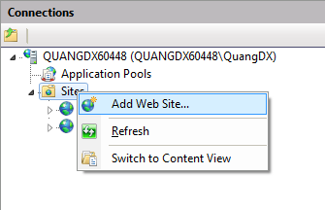

Figure 23: Configure IIS, right click on "Sites"

* A window appears, enter:
* Site name: choose a name for your website. Example: BusSuggestion
* Select application pool: select app pool that support .Net framework 4.0
* Physical path is website location where you publish
* Port number: for example, i use port 80

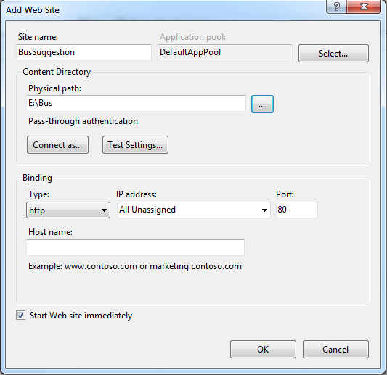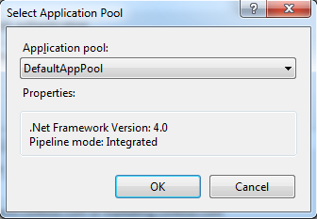

Figure 24: Configure IIS, Add Wed Site window

* Click OK.
* Browse your web to check

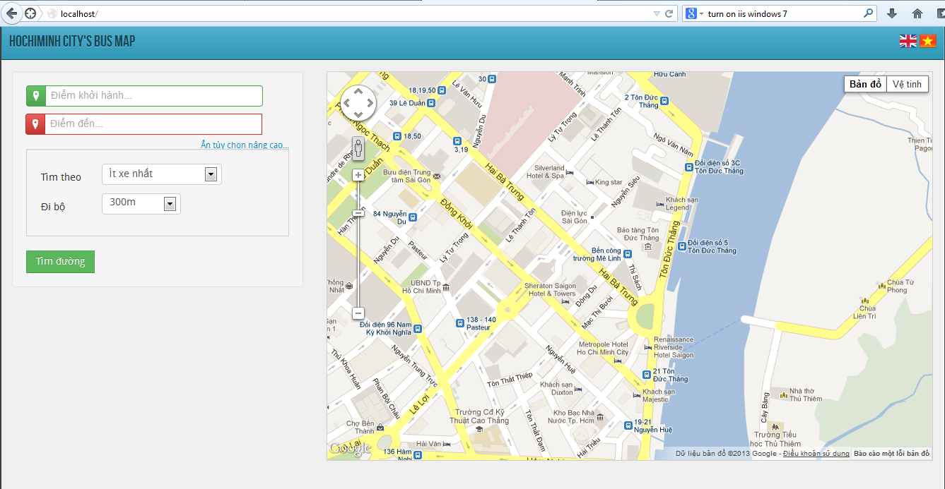

Figure 25: Configure IIS, check out your web

* If page fully load like above, you succeeded.

## User’s Guide

### Public User

Figure 26: Public user page's controls



**3**

**6**

**5**

**1**

**4**

**2**

**7**

|  |  |
| --- | --- |
| Item No | Meaning of item |
| 1 | Address boxes:   * Green text box is origin address * Red text boxes are destination address (maximum 3 destinations) |
| 2 | Delete destination buttons: delete destination address in text box and marker on map |
| 3 | Map:   * Green marker: starting point * Red marker: destination. * Orange line: walking * Blue line: direction from starting point to destination * Red line: direction from destination to destination 2 * Green line: direction from destination 2 to destination 3 * Walking marker: walking from here * Bus marker: take bus from here |
| 4 | Advance options:   * Show/Hide advance options * Search by: condition to get direction. There are 4 mode of search by: * Shortest distance: get direction that is the shortest one * Fewest bus: get direction that use the fewest number of bus * Lowest cost: get direction that total cost is lowest * Fastest: get direction that spent the least amount of time * Max walking transit: maximum walking distance you desire to walk * Max transfer permitted: maximum bus transfer time (available for all mode except fewest bus) * Time of departure: time you start your trip(only available in fastest mode) * Bus transfer time: time between each bus transfer time(only available in fastest mode) |
| 5 | Get directions button |
| 6 | Result table: List of results is described in words. |
| 7 | Language option |

Table 55: Meaning of public user page's controls

#### Sharing your location

When the first start, the browser will ask to access your location:

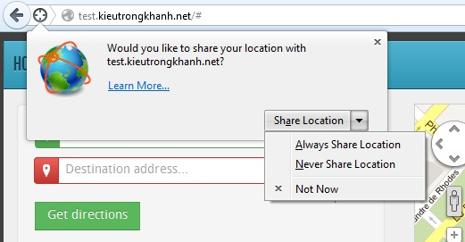

Figure 27: Pop up ask for sharing location

* If you want to share, just click button “Share Location”, and the map will point to your location immediately.
* If not, just click button “Not Now” or “Never Share Location” or just ignore it.

#### Choosing the origin and destinations

There are 2 ways to choose your origin and destinations:

* Type in address text box. Follow below steps:

Figure 28: Choosing origin/destination by typing in address textbox

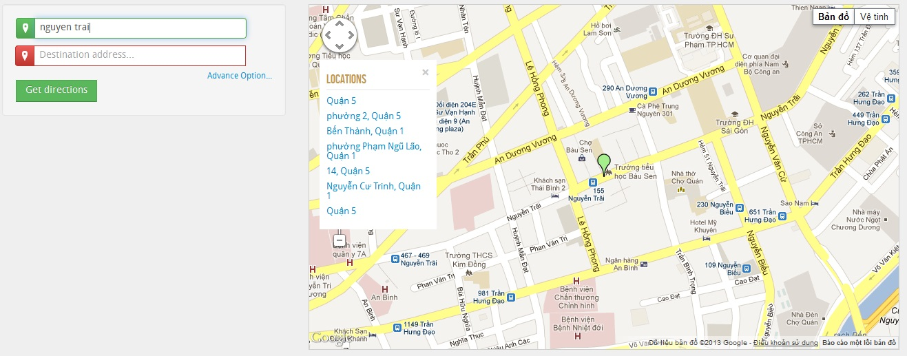

**1**

**2**

**3**

|  |  |
| --- | --- |
| No | Description |
| 1 | Type your start/destination addresses and press enter(or tab) |
| 2 | Select address from suggestion list if available |
| 3 | Map place the makers (green: start, red: destination) |

Table 56: Step by step choosing origin/destinations by typing in address textbox

* Click on map. Follow below steps:

Figure 29: Choosing origin/destinations by right click on map

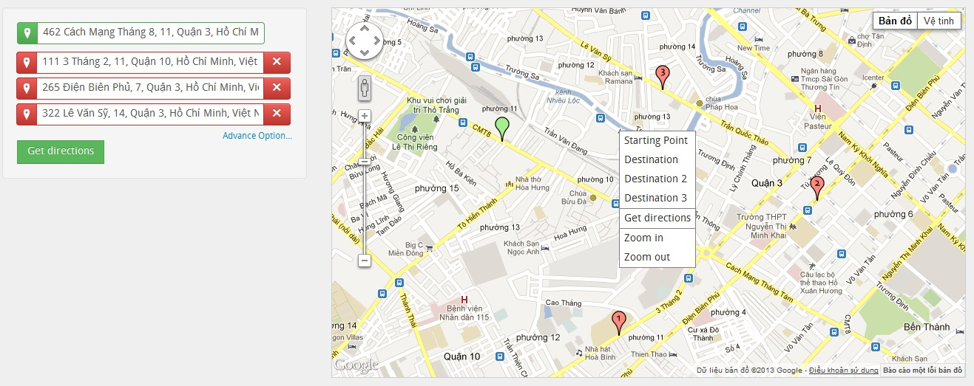

**3**

**2**

|  |  |
| --- | --- |
| No | Description |
| 1 | Right click on map where you want it to be the origin/destinations, the context menu appears. |
| 2 | Choose Starting point/Destination/Destination 2/Destination 3 on context menu. |
| 3 | Map place the makers (green: start, red: destination) and address text boxes are filled simultaneously. |

Table 57: Step by step choosing origin/destination by right click on map

Note: The maximum number of destination is 3 so you cannot add more.

#### Changing origin/destinations

You can change the origin or destinations by one of these:

* Type another address to address text box then press enter(or tab)
* Drag marker on map.
* Right click on new expected position and choose Starting Point/Destination/Destination 2/ Destination 3.

#### Removing destinations

You can remove the destinations by one of these:

* Click on delete destination button

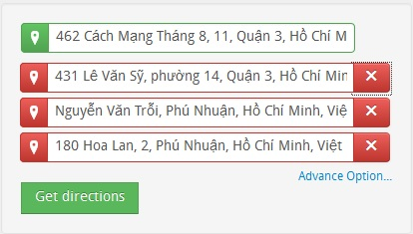

Figure 30: Delete destination buttons

* Right click on marker and choose remove.

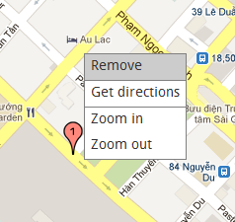

Figure 31: Remove destination by right click on marker

#### Setting advance option

By default, value for “Search by” is “fewest bus”, “Maximum walking transit” is “300m” and “Maximum transfer permitted” is “2”. You can change these values to get the most satisfied result.

#### Getting directions

After choosing origin and destination(s), click button “Get directions”.

Result will be drawn on map (by default, only the first itinerary is drawn):

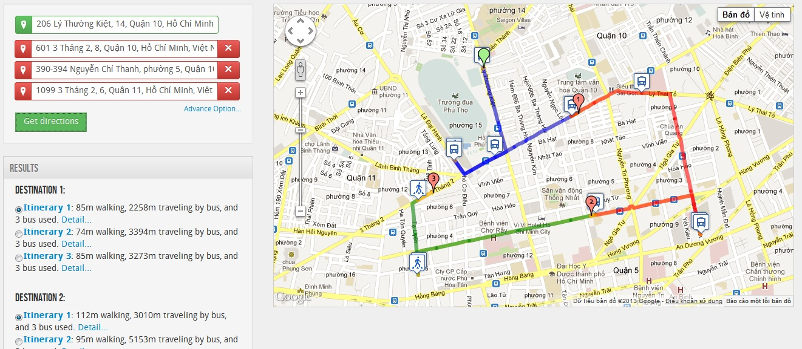

Figure 32: Directions on map

Click on bus markers or walking marker for more information.

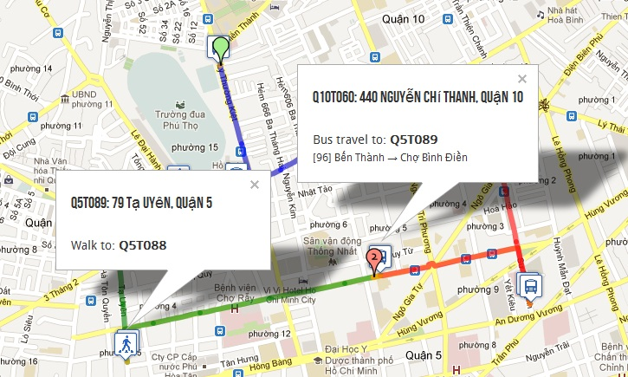

Figure 33: Click on marker for more information

Besides that, results in word are shown in result table:

* Number of itinerary is the number of option; you can choose one of these to follow.
* Click radio button in front of each itinerary to show direction on map.
* Click “Detail” for more information about that itinerary.

Figure 34: List directions in detail

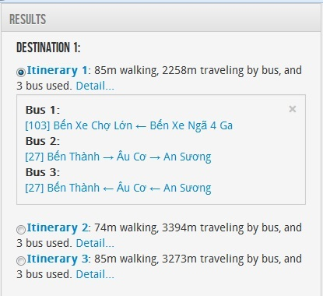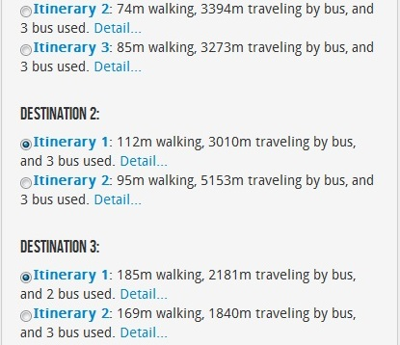

### Staff/Administrator User

#### Synchronizing

Figure 35: Synchronize page's controls



**1**

**3**

**5**

**2**

**6**

**4**

|  |  |
| --- | --- |
| Item No | Meaning of item |
| 1 | Navigation bar |
| 2 | Search route:   * Search by name * Search by status. There are 4 items in status combo box * New: This route is in buyttphcm server but you haven’t had yet * Changed: route that both you and buyttphcm have but different data (bus stop coordinate, number of bus stop…) * Removed: you have this route but buyttphcm don’t * All: all above status * Search button * Reset button: reset route name and status combo box to default |
| 3 | Map:   * Blue markers: bus stops belong to remote route that differ from local route * Red markers: bus stops belong to local route that differ from remote route * Blue line: remote route * Red line: local route |
| 4 | Synchronize button |
| 5 | Sync table: list all routes that are different between our data and buyttphcm’s data. Columns meaning:   * Code: is the code of bus. Green arrow is outward and red arrow is inward. * Name: is name of bus * Change: there are 3 status of change   + New:   + Changed   + Removed |
| 6 | Synchronize log: sync history |

Table 58: Meaning of synchronize page's controls

Synchronizing is a function that compares your bus route’s data (we call Local Route) to the bus route’s data (we call Remote Route) on [www.buyttphcm.com.vn](http://www.buyttphcm.com.vn) (official website of bus system in HCMC) to ensure to keep your data updated and work accurately.

This function shows all differences between Local and Remote Route in sync table.

By clicking on each item in table, map will show the differences:

Figure 36: Click on item in table to see differences

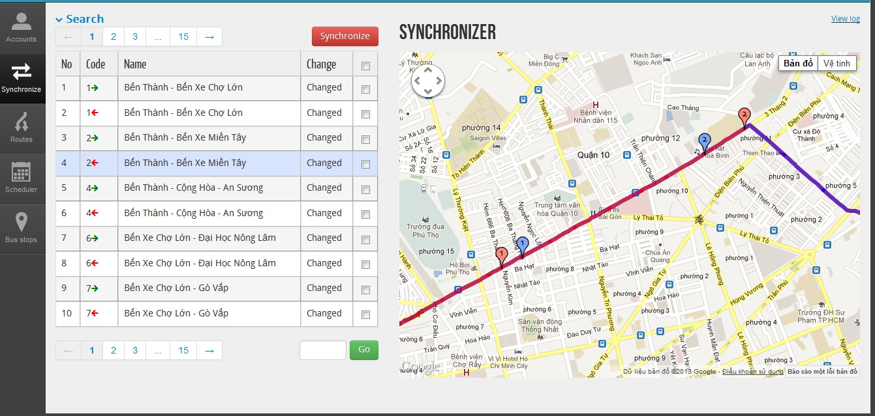

**Click**

**Differences**

To synchronize, follow below steps:

|  |  |
| --- | --- |
| No | Description |
| 1 | Check on route that you want to sync |
| 2 | Click red button “Synchronize” |
| 3 | Wait for finishing process and click button “OK”. You can cancel process by clicking button “Cancel” |

Table 59: Step by step synchronizing

Figure 37: Step by step synchronizing

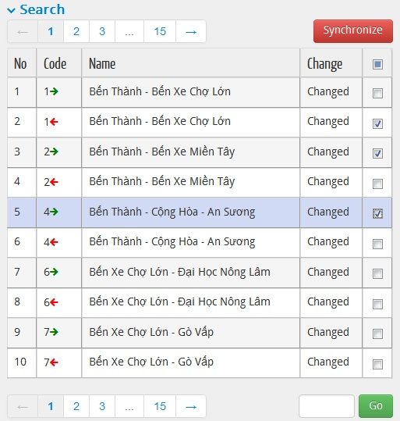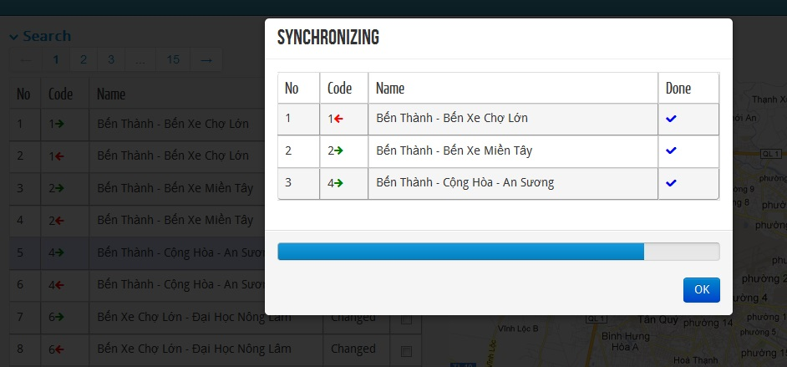

**1**

**2**

**3**

#### Managing Route

Figure 38: Route management page's controls

**5**



**1**

**44**

**3**

**2**

|  |  |
| --- | --- |
| Item No | Meaning of item |
| 1 | Navigation bar |
| 2 | Search route:   * Search by name * Search button * Reset button: reset route name to default |
| 3 | Map:   * Red markers: bus stops * Blue line: bus route |
| 4 | Add button: add more route |
| 5 | Route table: list all routes that match search condition. Columns meaning:   * Code: is the code of bus. Green arrow is outward and red arrow is inward. * Name: is name of bus * Edit button: edit route by changing code, name, price, reorder/remove bus stops. * Delete button: delete route |

Table 60: Meaning of route management page's controls

##### View Route

All bus routes in system will be shown in route table.

You can view route and its bus stops by click on row in table. Route will be shown on map

Figure 39: View route and its bus stops

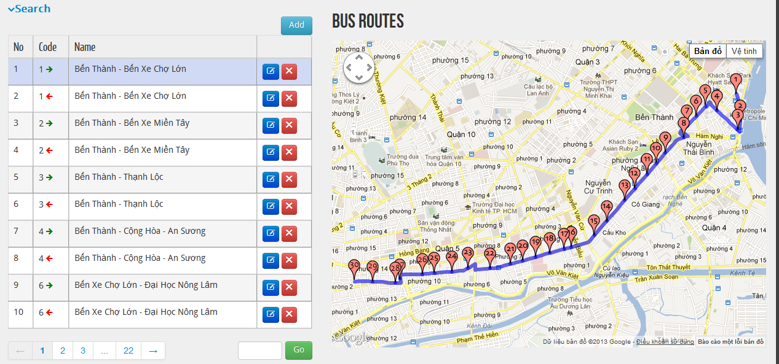

**Click**

##### Add Route

To add route, follow these steps:

Figure 40: Step by step adding a route

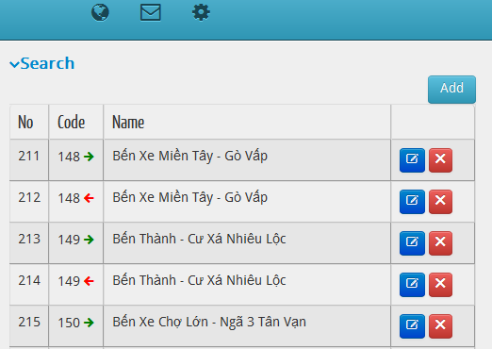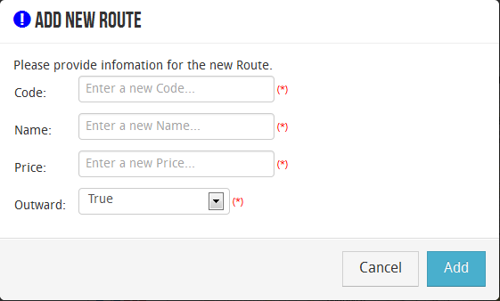

**2**

**1**

**3**

|  |  |
| --- | --- |
| No | Description |
| 1 | Click add button on right top of route table. |
| 2 | Fill all require information. |
| 3 | Click add button. |

Table 61: Step by step adding route

##### Edit Route

If you want edit a route, click on edit button:

Figure 41: Edit Route button

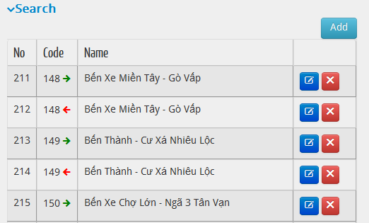

**Click**

After click edit button, website navigates to edit page. In here you can edit Code, Name, Outward and Price:

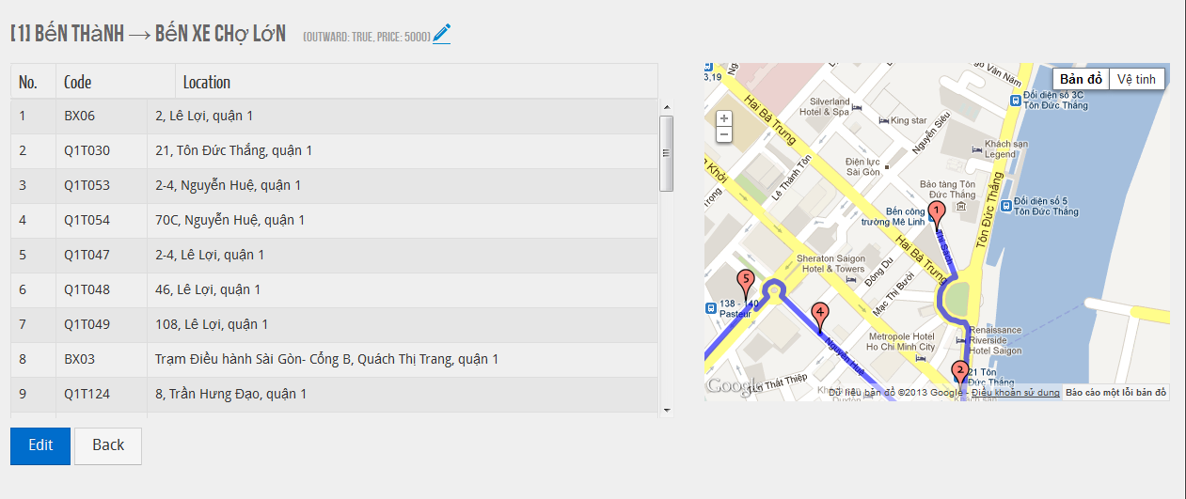

**Click**

Figure 42: Edit route's code, name, outward and price

In edit page, you can reorder or remove bus stops in route by click “Edit” button on the left bottom of bus stop table:

Figure 43: Step by step reordering/removing route's bus stop(s)

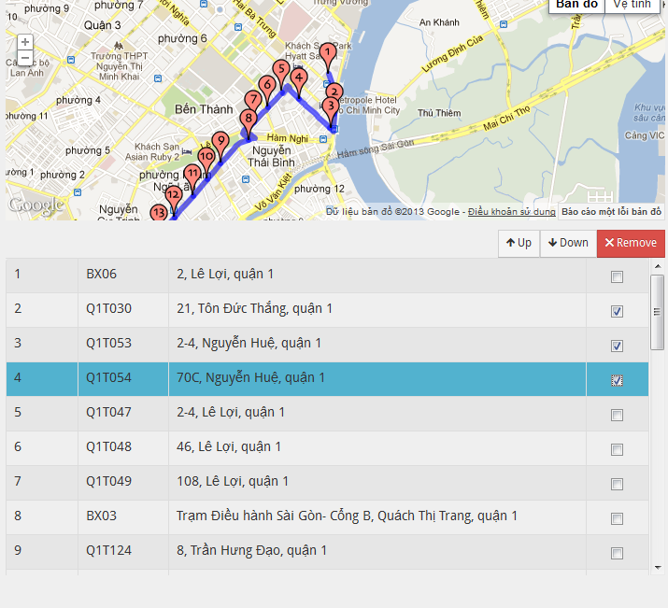

**2**



**3**

**1**

|  |  |
| --- | --- |
| No | Description |
| 1 | Check on bus stop that you want to reorder/remove |
| 2 | Click button Up(decrease order number)/Down(increase order number)/Remove |
| 3 | Click “Save” button to make change or click “Back” to cancel. |

Table 62: Step by step reordering/removing route’s bus stop(s)

##### Delete Route

To delete route, click on delete button (next to “Edit” button that was introduced above)

Figure 44: Delete route button

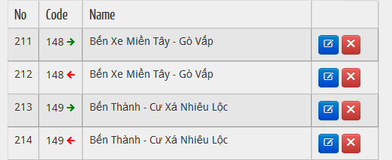

A dialog appears to ensure if you want to delete this route or not. If you sure, just click delete button:

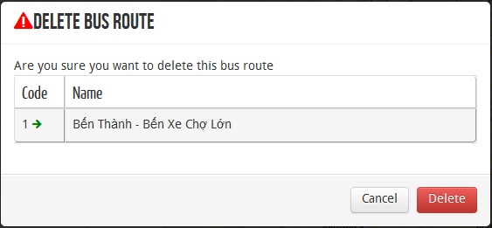

Figure 45: Delete route dialog

#### Schedule

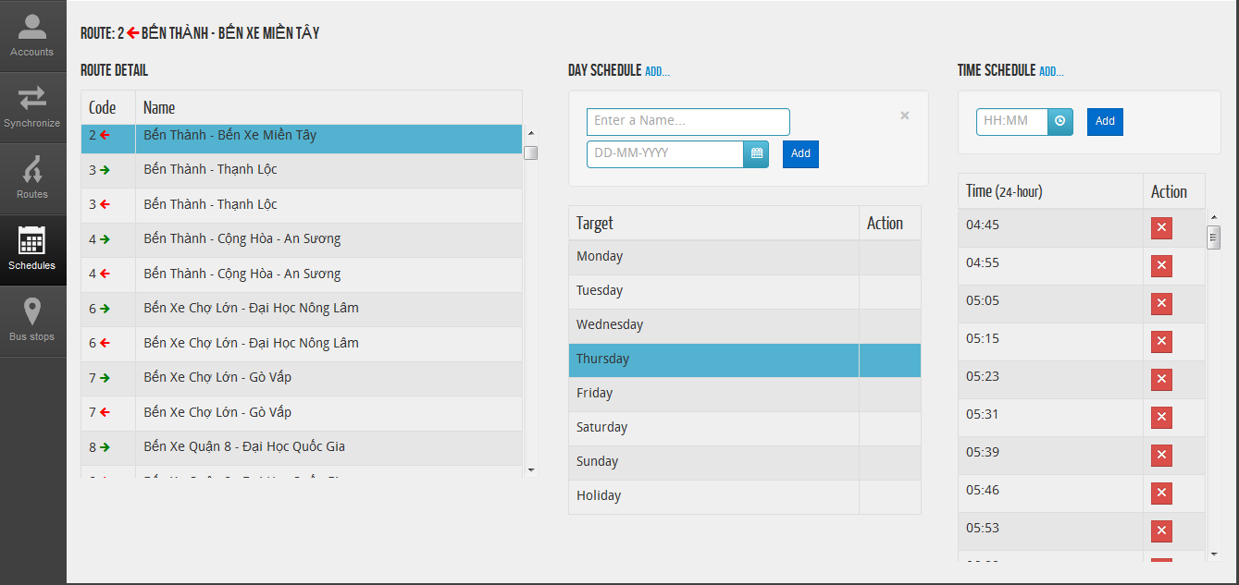

**2**

**8**

**7**

**6**

**5**

**3**

**4**

Figure 46: Schedule page's controls

|  |  |
| --- | --- |
| Item No | Meaning of item |
| 1 | Navigation bar |
| 2 | Route detail table |
| 3 | Day schedule table |
| 4 | Time schedule table |
| 5 | Add hypertext: click to show/hide add day schedule form |
| 6 | Add day schedule form:   * Name: Name of day schedule * Date * Add button: add item to day schedule table |
| 7 | Add hypertext: click to show/hide add time schedule form |
| 8 | Add time schedule form:   * Time * Add button: add item to tine schedule table |

Table 63: Meaning of schedule page's controls

##### Add day schedule

To add day schedule, do following:

Figure 47: Step by step adding day schedule



**1**

**3**

**4**

**2**

|  |  |
| --- | --- |
| No | Description |
| 1 | Click on route on route detail table that you want to add day schedule |
| 2 | Click add hypertext |
| 3 | Fill require information |
| 4 | Click add button |

Table 64: Step by step adding day schedule

##### Add time schedule

To add time schedule, following these steps

|  |  |
| --- | --- |
| No | Description |
| 1 | Click on route on route detail table that you want to add time schedule |
| 2 | Click on day in day schedule table that you want to add time schedule |
| 3 | Click add hypertext |
| 4 | Fill require information |
| 5 | Click add button |

Table 65: Step by step adding time schedule

##### Delete time schedule

To remove time schedule, click on delete button like below then click ok button on dialog appear

Figure 48: Delete time schedule button

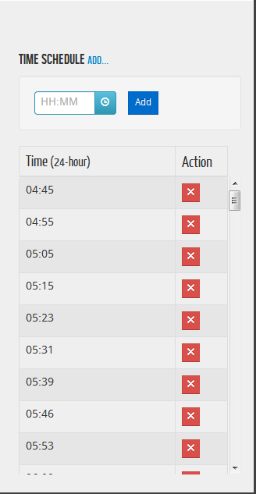

**Click**

#### Managing bus stop

Figure 49: Bus stop management page's controls

**14**



**5**

**3**

**4**

**2**

|  |  |
| --- | --- |
| Item No | Meaning of item |
| 1 | Navigation bar |
| 2 | Search bus stop:   * Search by address code: list all bus stop that match location address * Search by ward: list all bus stop belong to chosen ward in bus stop table * Search by route: list all bus stop belong to chosen route in bus stop table * Search button |
| 3 | Map:   * Red markers: bus stops * Blue marker: current chosen marker |
| 4 | Add button: add more bus stop |
| 5 | Bus stop table: list all bus stops that match search condition. Columns meaning:   * Code: is the code of bus stop * Location: address code * Street * Ward * Edit button: edit route by changing address, coordinate * Delete button: delete bus stop |

Table 66: Meaning of bus stop management page's controls

##### View bus stop

Click on bus stop on bus stop table, map will pan to that bus stop on map and turn marker to blue.

##### Add bus stop

Click on add button, a modal will appear:

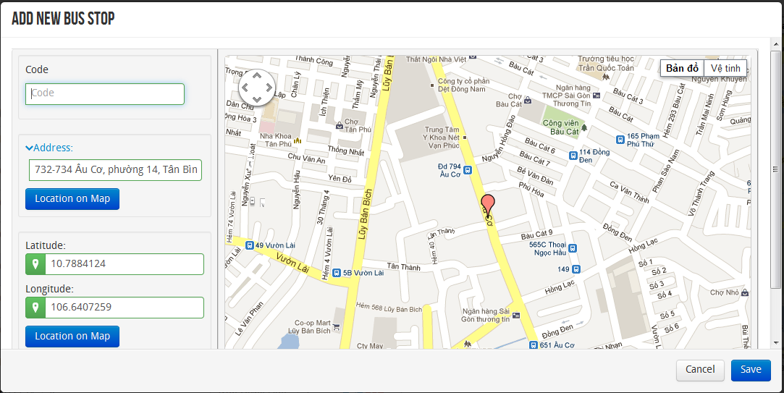

Figure 50: Add new bus stop modal

Following these steps to add bus stop:

|  |  |
| --- | --- |
| No | Description |
| 1 | Fill code text box |
| 2 | Choose location for new bus stop. There are 3 way to set location:   * Type in address text box then click location on map button * Type in latitude and longitude text boxes then click location on map button * Drag marker on map |
| 3 | Click save button |

Table 67: Step by step adding bus stop

##### Edit bus stop

Click edit button, a model will appear:

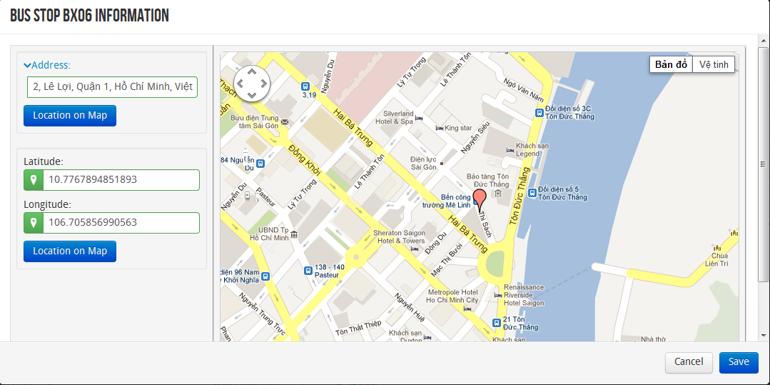

Figure 51: Edit bus stop modal

Following these steps to edit bus stop:

|  |  |
| --- | --- |
| No | Description |
| 1 | Edit location for bus stop. There are 3 way to edit location:   * Type in address text box then click location on map button * Type in latitude and longitude text boxes then click location on map button * Drag marker on map |
| 2 | Click save button |

Table 68: Step by step editing bus stop

##### Delete bus stop

Click delete button, a dialog appear to ensure you really want to delete this bus stop then click ok to delete.

# Works Cited

Báo Tin Mới, n.d. *Năm 2012, TP.HCM có 370 triệu lượt người đi xe buýt.* [Online]   
Available at: http://www.tinmoi.vn/nam-2012-tphcm-co-370-trieu-luot-nguoi-di-xe-buyt-011153226.html

ESRI, n.d. *MVC Architecture.* [Online]   
Available at: http://www.esri.com/news/arcuser/0609/aspnetmvc.html

Hong Tan Van, S. F., 2009. *Psychological Determinants of the Intention to Use the Bus in Ho Chi Minh City.* [Online]   
Available at: http://www.nctr.usf.edu/jpt/pdf/JPT12-1Fujii.pdf

Microsoft MSDN, n.d. *C# Coding Conventions.* [Online]   
Available at: http://msdn.microsoft.com/en-us/library/vstudio/ff926074(v=vs.100).aspx

Wikipedia, n.d. *Double-ended Priority Queue.* [Online]   
Available at: http://en.wikipedia.org/wiki/Double-ended\_priority\_queue

Wikipedia, n.d. *Heap Structure.* [Online]   
Available at: http://en.wikipedia.org/wiki/Heap\_(data\_structure)

Wikipedia, n.d. *Priority Queue.* [Online]   
Available at: http://en.wikipedia.org/wiki/Priority\_queue

www.agilekiwi.com, n.d. *Definition of Agile Development.* [Online]   
Available at: http://www.agilekiwi.com/other/agile/definition-of-agile-development/

www.buyttphcm.com.vn, n.d. [Online]   
Available at: http://www.buyttphcm.com.vn/TTLT.aspx

1. https://www.assembla.com/spaces/free-private-subversion-repository-only/prepare\_copy?type=private [↑](#footnote-ref-1)
2. https://www.assembla.com/spaces/free-agile-task-management/prepare\_copy?type=private [↑](#footnote-ref-2)
3. [↑](#endnote-ref-1)